
Lesson 4 : Weather and Erosion
Study Guide

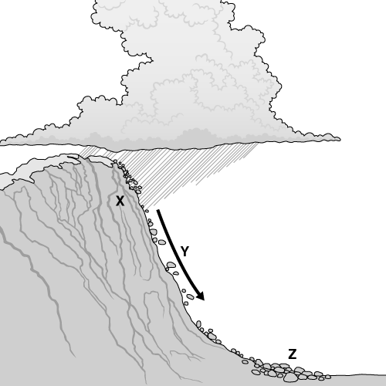
Erosion is shown in the picture by the letter Y
Deposition is shown by the letter Z
Weathering is shown by the letter X

Ahmad used these two beakers in an experiment to find out how limestone would react to certain liquids. Holes and pits formed in the limestone in vinegar.
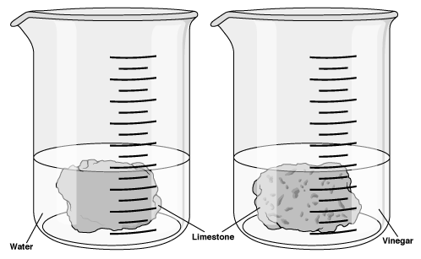

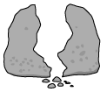
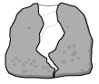
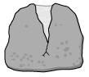
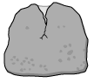
The process of physical weathering in order.
1. First 2. Second
- Third 4.Fourth

Tiny rock particles are always moving along with the slow movement of a glacier. The statement that best predicts what will happen to the weathered rock particles under a glacier when a glacier melts is that the weathered rock particles will be deposited in a new place producing a new landform.

Mahmoud and Abood are setting up an experiment to find out how weathering and erosion are affected by rainfall. Look at the picture of their lab setup.
Pouring water on the brown sugar represents weathering
To demonstrate erosion, the experiment must show removal
They change their setup by replacing the taller wooden block with a much taller block. Then, they pour the same amount of water over the brown sugar as before. What will most likely happen?

The amount of erosion and deposition will increase.

