Name: ___________________ Date: _____________

English:- Unit 2 Week 4: Poetry Assessment

Breakfast
I wake up
and feel a rumble.
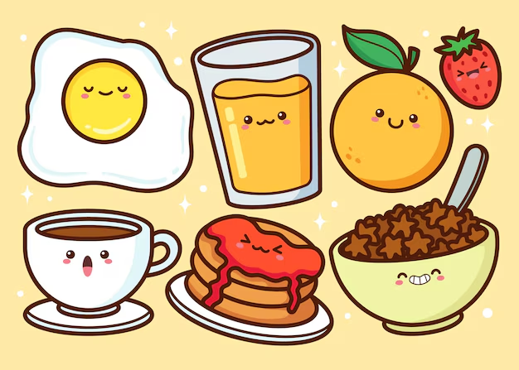
I get out of bed.
My tummy wants to be fed.

My mom calls,
“Breakfast is ready!”
I hope it is toast
since I like it the most.

At the table,
I see toast and jam
ready for my plate.
I can hardly wait!

What genre is this text?
- Realistic fiction b. Poetry c. informational text

What elements make this text different from other genres?
What is this poem about?
- Waking up to eat breakfast b. Eating dinner before bed
Connect the words from the poem that rhyme:

Plate ⧭ ⧭ Most

Toast ⧭ ⧭ Fed

Bed ⧭ ⧭ Wait

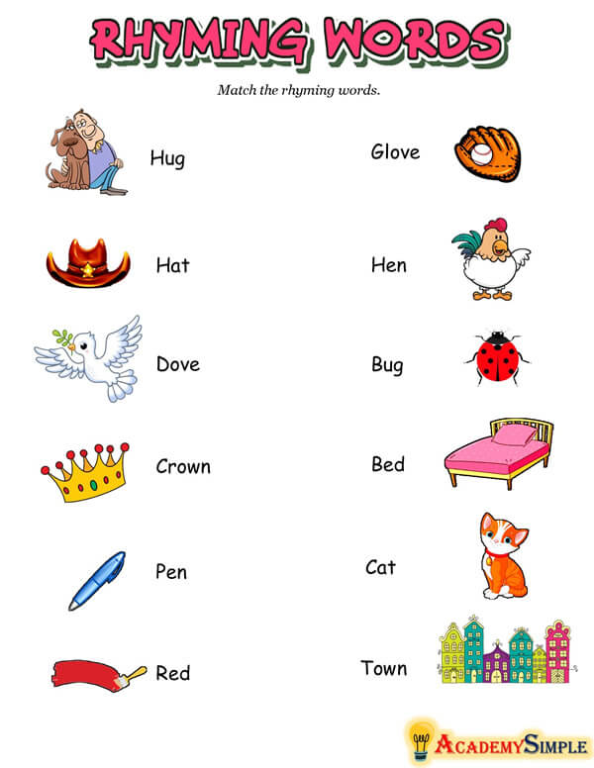

⭐ Bonus: Show where the stanzas are in the poem!

