Name: ______________________ Date: ________________

Topic 6 Study Guide Worksheet

- Circle the adult possum? 2.) How many baby possums are there?
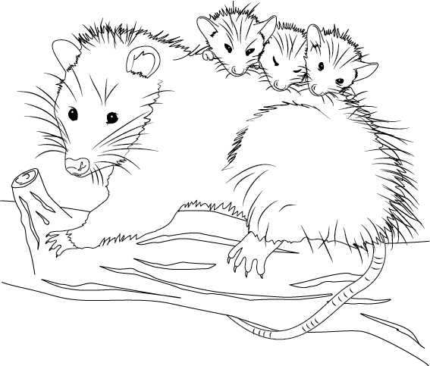
_________________

3.) What animal behavior do you see in the picture above?
- The possums are cute
- The adult possum is protecting their young
- The possum has claws

4.) What is true about the parent of a young animal?
- It is the same size
- It has different parts
- It is the same age
- It has different body parts

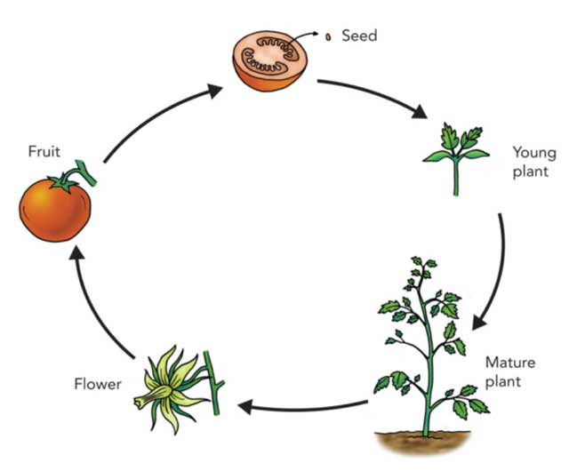
5.) What does this diagram show?
- All the types of tomatoes
- How to cook tomatoes
- The life cycle of a tomato
- How an adult plant protects the young plant

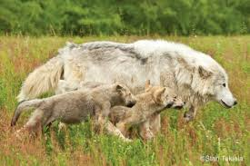
6.) This wolf is showing its young how to hunt. What is the adult doing?
- Finding water
- building a shelter
- Teaching a behavior
- Protecting its young
What are the three important things all animals need to survive?

Shelter | Food | Water

- 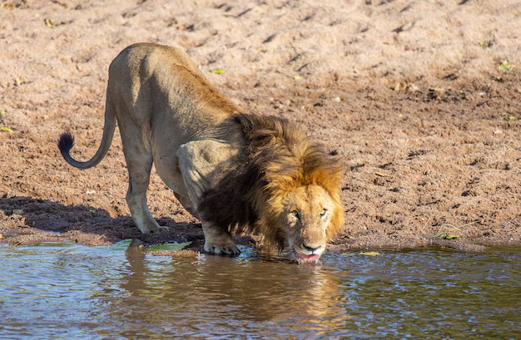 _____________________
- 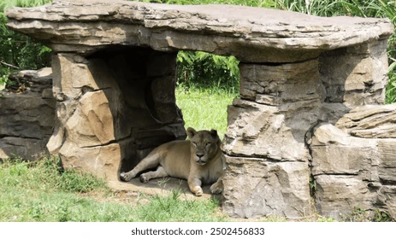 _____________________
- 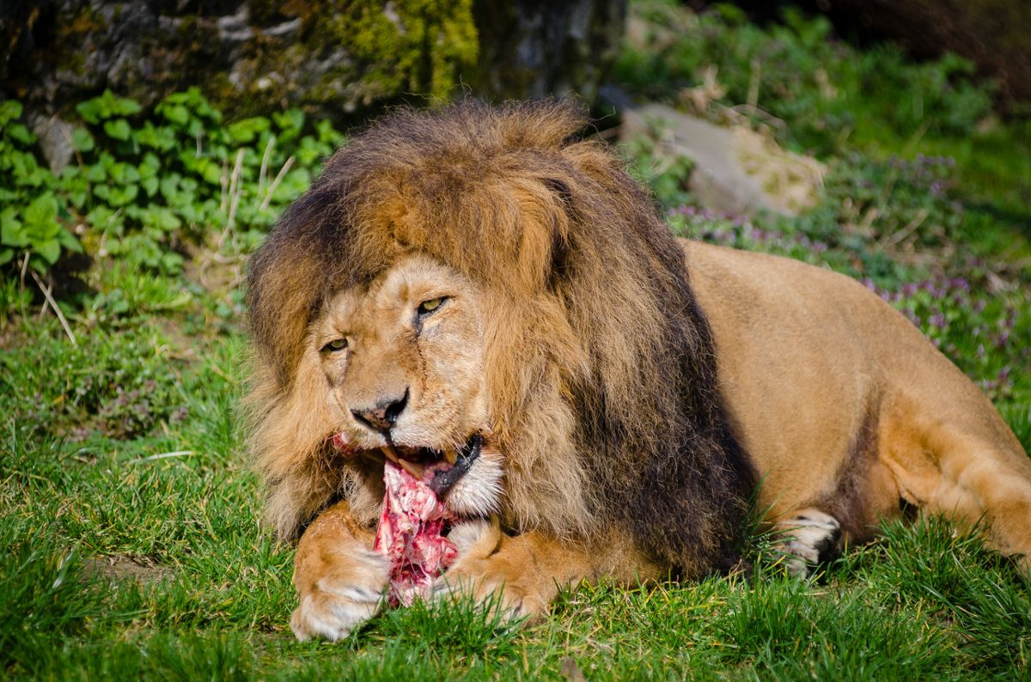 ____________________

Circle what is true about the adult plant with the young plant
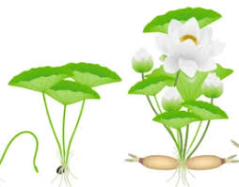
- The young plant has less leaves than the adult plant
- They are the same size
- They both have similar parts
- They are the same age

