Civilizations Develop in the Americas

Leveled Lesson Summary

Scholars disagree about exactly when and how the first people reached the Americas. A common theory held that between 12,000 and 10,000 years ago, Paleolithic people reached North America from Asia. This migration took place during the last Ice Age, which lasted from about 100,000 years ago to about 10,000 years ago. At the time, so much water froze into thick ice sheets that the sea levels dropped, exposing a land bridge between Siberia and Alaska in the area that is now the Bering Strait.
Early evidence supported the theory that bands of hunters and food gatherers followed herds of bison and mammoths across the land bridge between Siberia and Alaska. They slowly moved south through North America, Central America, and South America. Recent evidence suggests that people may have reached the Americas much earlier. They may have paddled small boats and fished along the coasts. As archaeologists have discovered new evidence, they have modified their theories. Researchers now base the dates of migration into the Americas mostly on evidence found at prehistoric sites.
Adapting to New Environments

The first Americans faced a variety of environments in which they could settle. For example, great mountain chains—the Rockies, the eastern and western Sierra Madre, and the Andes—dominate the western Americas. In addition, through the continents flow three of the world’s five longest rivers, the Amazon of South America and the Missouri and Mississippi rivers of North America.
Far to the north and south of the continents, people learned to survive in icy, treeless lands. Closer to the Equator, people settled in the hot, wet climate and dense vegetation of the Amazon rain forest. Elsewhere, hunters adapted to deserts like the Atacama of Chile, woodlands like those in eastern North America, and the fertile plains of both continents.
Farming Begins

In the Americas, as elsewhere, the greatest adaptation occurred when people learned to domesticate plants and animals. These changes took place slowly between about 8500 B.C. and 2000 B.C. In Mesoamerica, or Middle America, Neolithic people cultivated a range of crops, including beans, sweet potatoes, peppers, tomatoes, squash, and maize—the Native American name for corn. People in South America cultivated crops such as maize and cassava and domesticated llamas and other animals valued for their wool. By 3000 B.C. in parts of South America and 1500 B.C. in parts of Mesoamerica, farmers had settled in villages. Populations then expanded, and some villages eventually grew into the great early cities of the Americas.
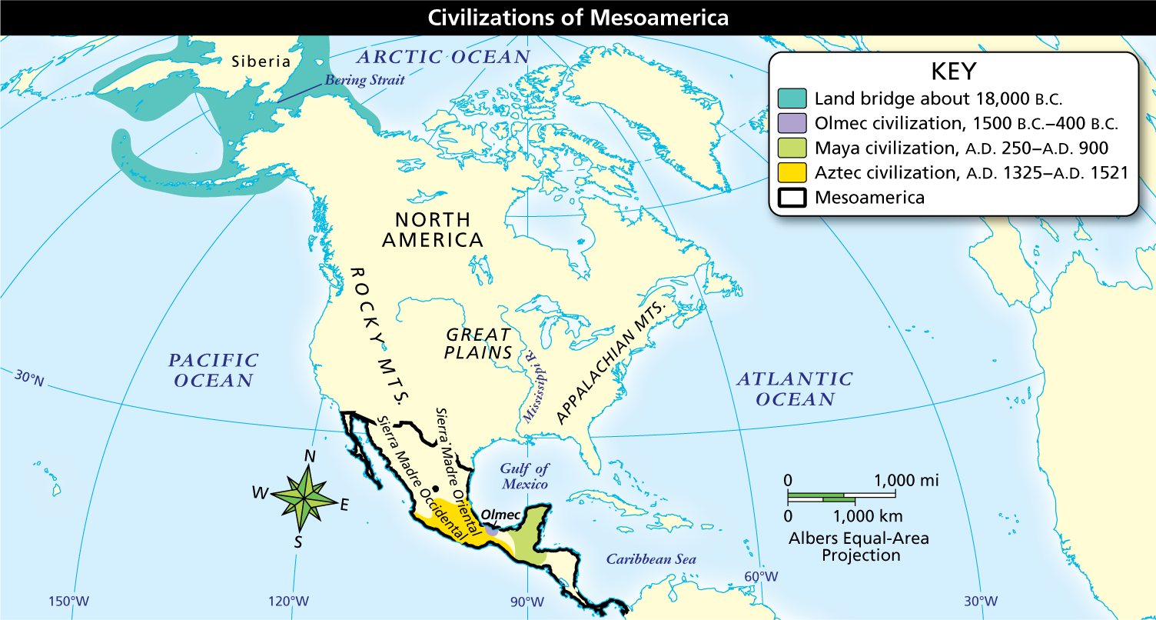

Alternate Display of Presentation

Full Image Description
About 18,000 B.C., the land bridge covered the Bering Strait between Siberia and North America. From 1500 B.C. to 400 B.C., the Olmec civilization covered a small area in the southern part of what is now Mexico, on the Gulf of Mexico. From A.D. 250 to A.D. 900, the Maya civilization covered an area in Central America extending from the Gulf of Mexico in the north to the Pacific Ocean in the south. From A.D. 1325 to A.D. 1521, the Aztec civilization covered much of what is now southern Mexico. Mesoamerica includes what is now Mexico and Central America.
Analyze Maps Early people are thought to have crossed the Bering Strait from Asia to the Americas either on foot or in small boats. What might have been one of the biggest geographic influences on Mesoamerican civilizations?
Notebook
Olmec Civilization Emerges

Many scholars consider the Olmec the first American civilization; it emerged in the fertile coastal areas along the Gulf of Mexico and lasted from about 1200 to 400 B.C. Compared to other civilizations such as the Maya, Aztec and Inca, archaeologists know little about the Olmec. We do not even know what they called themselves. In fact, Olmec is the name the Aztecs later used for these people. But rich tombs and temples suggest that they had a powerful class of priests. The Olmec did not build true cities, but rather priests and other leaders may have lived in ceremonial centers, while the common people lived in surrounding farming villages.
Olmec Culture and Trade

Ceremonial centers had large pyramid-shaped temples and other important buildings. Much of Olmec art is carved stone. The smallest examples include jade figurines of people and gods. The most dramatic remains are 14 giant stone heads found at the major ceremonial centers of San Lorenzo and La Venta.
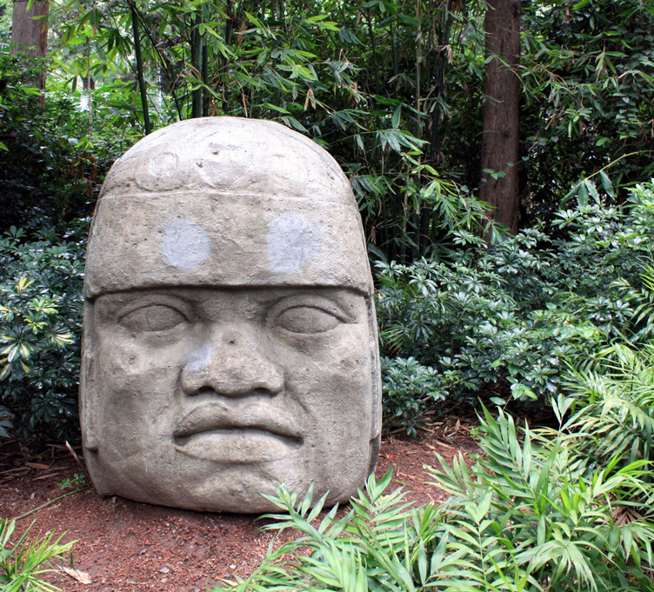
Archaeologists discovered the giant Olmec stone heads, made of volcanic rock and weighing up to five tons each, during excavations. The Olmec moved them to ceremonial sites from distant quarries.
Scholars think that these colossal heads, which the Olmec carved from 40-ton stones, are portraits of actual rulers. No one knows exactly how the Olmec moved these stones from distant quarries without wheeled vehicles or draft animals. Still, the evidence shows that the Olmec could mobilize a large labor force.
The Olmec also engaged in trading jade, obsidian, serpentine, mica, rubber, feathers, and pottery; through such trade, they influenced a wide area. The grinning jaguars and serpents that decorate many Olmec carvings appear in the arts of later Mesoamerican peoples. The Olmec also invented a calendar, and they carved hieroglyphic writing into stone. Recent archaeological excavations in Mexico indicate they may have developed a writing system, which would make them the first Mesoamerican civilization to do so.
Influence of the Olmec

Through trade, Olmec influence spread over a wide area. Archaeologists have identified Olmec religious and artistic influences on two later Mesoamerican civilizations—the Maya and Aztec.
Both these civilizations built pyramid-shaped temples similar to those of the Olmec. Olmec ceremonial centers had the remains of ball courts linked to religious rituals. Similar ball courts have been found at Maya and later Aztec sites.
The ball game was fast paced and involved great skill on the part of the players. They had to keep a rubber ball in motion and send it through hoops high on a stone wall. The ball was not allowed to touch the ground. Archaeologists do not know the exact meaning of the game, but it had religious and political importance. It also was a source of entertainment for crowds of spectators.
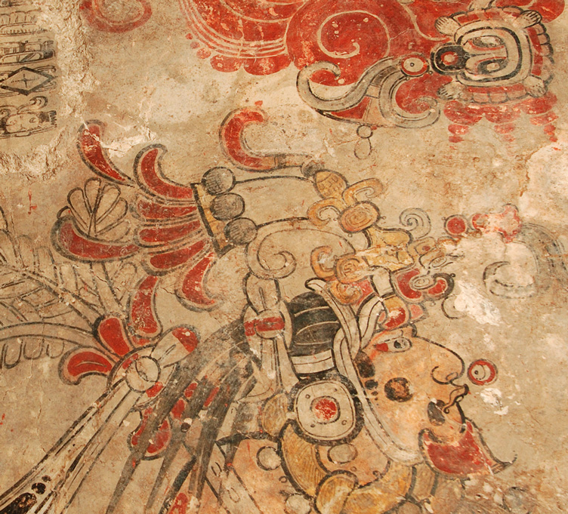
The ruins of San Bartolo have murals deep within the pyramidal complex of Las Pinturas.
The grinning jaguars, serpents, and other images that decorate Olmec carvings appear in the arts of later people. A figure similar to the Maya god of maize is found in Olmec paintings on the walls at San Bartolo, and the Olmec snake god is seen in the Maya gods Kukulcan and the Aztec Quetzalcoatl. The Olmec calendar and its number system were passed on to later people. Their most important legacy, however, may have been the tradition of priestly leadership and the religious rituals that were central to later Middle American civilizations.
Infer Why don’t archaeologists know where the Olmec came from?

