The Maya

Leveled Lesson Summary

Scholars have long thought that among the peoples the Olmec influenced were the Maya. New evidence suggests that the Maya may have developed ceremonial centers about the same time as the Olmec. By 300 B.C., the Maya were building large cities, such as El Mirador in Guatemala. By about A.D. 250, the Maya golden age—known as the Classic Period—began, with city-states flourishing from the Yucatán Peninsula in southern Mexico through much of Central America.
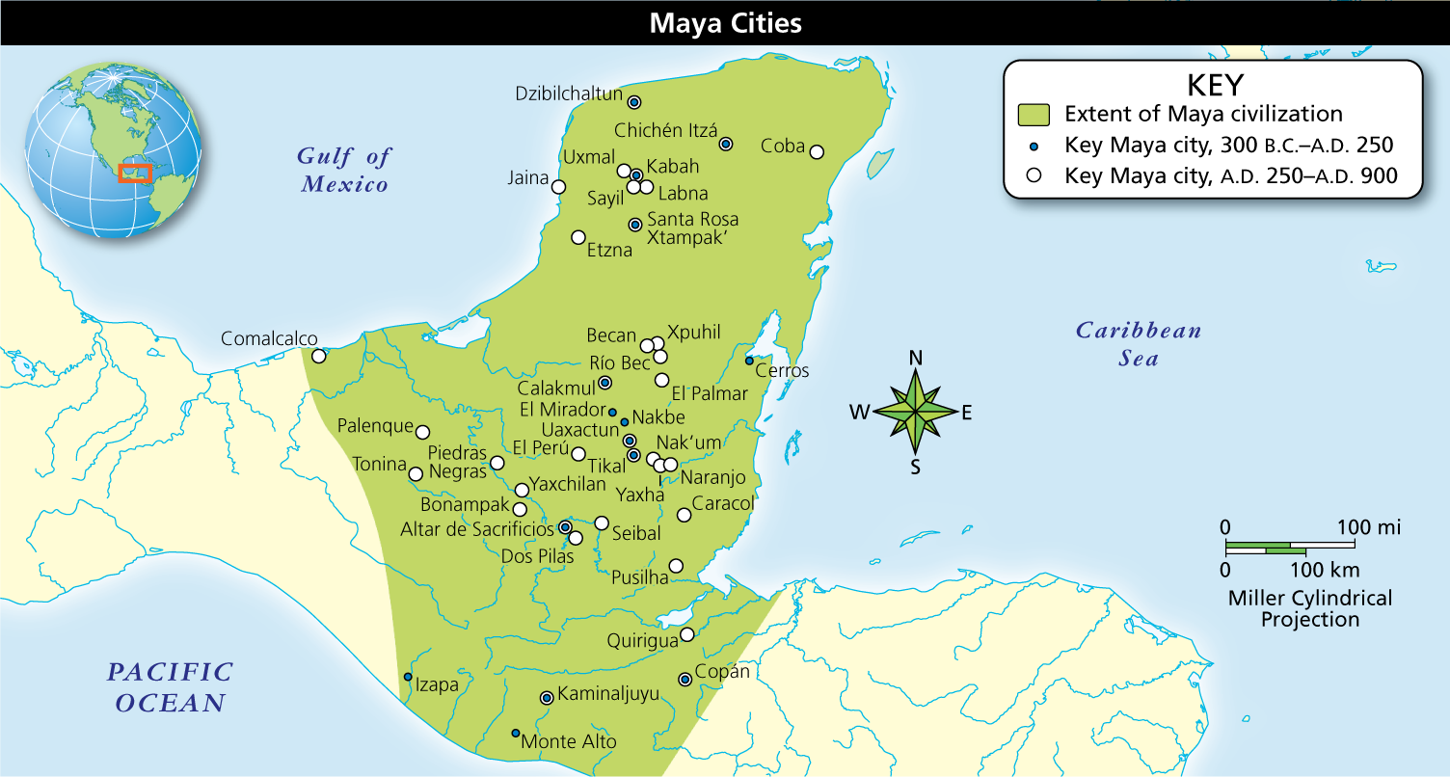

Alternate Display of Presentation

Full Image Description
Map shows the extent of Maya civilization, jutting out from Central America between the Gulf of Mexico to the west and the Caribbean Sea to the east. From 300 BC to AD 250, there are fifteen key cities shown. From AD 250 to AD 900, there are more than thirty key cities shown. Only two of these later cities are located along the coast.
Analyze Maps Maya cities were centered around temples used for ceremonial purposes and for observations of the stars, from which the Maya calculated mathematics and astronomy. Where were most of the later cities established?
Notebook
Farming Methods

Before the Maya developed large population centers, like those later constructed by the Inca and Aztecs, they lived scattered across the land. They developed two farming methods that allowed them to thrive in the tropical environment. In many areas, farmers burned down forests and then cleared the land in order to plant on it. After a few years, the fields were no longer fertile. The Maya would then abandon these lands until they could be used once again.
In the meantime, farmers would burn and clear new lands for farming. In addition, along the banks of rivers, Maya farmers built raised fields to lift crops up above the annual floodwaters. These methods allowed the Maya to produce enough maize and other crops to support rapidly growing cities.
City-States Ruled Over the People

The Maya cities that developed before and during the Classic Period never formed an empire. Instead, individual and powerful city-states evolved. The smaller city-states ruled over the people living directly within and near their borders. The largest ones reigned over neighboring areas as well—often requiring nearby cities to show allegiance to their kings and to participate in their ritual activities. Over the course of hundreds of years, many different city-states held power, with warfare and trade a constant theme of life among them. Cities such as Palenque, Copán, and Piedras Negras all carried great influence in their time, but the largest and most supreme power resided in the rulers of Tikal and Calakmul.
While the Maya were not united politically as later Aztec and Inca civilizations came to be, city-states maintained regular contact through a system of economic exchange, which generated much wealth. Traders carried valuable cargoes long distances by sea and along roads made of packed earth. Trade goods included items of daily use—such as honey, salt, and cotton—and nonessential but prized items such as feathers, jade, and jaguar pelts. These goods might have been used in ceremonies or to show status.
Social Hierarchy

Each Maya city had its own ruler, who was usually male. Maya records and carvings show that women occasionally governed on their own or in the name of young sons. Nobles served many functions in support of the ruler. Some were military leaders, while some collected taxes and enforced laws. Others managed public works, similar to the way the Olmec used collective labor for monument and temple building. Scribes, painters, and sculptors were also very highly respected. Merchants may have formed a middle class in society, though the wealthiest and most powerful merchants were certainly nobles, as they had been in the Olmec civilization.
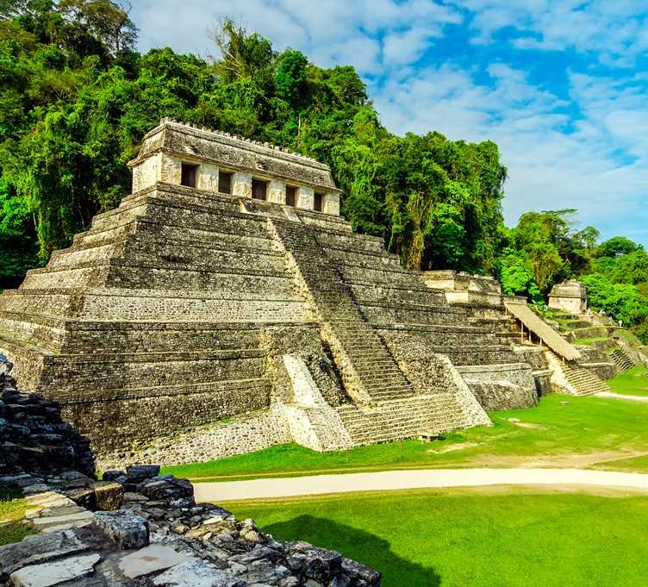
Maya temples were built in the shape of pyramids using hand-cut limestone blocks. The interior usually consisted of a few narrow rooms, indicating that they were intended for ceremonial purposes rather than for the public.
The majority of the Maya were farmers. They grew maize, beans, and squash—the basic food crops of Mesomerica—as well as fruit trees, cotton, and brilliant tropical flowers. To support the cities, farmers paid taxes on food and worked on construction projects. Some cities also included a population of slaves, who generally were commoners who had been captured in war.

