Phoenician Contributions

Leveled Lesson Summary

While powerful rulers subdued large empires, many small states of the ancient Middle East made their own contributions to the civilizations of the ancient Middle East. The Phoenicians (fuh NISH unz), for example, gained fame as sailors and traders. They occupied a string of cities along the eastern Mediterranean coast, in the area that today is Lebanon and Syria.
Manufacturing and Trade Expands

The coastal land was too narrow to support a large farming population. Instead, the resourceful Phoenicians turned to manufacturing and trade. They made glass from coastal sand. From a tiny sea snail, they produced a widely admired purple dye, called “Tyrian purple” after the city of Tyre.
Phoenicians traded with people all around the Mediterranean Sea. To promote trade, they set up colonies from North Africa to Sicily and Spain.
A colony is a territory settled and ruled by people from another land. A few Phoenician traders braved the stormy Atlantic and sailed as far as Britain. There, they exchanged goods from the Mediterranean for tin. Some scholars have suggested that a Phoenician expedition may have sailed down the Red Sea and followed the East African coast to its southern tip.
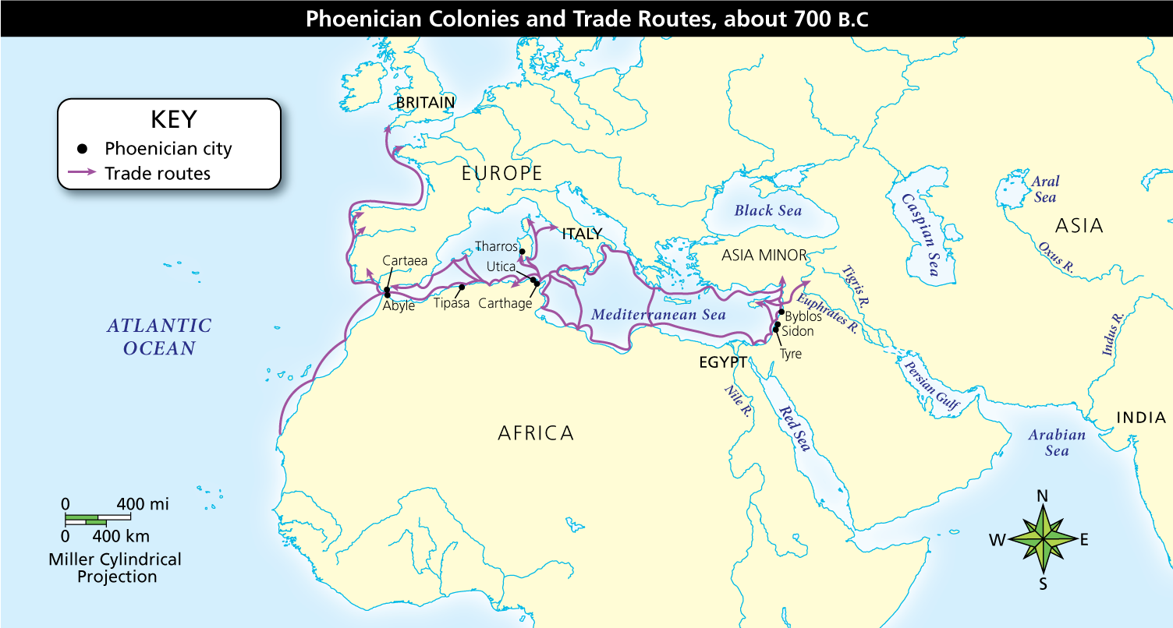
Full Image Description
Arrows show trade routes all around the Mediterranean, including Asia Minor, Egypt, northern Africa, Italy, and western Europe as far north as Britain. Phoenician cities are labeled, including Cartea, Abyle, Tipasa, Utica, Tharros, Carthage, Byblos, Sidon, and Tyre.
Analyze Maps What information on the map supports the claim that the Phoenicians were skilled sailors?
Notebook
Phoenicians also used papyrus, a plant that they brought from Egypt, to make scrolls, or rolls of paper for books. The words Bible and bibliography come from the Phoenician city of Byblos.
The Phoenician Alphabet

Historians have called the Phoenicians “carriers of civilization” because they spread Middle Eastern civilization around the Mediterranean. Yet the Phoenicians made their own contribution to our world, creating the basis for our alphabet.
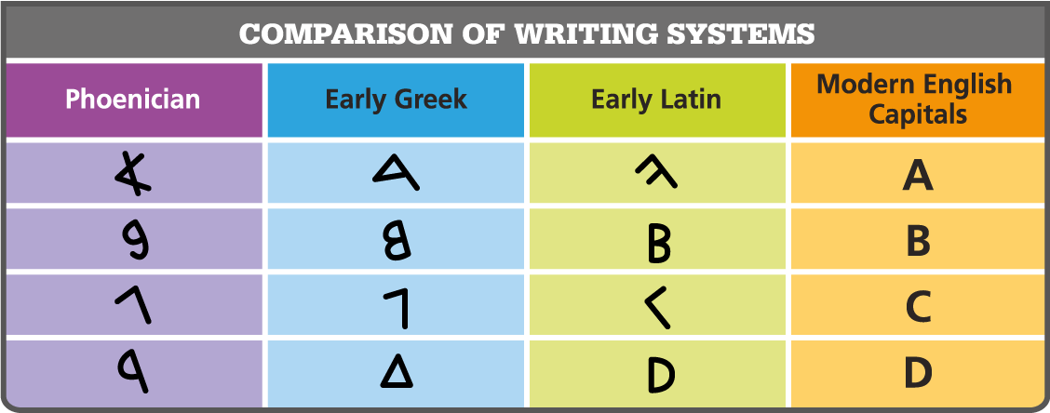
Analyze Information How was the alphabet used today in English influenced by the Phoenicians?
Notebook
At first, the Phoenicians used cuneiform, but the uniform wedges in which symbols represent syllables or whole words may have proved too awkward. Phoenician traders needed a quick, flexible form of writing to record business deals. So they adapted the idea of using symbols to represent spoken sounds. Their system of 22 symbols for consonant sounds became the first real alphabet. An alphabet is a system of writing that uses symbols to represent a single basic sound, such as a consonant or vowel.
Later, the Greeks adapted the Phoenician alphabet and added symbols for the vowel sounds. From this Greek alphabet came the letters in which this sentence is written—that is, the alphabet we use today.
Integrate Information How has the Phoenician development of an alphabet been a lasting contribution to civilization?

