Poetry anchor chart :
Q1 : Why do poets write poetry ?
To please and entertain the reader and to express ideas or feelings using sound devices and mental images .

Q2 : What are the elements of poetry ?
1)Rhythm : a repeated movement or sound . For example : beep , beep and beep .
2)Rhyme : are two words that have the same or similar ending sound .For example : book , look , cook and mook.
3)Onomatopoeia : a word that looks like the sound it makes , and we can almost hear it . For example : splash, crash and bang .
4) Imagery (sensory details ): words that appeal to the five senses : taste , touch , smell , sound and sight . For example : light , soft , loud , spicy , sweet .
5)Repetition : is when a single word or phrase is used multiple times . For example : Hold fast to dreams
For if dreams die
Life is a broken-winged bird .

*Poetry text structure :
Words are arranged in lines and groups of lines called stanzas .
Who is the author of (Poetry Collection) ?
Malathi Michelle Iyengar , learned to play the clarinet while growing up in North Carolina .She studied music and education in college and spent a year in Asia studying clarinet . Now Iyengar lives in California and teaches a public
elementary school .
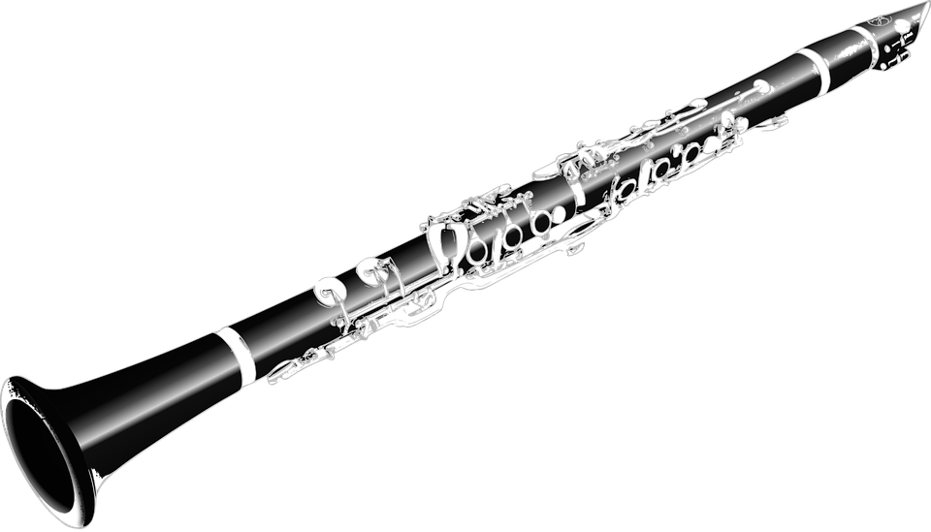

*Vocabularies :
1) Vivid : clear , bright ,and lifelike .
2) Retired : no longer working .
3) Trembles : shakes slightly .
4) Crinkled : wrinkled or creased , as crushed a piece of paper .
5)Melodic : pleasing and harmonious to hear , sweet sounding .

