Name:__________________________ Date:_________________________
Social Studies Study Sheet Unit 3: Lessons 1 - 2
First Grade

What does this picture show you?
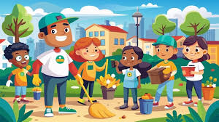
- Classroom
- Community
- Rules and laws

A member or person from a community is called a ________________.

- Citizen b. Student in a classroom c. rule

What does a rule tell citizens?

- When to sleep
- How to behave
- When to brush their teeth

Being a good citizen at school means:

a. You take care of the park.
b. You listen to the teacher.
c. You keep the community clean.

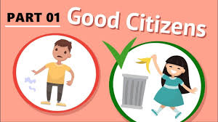
What does a good citizen do with rules and laws?
a. tries to break them
b. tries to read them
c. tries to know and follow them

What is a law?
a. a rule made by teachers
b. a rule made by parents
c. a rule made by governments

Match the place with the people who make its rules:

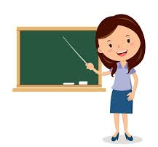
Home Teacher

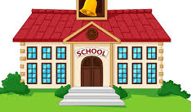
School President


Town in a Neighborhood Parents

