Economic Process
The economic process is complicated, but its basic idea is simple: Producers and consumers exchange goods and services in a market. A market is an organized social institution allowing producers and consumers to trade goods and services.
Throughout history, people have often engaged in barter, the trading of goods and services for other goods and services. Today, the means of exchange in a market is usually money. Modern governments issue money in the form of currency—either cash (paper bills and metal coins) or electronic units deposited in bank accounts.
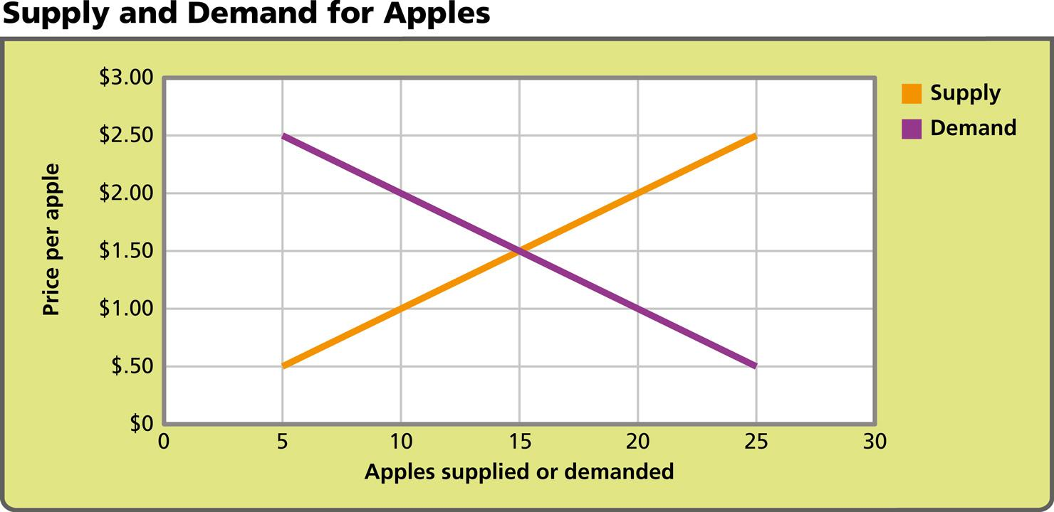
Analyze Graphs When the demand for apples is high, the price goes up, and producers are motivated to try to increase the quantity they produce. When the price is too high for consumers, the demand goes down, and the price goes down.
- Draw Conclusions On this graph, at what price do supply and demand meet?
Notebook
Image long description
The vertical scale on the left side of the graph shows the price per apple, from zero to three dollars. The horizontal scale on the bottom shows the number of apples supplied or demanded, from zero to thirty. An orange line shows supply; a purple line shows demand.
Supply
5 apples = 0.5 dollars per apple
10 apples = 1 dollar per apple
15 apples = 1.5 dollars per apple
20 apples = 2 dollars per apple
25 apples = 2.5 dollars per apple
Demand
5 apples = 2.5 dollars per apple
10 apples = 2 dollars per apple
15 apples = 1.5 dollars per apple
20 apples = 1 dollar per apple
25 apples = 0.5 dollars per apple
Types of Businesses
Businesses can be grouped in different ways. One grouping is by industry. A farmer is in the agricultural industry. Companies that make cars, televisions, or cell phones are in the manufacturing industry. Warehouses may be part of the wholesale industry. Stores are part of the retail industry.
Businesses and the Economic Process
Businesses want to make a profit. Profit is the money a company has left after subtracting its costs from the money it has received from its sales. To make a profit, companies try to reduce expenses and increase revenue. Revenue is the money earned by selling goods and services. The price of resources used to produce goods and services affects profit. If resources become more expensive, the cost of making goods with them will also increase. Businesses’ profits will drop unless they can raise prices.
Companies can increase profit and revenue through specialization, the act of concentrating on a limited number of goods or activities. Specialization allows companies to use resources more efficiently and to increase production.
Companies’ profits are affected by competition, which is the struggle among producers for consumers’ money. If one company raises the price of its products, another company may sell similar goods for a lower price to win more business. Companies also use advertising to help increase demand for their products and to compete with other companies.
An economy grows when businesses produce and sell more goods and services. In a growing economy, prices may increase over time. This general increase in prices is called inflation. Prices may also fall. A general decline in prices is called deflation.
Economies do not keep growing forever. Eventually, economic activity falls for a time as production slows and consumers buy fewer goods and services. This lack of demand for goods and services can lead to increased unemployment. A decline in production over six or more months in a row is known as a recession.
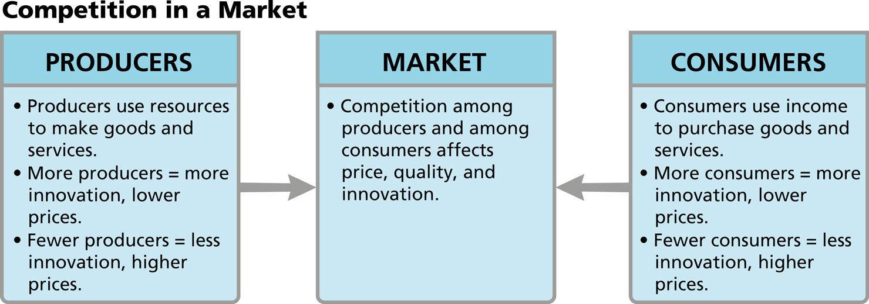
Analyze Diagrams Competition shapes interaction among producers, buyers, and sellers.
- Draw Conclusions Why would a producer offer a quality product at a lower price than another producer?
Notebook
Image long description
Three boxes show the Producers, the Market, and the Consumers. An arrow from the Producers box on the left points toward the Market in the middle; an arrow from the Consumers box on the right also points toward the Market.
Producers
Producers use resources to make goods and services.
More producers equals more innovation and lower prices.
Fewer producers equals less innovation and higher prices.
Consumers
Consumers use income to purchase goods and services.
More consumers equals more innovation and lower prices.
Fewer consumers equals less innovation and higher prices.
Market
In the market, competition among producers and among
consumers affects price, quality, and innovation.
- Reading Check Identify Main Ideas How does competition affect producers and consumers?

