Economic Systems
Each society’s economic system determines how people make and distribute goods and services. There are four types of economic systems: traditional, market, command, and mixed. The roles of individuals, businesses, and government vary in each system. Economic goals and incentives can also vary.

Analyze Images Market economies encourage people to start new businesses.
- Identify Main Ideas What incentive drives people to start a new business?
Notebook
Traditional Economy
A traditional economy is an economy in which people make economic decisions based on their group’s customs and values. They usually satisfy their needs and wants through hunting or farming, as their ancestors did. People in traditional economies usually do not want to change their basic way of life.
This static nature of the economy is one disadvantage of traditional economies. People do not usually have a high standard of living. Advantages include the lack of waste associated with this economy and the knowledge of what one’s role is within the society. Today, traditional economies are not common.
Market Economy
A market economy is an economy in which individual consumers and producers make economic decisions. This type of economy is also called capitalism. Market economies are based on the principles of freedom, competition, and profit. Market economies encourage people to establish new businesses by giving them economic freedom. They are free to do what they want, within the law, and to earn as much profit as they can.
Market economies have many benefits. Because people own their own businesses, they have a stake in the businesses’ success. That stake makes them highly motivated to find new, better, or faster ways of doing things. In this way, market economies encourage technological innovation and efficiency. Producers focus on making the products that consumers want as inexpensively as possible. They offer those products at prices that consumers are willing to pay.
However, like all economic systems, the market economy does have downsides. It can encourage the growth of huge companies that have little competition and can therefore dictate high prices for their products. It also may result in an unequal distribution of income, leaving some people very rich and some very poor. In addition, some services, such as national defense or police protection, may not function well under private ownership. That is because it would be difficult for businesses to get all members of society to share in the cost of these services.
Command Economy
A command economy is an economy in which the central government makes all economic decisions. This kind of system is also called a centrally planned economy. In a command economy, individual consumers and producers do not make basic economic decisions.
This lack of economic freedom is one disadvantage of command economies. Another disadvantage is lack of competition and lack of incentives motivating workers and managers. Why should they work hard when they do not own the business and have little stake in its success?
A command economy does have some advantages. There is little unemployment because the government makes sure everyone has a job. Also, the social welfare of the public may be valued more than profit. Income tends to be more evenly shared.
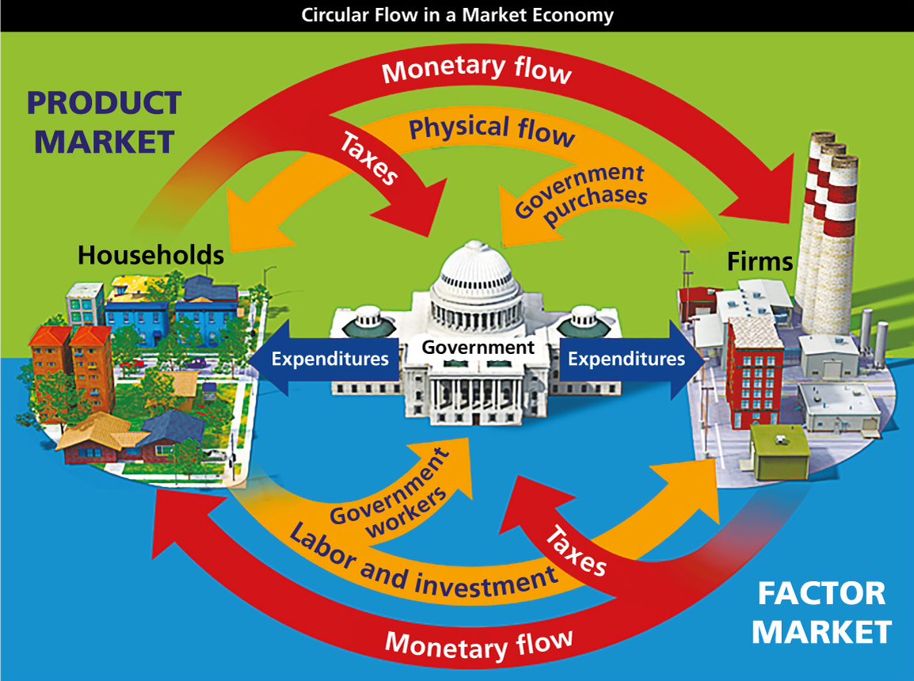
Analyze Diagrams This diagram shows the circular flows of economic activity in a mixed economy.
- Infer What are examples of the flow of money from households to firms and the physical flow from firms to households?
Notebook
Image long description
Government sits at the center and makes expenditures in two directions: toward Firms on one side and toward Households on the other.
Going clockwise:
- As part of the Factor Market, Taxes flow from Firms to Government, and Monetary Flow goes from Firms toward Households.
- As part of the Product Market, Taxes flow from Households to the Government, and Monetary Flow goes from Households toward Firms.
Going counter-clockwise:
- As part of the Factor Market, Government Owned Factors flow from Households to Government, and Physical Flow goes from Households toward Firms.
- As part of the Product Market, Government Purchases flow from Firms to Government, and Physical Flow goes from Firms to Households.
Mixed Economy
In reality, pure market and pure command economies do not exist. Most societies have mixed economies, with varying degrees of government control. A mixed economy combines elements of traditional, market, and command economic systems.
An example of a mixed economy is socialism. In socialism, some businesses are controlled by the state or worker cooperatives. However, some goods and services are distributed through individual decisions in a market. A socialist government aims to level the extremes of wealth between the rich and poor. It provides many welfare benefits, ensuring that the poor and disabled are cared for. One disadvantage of socialism is the need for higher taxes to pay for these services. Business owners do not gain the full reward of their hard work because of these taxes.
Countries such as North Korea and Cuba have mixed economies that are close to pure command economies. In these countries, government owns and controls most businesses and makes most economic decisions.
Countries such as the United States and Australia have mixed economies that are closer to pure market economies. In these countries, most economic decisions are made by individuals and businesses. The government makes some economic decisions, however. For example, government passes laws to protect consumers’ rights. Government spending and taxation provide jobs and services and influence economic growth.
- Reading Check Identify Main Ideas What are the differences among traditional, command, and market economies?

