IT-Final Study Guideline - Grade 9

The exam will be completely written, You should know :
1- How to write the basic structure of any HTML code.
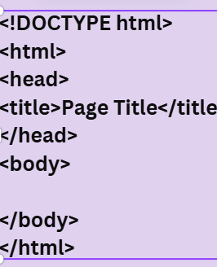
- Understanding <div> tag, how to add it in the code and its uses.
- Understanding class and ID attributes, and how to add them in the code and their uses.
- CSS: why do we use it?
The ways that we can add it into HTML documents (Inline, internal and external).
You will be asked to write a code in any way that I specify.
5- CSS: Text color and background color.

The slides that are needed to study from will be uploaded under the resources section on LMS

The worksheet below will show you the pattern of questions.

WRITTEN PRACTICE (Total: 40 marks)

Section 1: HTML Basics

1.1. Write the Basic Structure of an HTML Document
Answre:

<!DOCTYPE html>
<html>
<head>
<title>Document Title</title>
</head>
<body>
</body>
</html>

1.2. Understanding the <div> Tag
- Question: What is the purpose of the <div> tag in HTML? Provide an example of how to use it.
Section 2: Attributes: class and id

2.1. Class and ID Attributes
- Question 1: What is the difference between the class and id attributes in HTML?
- Question 2: Write HTML code to create a paragraph with a class of "intro" and an ID of "first-paragraph".
Answer:
<p class="intro" id="first-paragraph">
This is the first paragraph.
</p>

Section 3: CSS

3.1. Why Do We Use CSS?
- Question: Why is CSS used in web development? Write a brief explanation.

3.2. Adding CSS to HTML Documents
- Question 1: What are the three ways to add CSS to an HTML document?
a. Inline CSS
b. Internal CSS
c. External CSS
- Question 2: Write an example of each way to add CSS to an HTML document:
Inline CSS:
<p style="color: red;">This is an inline-styled paragraph.</p>
Internal CSS:
<style>
p {
color: red;
}
</style>
<p>This is an internal-styled paragraph.</p>
- External CSS:
<link rel="stylesheet" href="styles.css">

4.1 Fill in the Blank
- The ___ attribute is used to uniquely identify an element in HTML.
- In CSS, the ___ selector is used to target all elements with the same class.

4.2 Match the Following
- Match the HTML tags with their correct purpose:
HTML Tag | Purpose
<div> | a) Adds a title to the webpage
<p> | b) Used for paragraphs
<title> | c) Used for layout and structure
<h1> | d) Represents the highest level heading

4.4. Write Code
- Write the HTML and CSS code to create a webpage with:
  - A header that says "Welcome to My Website"
  - A paragraph below the header with the text "This is a simple webpage."
  - Apply CSS styles to make the header text blue and the paragraph text green.

