Name: __________________________ Date: _________________

Science Assessment *Study Sheet* First Grade

What does sound come from?
- An object that vibrates or moves back and forth quickly makes sound.

What is pitch?
- Pitch is how high or low a sound is.

What did we first use to communicate?
- We used drums and bells to communicate because the sound can be heard very far away.

What is light?
- Light is energy that allows us to see.

Opaque, Transparent and Translucent
- Opaque objects block all or most light like a tree. Light does not go through.
- Transparent objects let all light through. Like clear glass.
- Translucent objects block some light and let some light through. Like colored glass.
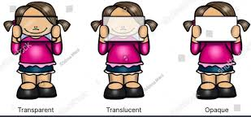

What is gravity?
- Gravity is a force that pulls objects down to the ground.

What is the Sun?
- The Sun is a star. It is the closest star to Earth.

What does rotation mean?

- Rotation is when something spins. Earth spins or rotates around. This is what makes day and night.

What is a thermometer?
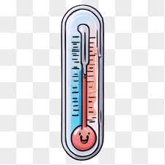
- A thermometer is a tool used to tell how hot or cold something is.

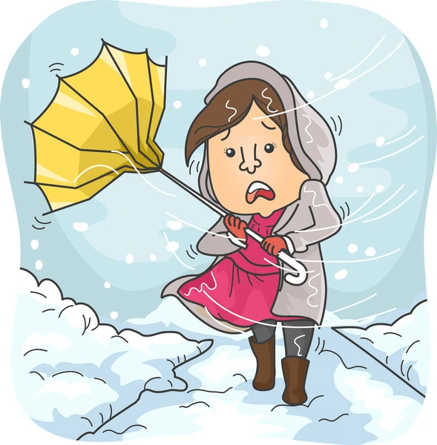
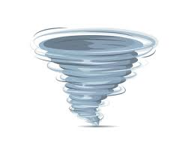
What are the different storms?

Tornado: a storm with high winds that spin Blizzard: a storm with high winds and snow

What are the parts of the plant? Practice labeling the plant!
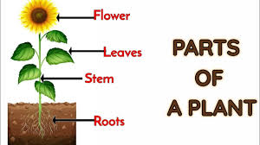
What do fish use to breathe underwater?
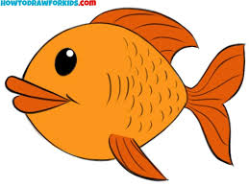
Fish use gills to breathe underwater
Where do fish live (their environment?)
They live in oceans, deep, salty water

Life Cycle of a Frog Practice labelling the life cycle!



 



