Name: ____________________ Date:_______________
Grammar Study Sheet (First Grade)

Identify if the bolded and underlined word is a noun, verb or adjective:

- Look at the red bird! Noun Verb Adjective

- Calvin has bigger shoes. Noun Verb Adjective

- Timmy asked Darius for shoes. Noun Verb Adjective

- I saw a tall sunflower. Noun Verb Adjective

Singular and Plural Nouns: Circle the correct noun and fix the sentence.

-  apple apples

Henry ate one apples. _______________________________

- 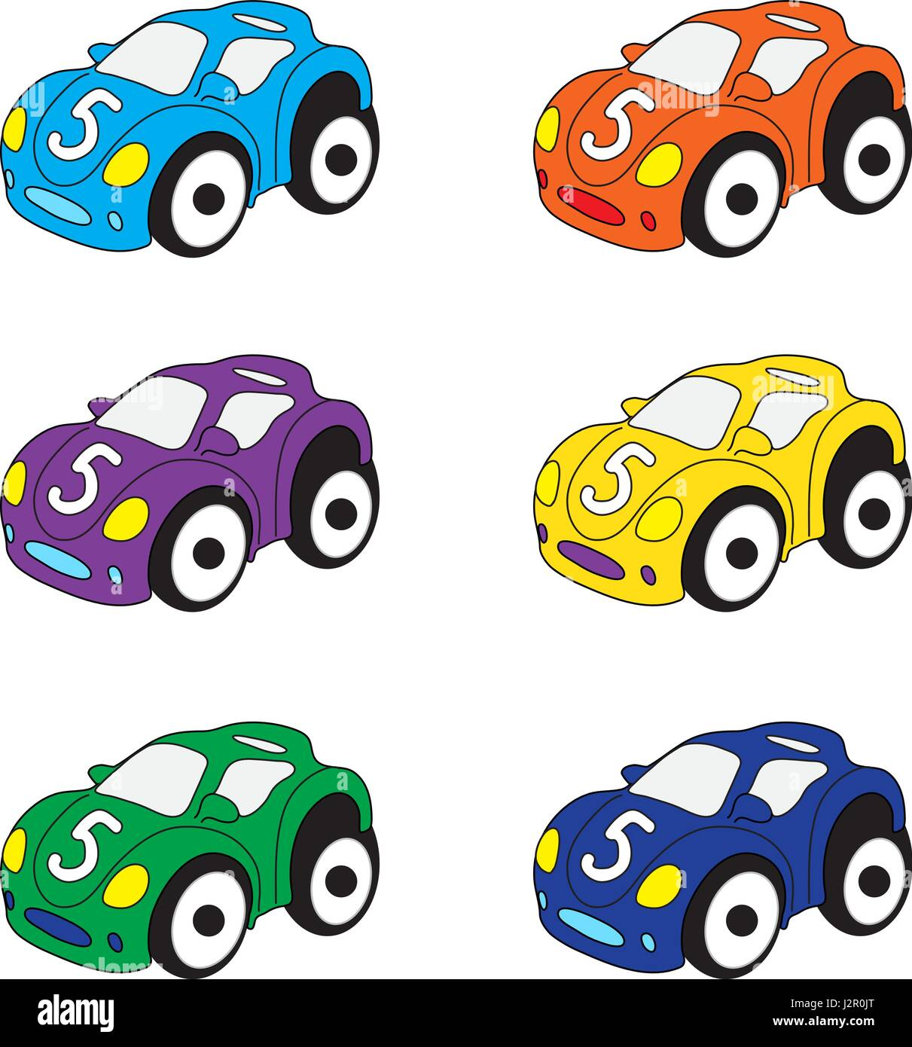 car cars
Jim played with his toy car. ___________________________________

- 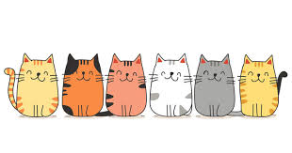 Kitten Kittens
The six kitten sat on the chair. _______________________________

Punctuation: Put the correct punctuation mark at the end of each sentence:

- Do you have bigger racing shoes ______ . ! ?

- The ant worked hard _____ . ! ?

- The test will be so easy ____ . ! ?

Pronouns: Choose the correct pronoun for the underlined words in the sentence:

- Laila is a smart student. He She We

- Laila and Amena went to the park. He We They

- The frog jumped into the water. He She It

- The man is planting a flower. He She We

Contractions: Write the correct contraction for the words below:

- We have _____________

- He is _____________

- I will _____________
- We are ______________

