Name: ____________________ Date:______________
Math Assessment *Study Sheet* First Grade

1. Count the tens and ones. Then write the numbers.
^{Tens} | ^{Ones} |  | ^{Tens} | ^{Ones}
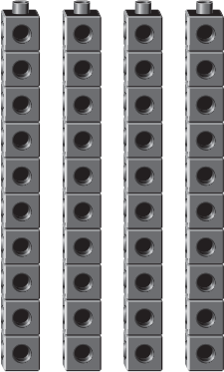 | 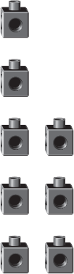

____ tens and ____ ones is ____.

Write one way to show 33. | Write another way to show 33.
_______ tens ______ones | ______ tens ______ ones

Which of these is a way to show 46?
- 4 tens and 16 ones
- 4 tens and 6 ones
- 46 tens and 0 ones
- 6 tens and 4 ones

Write two ways to show 45:

What number does 4 groups of ten show? Draw and show your answer:

Complete the list to show all the ways to make 35:
^{Tens} | ^{Ones}
³ | ⁵
¹ | ²⁵
How many ways can you make 35?
- Four
- Five
- Six

1 more than 38 is _______
1 less than 38 is ________
10 more than 38 is ________
10 less than 38 is _________

1 more than 67 is ________
1 less than 67 is ________
10 more than 67 is _______
10 less than 67 is ________

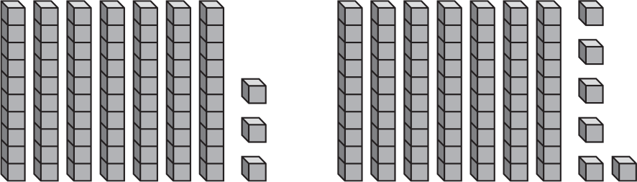

greater than less than

_________ ________

Use these symbols >, <, = and write greater than , less than , or equal to to compare the following numbers.

- 23 34 2. 43 43 3. 58 52
____________ ____________ ______________

- 15 17 5. 19 25
__________ ___________

