Name: ________________________ Date:___________________

Social Studies Worksheet (Study Sheet): Unit 3 Lesson 3 and 4

Right | Responsibility | Cooperate

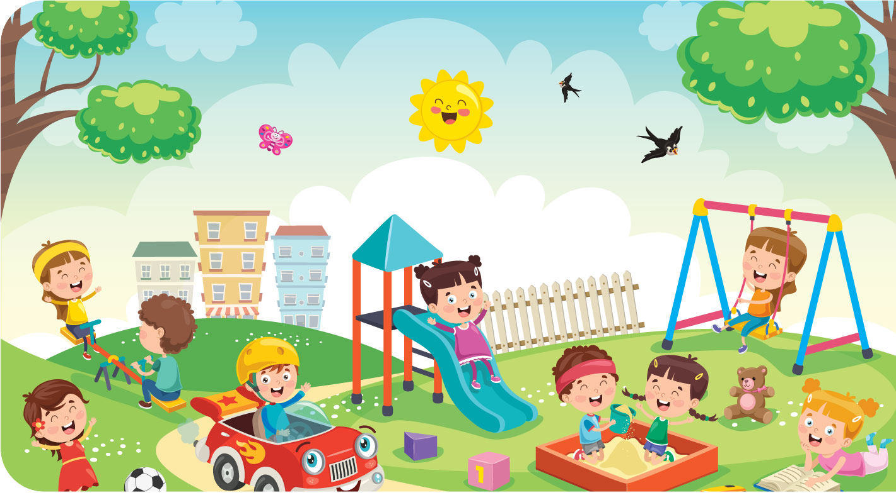
- Something you are allowed to do or have is a _______________.
- Something you should do that is correct is a __________________.
- When we ___________________, we work together and help each other.

Circle the (3) three that are your rights:
a) Learning
b) Buying toys
c) Drinking clean water
d) Eating food

Circle the (2) two that are responsibilities:
a) Playing games
b) Cleaning your room
c) Watching TV
d) Doing your homework

Which of these are needs? Which of these are wants?

Need | Want


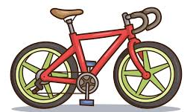


___________ ____________ ___________ ___________

Which of these is something a good citizen does?
a) Shares with others
b) Breaks things on purpose
c) Ignores others' feelings
d) Doesn’t follow rules

What (2) two good choices can you make in the classroom?
a) Leave trash on the ground
b) Pick up trash and throw it away
c) Help your friend if they fall
d) Hit your classmate

Which of these is a responsibility at school?
a) Listening when others are speaking
b) Yelling in the classroom
c) Taking things that aren't yours
d) Ignoring the teacher

