Name :- _________________ exam on exponential mark 30
Date :- ___________________ Mr. Kamel
Q1: - Write the following using exponential form (4 mark)
- $(-3)×(-3)×(-3)×(-3)$

- $6×6×6×6×6×6×6$

- $\frac{1}{3}×\frac{1}{3}×\frac{1}{3}×\frac{1}{3}$

- $ac×ac×ac$

Q2 :- use calculator to work out these values (5 mark)
- $4^{5}$

- ${\left(-3\right)}^{4}$

- $9^{3}÷3^{8}$

- $5^{8}+4^{2}$

- $1^{3}×8^{4}$

Q3 :- write the correct power on the lift hand side to make these equations equal (6 mark )
- $3 = 27$

- $10 =100000000$

- $1000 =1000000000$
- $\frac{1}{2}=\frac{1}{16}$

- $9 =1$

- $9 = 729$

Q 4 :- fill in the blanks with $>,<or=sign$(5 mark )

- $3^{2}_______15$

- $7^{4}_______5^{4}$

- $6^{3}______4^{4}$

- $2^{3}______3^{2}$

- $10000______{10}^{5}$

Q5 :- fill in the blanks the right answer (5 mark )
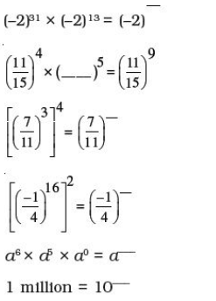
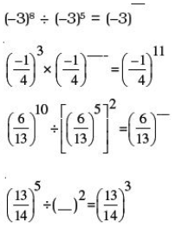

Q6 :- Solve the following exponential equations (5 marks )
- $3^{3x+1}=27$

- $9^{2x-4}=1$

- $4^{2-2x}=64$

- $7^{3x}=343$

- ${(2^{2})}^{2x+1}=32$

