

New Vocabulary

Grandma and the Great Gourd
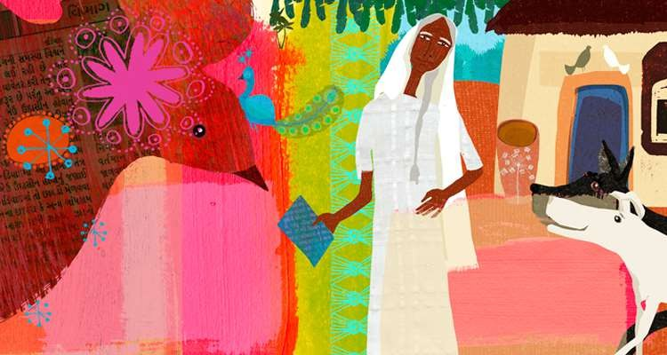




Fierce:- wild or dangerous
Ex. Be careful, it’s a fierce animal.

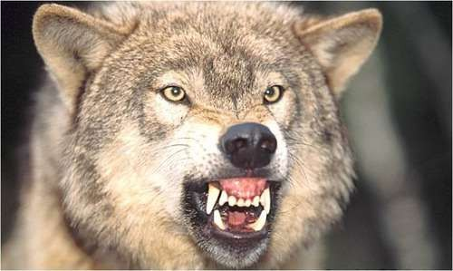

baring:- showing
Ex. It is baring its teeth.


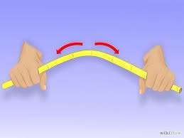

flexing:- curling
Ex. They move by flexing their bodies.
.




crouching:- bending down
Ex. He is crouching down to the ground.



Swipe :- hit
Ex. She swiped me right across the nose.
.


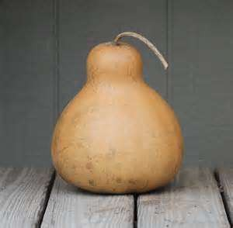

gourd:- vegetable
Ex. Is gourd a vegetable or a fruit?



roll:- to move by turning over and over
Ex. Roll up these balls .




Jungle :-area with lots of trees and plants
Ex. Wild animals live in the jungle .



skinny:- not fat , thin
Ex. She has skinny legs.

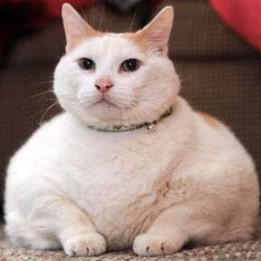

plump:- chubby , fat
Ex. This cat is plump and white.

