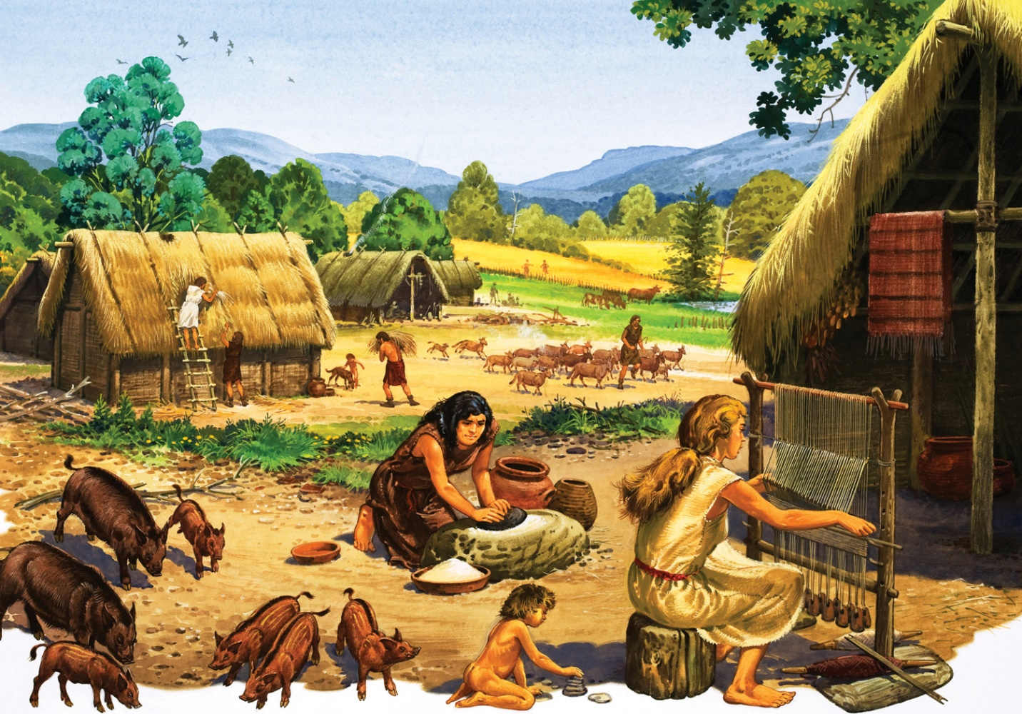
Scholars believe that Stone Age hunters followed animal herds across a land bridge that once connected Asia and North America.
The Neolithic Revolution
Historians have divided the long period of human prehistory into two main periods. They call the earliest period of human history the Old Stone Age, or Paleolithic Period. This long period dates from the time that the ancestors of early humans began to make tools—about 2 million years ago—up to about 12,000 years ago. Historians have identified a second period as the New Stone Age, or Neolithic Period. This age began about 12,000 years ago and ended with the development of metalworking about 5,000 years ago.
Old Stone Age Skills and Beliefs

During both periods, people made and used stone tools. During the New Stone Age, however, people in some parts of the world developed new skills and technologies that led to dramatic changes in their ways of life.
Over tens of thousands of years, people developed various skills that affected daily life. Recent discoveries offer evidence that the ancestors of modern humans may have used fire as early as one million years ago. Learning to control fire was a huge advance, allowing early humans to cook food, keep animals away at night, and stay warm.
Slowly, scholars and scientists have pieced together evidence to suggest how early people lived. Paleolithic people were nomads, or people who move from place to place in search of food. The evidence shows that early people lived in small hunter-gatherer societies, numbering about 20 or 30 people.
In general, men hunted or fished. Women and children gathered food such as berries, fruits, nuts, wild grains, roots, or even shellfish. This food kept the band alive when game animals were scarce.
Strategies for Survival

Early people depended heavily on their environment for survival. They found ways to adapt to their surroundings and meet their basic needs for food and shelter. People made simple tools and weapons, such as digging sticks, spears, and axes, out of the materials at hand—stone, bone, or wood. These tools were modified depending on people’s needs. For example, preparing a foot-long fish to be cooked requires different tools than skinning and cutting up a buffalo. At some point, Stone Age people developed spoken language, which let them cooperate during the hunt and perhaps discuss plans for the future.
During the Old Stone Age, people developed many different technologies. Many of these technologies were developed in response to the environment. By about 40,000 years ago, people living near rivers or along coastlines had learned to make rafts or canoes. They could then cross large bodies of water. Scientists have found evidence that people used water craft to travel from Southeast Asia to Australia. Although these migrating people may have island-hopped slowly over centuries, they had to cross up to 40 miles (64 kilometers) of open ocean.
Hunter-gatherer societies adapted to the environment in other ways. People who lived near water learned to fish. Those who lived in climates with harsh winters used animal skins and fur to make clothing and blankets to stay warm. They also stored food to prepare for hard times.
Early Religious Beliefs

Toward the end of the Old Stone Age, people began to leave evidence of their belief in a spiritual world and developed religious rituals. Early humans—like some of their descendants—most likely believed the world was full of spirits, such as the spirits of the animals they hunted. Other forces might reside in natural objects, or dreams. The belief that spirits inhabit plants, animals, or other natural objects, is known as animism.
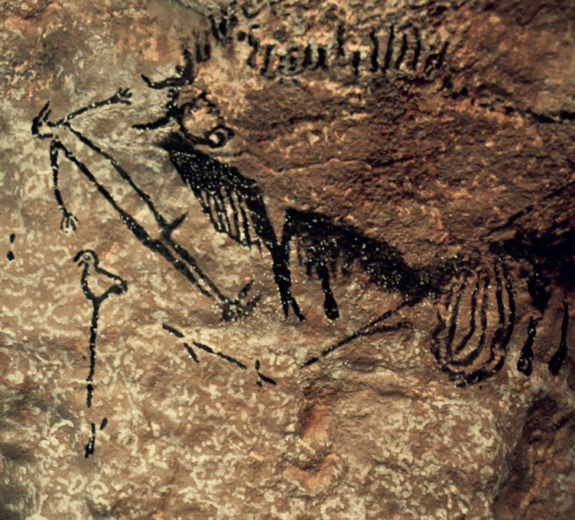
Scientists study cave art to understand early religious beliefs known as animism.
In Europe, Australia, and Africa, cave or rock paintings vividly portray deer, horses, and buffalo. Some cave paintings show stick figures of people, too. The paintings often lie deep in caves, far from a hunting band’s living quarters. Such cave paintings may have been part of religious rituals in which hunters sought help from the spirit world for an upcoming hunt.
About 100,000 years ago, some people began burying their dead with great care. This practice suggests a belief in life after death. Old Stone Age people may have believed the afterlife would be similar to life in this world, so they provided the dead with tools, weapons, and other needed goods. Burial customs like these survived in many places into modern times.
Describe Describe the tools used by hunter-gatherer societies.
Farming Begins a New Stone Age

About 12,000 years ago, bands of nomadic people made a breakthrough that had far-reaching effects. They learned to farm. By producing their own food crops, people could remain in one place instead of hunting and gathering. Slowly, these early farmers settled into permanent villages and developed a whole new range of skills and tools. This change, from nomadic life to settled farming, ushered in the New Stone Age.
The Neolithic Revolution

No one knows exactly how or when people began to plant seeds for food or raise certain animals for their own use. Some of the earliest evidence of farming has been found in the Middle East. Farming, however, probably developed independently throughout the world.
No matter which way it occurred, the change had such dramatic effects that historians call it the Neolithic Revolution. The Neolithic Revolution refers to the change in human societies from hunting and gathering to a more settled way of life based on agriculture and the domestication of animals.
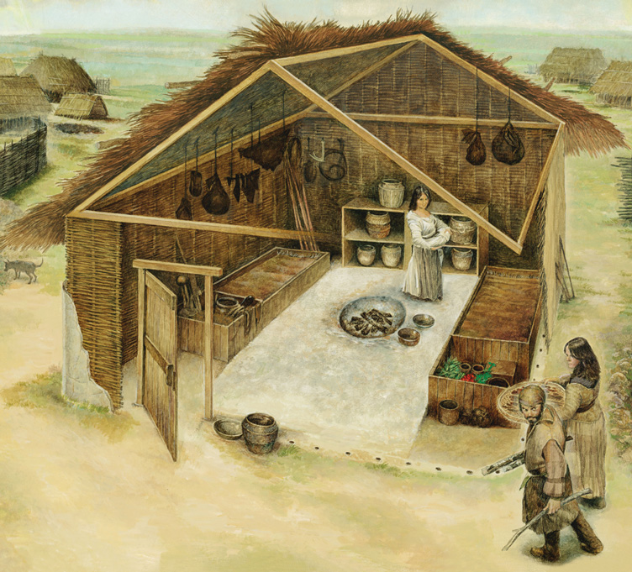
The Domestication of Plants and Animals

Early food gatherers may have been the first humans to domesticate plants and animals—that is, to raise them in a controlled way that makes them best suited to human use. The domestication of plants may have begun with food gatherers who noticed that if seeds were scattered on the ground they produced new plants the next year. Perhaps a band of hunter-gatherers camped at a place where plants grew and began cultivating them season after season.
All these changes occurred slowly. Eventually, people began to select and plant seeds from the best producers, which led to larger fruits or better grains. Among the earliest domesticated plants were figs, wheat, barley, and rice from different parts of Asia. Potatoes and beans were domesticated in South America while squash and maize were grown in Central America.
By the new Stone Age, people had learned to domesticate some of the animals they had once hunted. Domesticating wild animals would have taken time. Perhaps hunters rounded up and enclosed some wild animals rather than wait for them to return each year as they migrated. People either kept the animals in rough enclosures or herded them to good grasslands.
Only some wild animals could be domesticated. People then used these animals as they always had—for food or skins—as well as for other benefits, such as milk or eggs. A few animals were even used for pulling.
Dogs were probably the first animals people domesticated, perhaps as early as 20,000 years ago. They became guard dogs and companions to humans. About 10,000 years ago people in parts of Asia and Africa domesticated goats, sheep, pigs, and cattle. Later, llamas and alpacas were domesticated in South America.
Identify Main Ideas How did farming change the lives of Neolithic people?

