What Forces on Earth’s Surface Shape the Land?
Two kinds of processes shape the landforms on Earth’s surface: processes on Earth’s surface that wear Earth’s crust down, and processes beneath its surface that push the crust up. Forces on Earth’s surface wear down and reshape the land.
Weathering
Weathering is a process that breaks rocks down into tiny pieces. There are two kinds of weathering: chemical weathering and mechanical weathering. In chemical weathering, rainwater or acids carried by rainwater dissolve rocks. In mechanical weathering, moving water, ice, or sometimes wind breaks rocks into little pieces. Mechanical weathering can happen after chemical weathering has weakened rocks.
Weathering helps create soil. Tiny pieces of rock combine with decayed animal and plant material to form soil. Soil and pieces of rock may undergo erosion, a process in which water, ice, or wind remove small pieces of rock and move them somewhere else.
Soil is required to sustain plant and animal life and for agriculture. Because of this, weathering is very important to human settlement patterns. As you read earlier, people tend to settle in areas that have fertile soil and ample water. This makes it easier to grow the crops needed to feed a community.
Weathering can be a constructive force that helps form soil. Erosion can be a destructive force that carries fertile topsoil away and leaves land unsuitable for farming. In the 1930s, a combination of drought, unwise farming practices, and strong winds led to the Dust Bowl in the central United States. For nearly a decade, dust storms stripped the land of soil. Many farmers were forced to abandon their land and move west to find jobs.
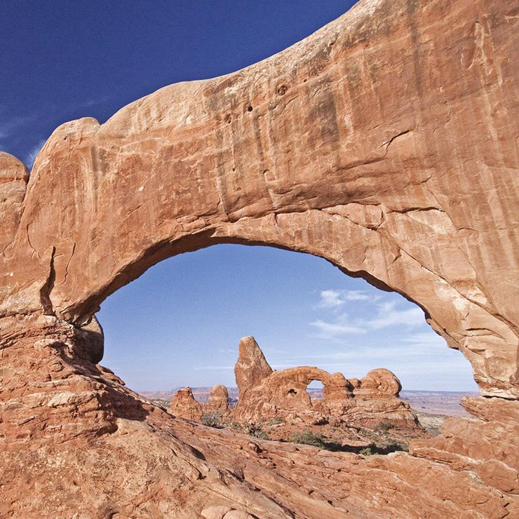
Analyze Images The power of the wind to shape landforms is clear in these structures from Arches National Park in Utah.
- Classify and Categorize What process shaped these rocks?
Shaping Landforms
Weathering and erosion have shaped many of Earth’s landforms. These landforms include mountains and hills. Mountains are wide at the bottom and rise steeply to a narrow peak or ridge. Hills are lower than mountains and often have rounded tops. While forces within Earth create mountains, forces on Earth’s surface wear them down.
The parts of mountains and hills that are left standing are the rocks that are hardest to wear away. Millions of years ago, the Appalachian Mountains in the eastern United States were as high as the Rocky Mountains of the western United States. Rain, snow, and wind wore the Appalachians down into much lower peaks.
Rebuilding Earth’s Surface
When water, ice, and wind remove material, they deposit it farther downstream or downwind to create new landforms. Deposition is the process of depositing, or dropping, eroded material. Plains, or large areas of flat or gently rolling land, are often formed by the deposition of material carried downstream by rivers. Deltas are flat, fan-shaped plains built in the seabed where a river fans out and deposits material over many years.
A plateau is a large, mostly flat area that rises above the surrounding land. Plateaus often have at least one side that is a steep slope. At the top of this slope is usually a layer of rock that is hard to wear down. Valleys are stretches of low land between mountains or hills. Rivers often form valleys where there are rocks that are easy to wear away.
- Reading Check Compare and Contrast How is erosion different from weathering?

