Earth in Space
Earth, the sun, the planets, and the stars in the sky are all part of our galaxy, or cluster of stars. We call our galaxy the Milky Way because its stars look like a trail of spilled milk across a night sky far from city lights. Our sun is one of its billions of stars.
Even though the sun is about 93 million miles (150 million km) away, it provides Earth with heat and light. To understand how far Earth is from the sun, consider that this distance is nearly 4,000 times the distance around Earth at the Equator.
Rotation of Earth
As Earth revolves around the sun, it is also rotating, or spinning, in space. Earth rotates around its axis.
Each complete turn, or rotation, takes about 24 hours. At any one time, it is night on the side of Earth facing away from the sun. As Earth rotates, that side of Earth turns to face the sun, and the sun appears to rise. The sun’s light shines on that side of Earth. It is daytime. Then, as that side of Earth turns away from the sun, the sun appears to set. No sunlight reaches that side of Earth. It is nighttime.
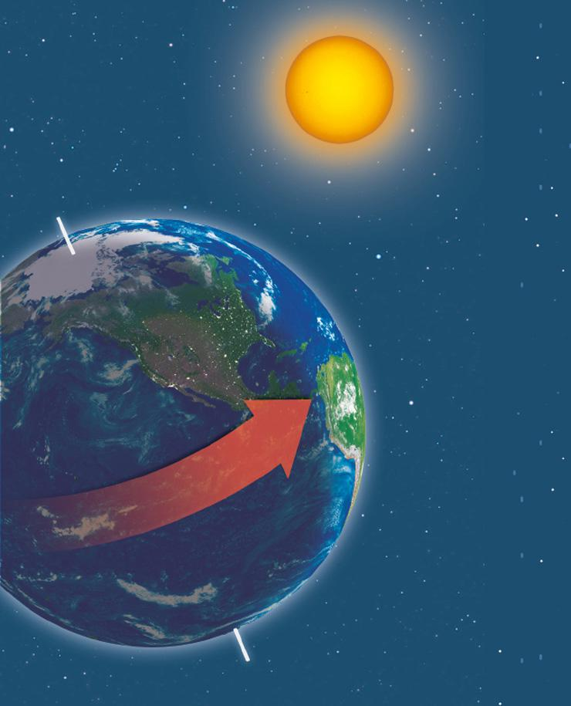
Analyze Images Earth rotates toward the east, causing the day-night cycle.
- Draw Conclusions Which part of the United States will see daylight first?
Time Zones
Because Earth rotates toward the east, the day starts earlier in the east than it does farther west. Over short distances, the time difference is small. For example, the sun rises about four minutes earlier in Beaumont, Texas, than it does in Houston, 70 miles to the west. But if every town had its own local time, people would have a hard time keeping track. So governments have agreed to divide the world into standard time zones, or areas sharing the same time. Times in neighboring zones are one hour apart.
The Prime Meridian
The Prime Meridian, in Greenwich, England, is at the center of one of these zones. The standard time in that zone is sometimes known as Greenwich Mean Time (GMT), or Universal Time (UT). Other time zones are sometimes described in terms of how many hours they are behind or ahead of UT. For example, Central Standard Time in the United States is UT–6, which means six hours behind UT.
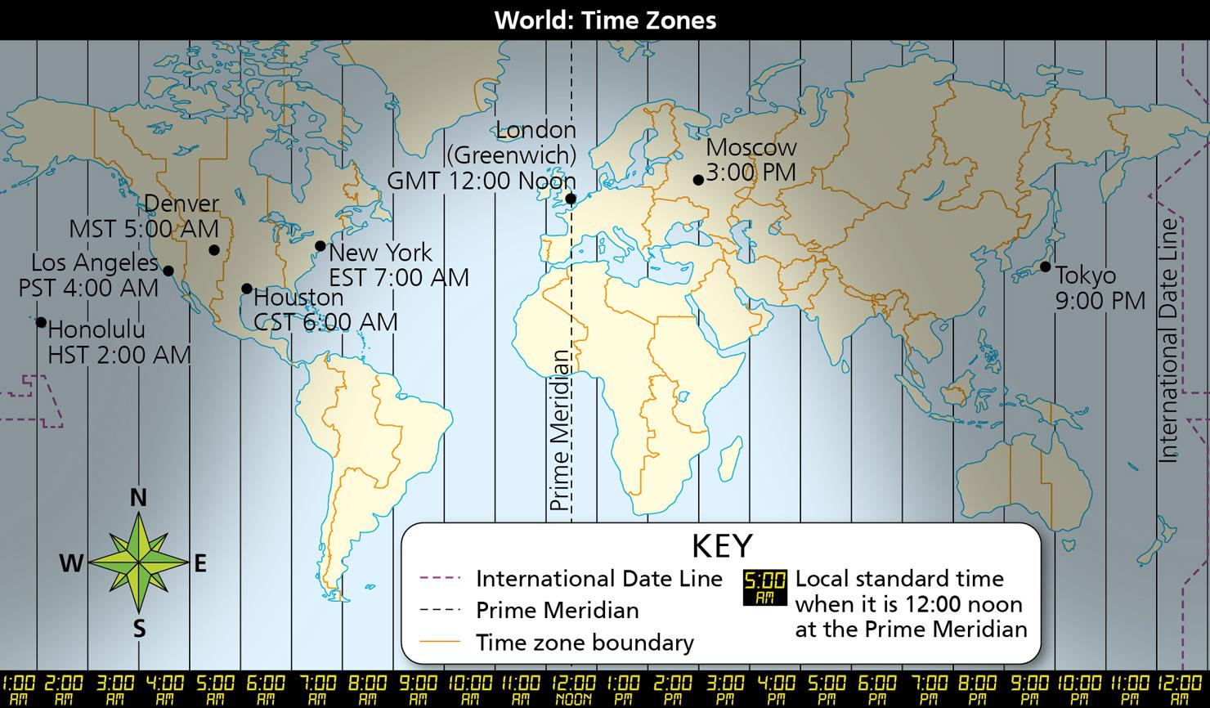
Analyze Diagrams Earth is divided into time zones. Most neighboring zones are one hour apart. Infer If it is 8 p.m. in New York, what time is it in Los Angeles?

Image long description
A world map shows each time zone as a line running from north to south. The map shows North America to the west and Asia to the east. The International Date Line is on the easternmost part of the map. The Prime Meridian is at the center of the map and runs through Greenwich, London.
The map shows the following cities and indicates their local time when it is 12 noon at the Prime Meridian:
- Honolulu, 2 AM
- Los Angeles, 4 AM
- Denver, 5 AM
- Houston, 6 AM
- New York, 7 AM
- London, 12 noon
- Moscow, 3 PM
- Tokyo, 9 PM
- Reading Check Identify Main Ideas What causes daytime to turn to nighttime?

Why Are There Seasons?
Earth travels around the sun in an oval-shaped orbit. An orbit is the path one object makes as it revolves around another. Earth takes 365 1/4 days, or one year, to make one complete journey around the sun, called a revolution.
Earth’s axis, an imaginary line between the North and South poles, is tilted relative to its orbit. Therefore, as Earth makes a revolution, direct sunlight moves north and south of the Equator as the year progresses. That is why seasons occur.
Earth’s orbit around the sun affects the length of daylight as well as the seasons. An equinox (ee kwih nahks) is a point at which, everywhere on Earth, days and nights are nearly equal in length. A solstice (sohl stis) is a point at which days are longest in one hemisphere and shortest in the other. The winter solstice has the shortest length of daylight, and the summer solstice the longest.
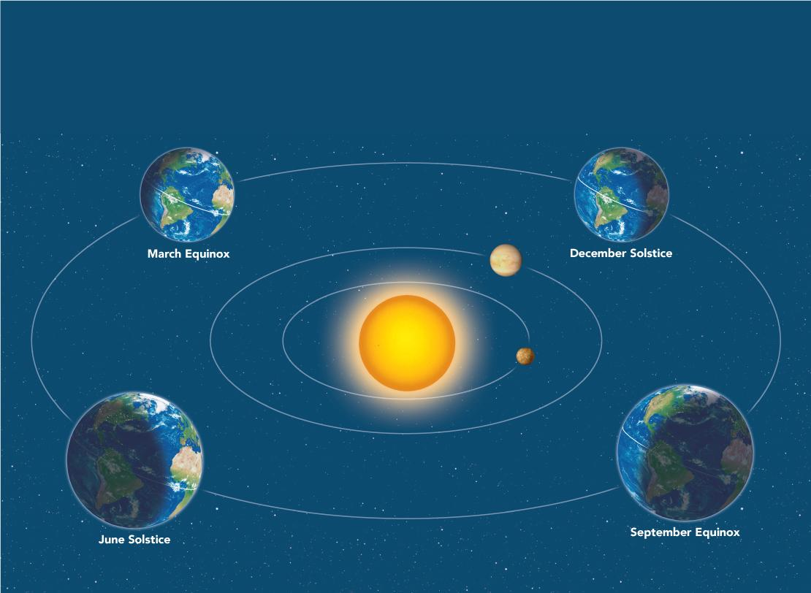
Analyze Diagrams Seasons are caused by the tilt of Earth’s axis as it revolves around the sun.
- Synthesize Visual Information Which hemisphere gets the most daylight at the December solstice?
Image long description
The map shows the earth at the following four stations around the sun:
- March Equinox: About March 21, the sun is directly overhead at noon on the Equator. At this point in Earth's orbit, its axis is tilted neither toward nor away from the sun. An equinox is a point at which, everywhere on Earth, days and nights are nearly equal in length. March brings the spring equinox in the Northern Hemisphere and the fall equinox in the Southern Hemisphere.
- June Solstice: About June 21, the North Pole is tilted closest to the sun. This brings the heat of summer to the Northern Hemisphere. This is the summer solstice in the Northern Hemisphere and the winter solstice in the Southern Hemisphere. A solstice is a point at which days are longest in one hemisphere and shortest in the other.
- September Equinox: About September 23, the sun is again directly overhead at noon on the Equator, and all of Earth has days and nights of equal length. This is the fall equinox in the Northern Hemisphere and the spring equinox in the Southern Hemisphere. Less direct sunlight in the Northern Hemisphere brings the chill of fall there.
- December Solstice: About December 21, the South Pole is tilted closest to the sun. This is the winter solstice in the Northern Hemisphere and the summer solstice in the Southern Hemisphere. The lack of sunlight in the Northern Hemisphere brings the cold of winter.
- Reading Check Draw Conclusions How can days be short and cold in one hemisphere when they are long and hot in another?

