What Forces Inside Earth Shape the Land?
Forces deep inside Earth are constantly reshaping its surface. Plate tectonics is a process involving huge blocks of Earth’s crust and upper mantle that are called tectonic plates. Tectonic plates include continents or parts of continents, along with parts of the ocean floor.
Earth’s tectonic plates lie upon a layer of hot mantle rock, which flows like melted plastic. Plates may move atop the mantle an inch or two (a few centimeters) a year.
Over time, the movement of tectonic plates creates mountains. When two plates of crust push against each other, the pressure makes the crust bend to form steep mountains.
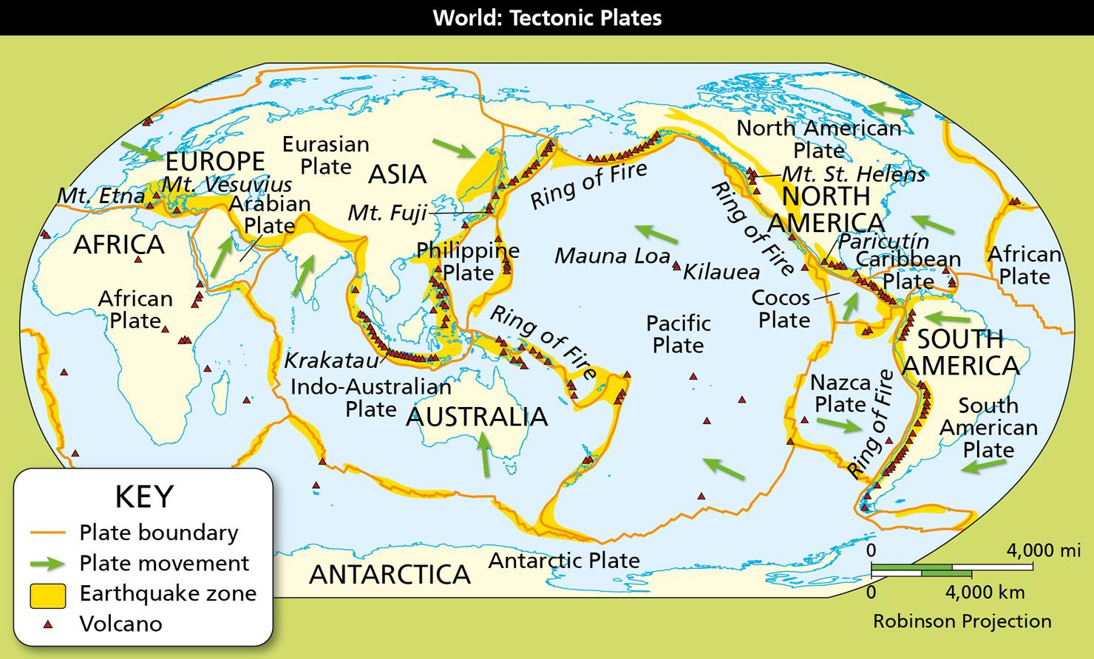
Geography Skills
The map shows Earth’s major tectonic plates and the directions in which they are moving. Earthquakes and volcanoes occur along plate edges.
- Movement In what direction is the Pacific Plate moving in relation to the Eurasian Plate?
- Infer Why is the Ring of Fire sometimes called the Pacific Ring of Fire?
Image long description
The map starts with Africa in the west and goes east to Europe and Asia, and across the Pacific Ocean to the Americas. The tectonic plate boundaries run as follows:
- Around Africa, forming the African Plate, which moves north toward the Arabian Plate.
- That plate also runs through the Indian Ocean to form the Indo-Australian Plate, which moves north toward the South Asian peninsula.
- The Antarctic Plate moves north toward Australia.
- The Eurasian Plate extends north of Europe and moves east through Europe and toward Asia.
- The Pacific Plate forms a ring around the Pacific Ocean and moves west toward the Pacific islands.
- The eastern boundary of the Pacific Plate is part of the Nazca Plate and the Cocos Plate, which move east toward South America, Central America, and North America.
- Further east are the South American Plate, the Caribbean Plate, and the North American Plate, all moving west toward America from the Atlantic Ocean.
The map also shows volcanoes, including Mount Etna and Mount Vesuvius in Europe, and the range of volcanoes that make up the Ring of Fire in the Pacific. The Ring of Fire includes a string of volcanoes in Southeast Asia and East Asia. It extends across the Pacific to South America and runs up the western part of South American to Central and North America. The Ring is completed to the north by volcanoes that go west from Alaska and across the north Pacific back to Asia.
Earthquakes
When plates slide against each other, earthquakes occur. They often occur at seams in Earth’s crust called faults, often near the boundaries between plates. Earthquakes cause the ground to shake. Some earthquakes are too small for people to feel. But others can destroy buildings and cause great harm. For example, the 1906 San Francisco earthquake killed more than 3,000 people.
Volcanoes
When plate movement forces oceanic crust beneath continental crust, steam and heat are released, melting the rocks above. This causes the rock to melt and rise, forming volcanoes. The Pacific Ring of Fire describes the chain of volcanoes forming a semicircle around the eastern, northern, and western edges of the Pacific Ocean. Here, oceanic plates are forced beneath continental plates. This movement creates dynamic belts of earthquakes and volcanoes.
Volcanoes spew magma, or molten rock, from inside Earth to the surface. When magma erupts out of a volcano and flows onto Earth’s surface, it is called lava. Volcanic eruptions can be very dangerous for people, but volcanoes also serve an important purpose. When lava cools, new land forms. Undersea volcanoes can even grow into islands after thousands of years of eruptions.
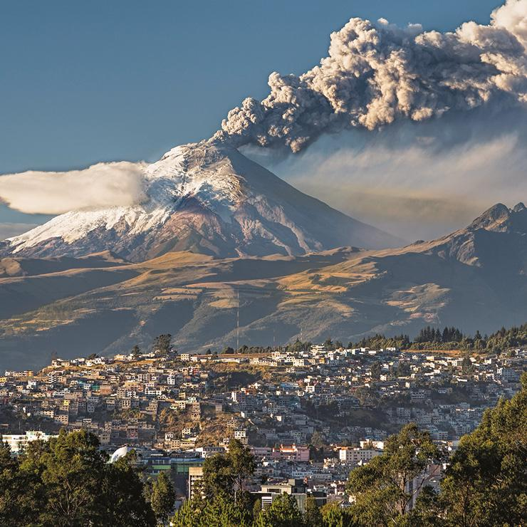
Analyze Images Volcanoes pour out hot lava, ash, rocks, and poisonous gases, making them dangerous.
- Identify Cause and Effect What causes volcanoes to erupt?
Natural Hazards
Volcanoes and earthquakes are examples of natural hazards, or dangers. Other natural hazards include hurricanes, tornadoes, landslides, and floods.
These events threaten lives and property. But people can take steps to prepare for natural disasters, so that damage will not be as severe when a disaster strikes. For example, architects can design buildings that will not collapse when the ground shakes. Local governments can set routes for people to leave affected areas during a hurricane. Citizens can practice what to do during an earthquake and keep emergency supplies at home.
- Reading Check Identify Supporting Details What are some ways people prepare for natural hazards?

