Features That Define Civilization
What did the early civilizations that rose in different parts of the world have in common? While cities are the central feature of civilization, historians distinguish seven other features found in most early civilizations: (1) well-organized governments, (2) complex religions, (3) job specialization, (4) social classes, (5) arts and architecture, (6) public works, and (7) writing.

Organized Governments As cities grew, they needed to maintain a steady food supply. To produce large amounts of food and oversee irrigation projects, new forms of government rose. City governments were far more powerful than the councils of elders and local chiefs in farming villages.
At first, priests probably had the greatest power. In time, warrior kings emerged as the chief political leaders. They replaced the old councils of elders and set themselves up as hereditary rulers who passed power from father to son.

Almost always, rulers claimed that their right to rule came from the gods. They thus gained and held religious, as well as political power.

Governments became more complex as rulers issued laws, collected taxes, and organized systems of defense. To enforce order, rulers relied on royal officials. Over time, separate departments evolved to oversee different functions of government. These separate departments oversaw tax collection, irrigation projects, or the military.

Complex Religions Like their Stone Age ancestors, most ancient people were polytheistic, which means they believed in many gods. People appealed to sun gods, river goddesses, and other spirits that they believed controlled natural forces. Other gods were thought to control human activities such as birth, trade, or war.
In ancient religions, priests and worshipers sought to gain the favor of the gods through complex rituals such as ceremonies, dances, prayers, and hymns.

To ensure divine help, people built temples and sacrificed animals, crops, or sometimes other humans to the gods. Sacrifices and other ceremonies required the full-time attention of priests, who had special training and knowledge.

A photo of two daggers next to their golden sheaths
These daggers are from the tomb of an Egyptian pharaoh, or ruler. The dagger on top has a blade of gold. The bottom dagger has a blade of iron.

Job Specialization The lives of city dwellers differed from those of their nomadic Stone Age ancestors. Urban people developed so many new crafts that a single individual could not master all the skills needed to make tools, weapons, or other goods.
For the first time, individuals began to specialize in certain jobs. Some became artisans, or skilled craftspeople, who made pottery, finely carved statues, or woven goods. Among the crafts that developed in cities, metalworking was particularly important. People learned to make tools and weapons, first out of copper and later out of bronze, a more durable mixture of copper and tin.

Cities had other specialists, too. Bricklayers built city walls. Soldiers defended the walls. Merchants sold goods in the marketplace. Singers, dancers, and storytellers entertained on public occasions. Specialization made people dependent on others for their various needs.

As some villages swelled into the world’s first cities, people could work at jobs other than farming. This was a radical departure from the traditional economies of the Stone Age. A traditional economy relies on custom or tradition and tends not to change over time.

Social Classes In cities, social organization became more complex. People were ranked according to their jobs, which led to the growth of social classes. Priests and nobles usually occupied the top level of an ancient society. Next came a small class of wealthy merchants, followed by artisans. Below them stood the vast majority of people—peasant farmers who lived in the surrounding villages and produced food for the city.
In many civilizations, slaves occupied the lowest social level. Poor families sometimes sold family members into slavery to pay their debts. Others were prisoners captured in war. Because male captives were often killed, women and children made up the largest number of slaves in some societies.

Arts and Architecture The arts and architecture of ancient civilizations expressed the talents, beliefs, and values of the people who created them. Temples and palaces often dominated the city landscape, reassuring people of the strength and power of their government and religion.
Skilled workers decorated these massive buildings. In museums today, you can see the temple wall paintings and statues of gods and goddesses.

Furniture and jewelry found in ancient tombs around the world are also on display. These artifacts give ample evidence of the artistic genius of the first civilizations.

Public Works Closely linked to the temples and palaces in the cities were vast public works that strong rulers ordered to be built. Such projects included irrigation systems, roads, bridges, and defensive walls.
These projects were costly, requiring masses of human labor and sometimes even the lives of workers. Still, they were meant to benefit the city, protect it from attack, ensure its food supply, and, of course, enhance the reputation of its ruler.

Writing Almost all early civilizations developed a critical skill—writing. Writing may have begun in temples, where priests needed to record precise rituals and prayers, accurate information about the seasons, and amounts of grain collected. Other writing systems may have developed around rulers who proclaimed their great achievements on stone monuments.
Writing systems emerged in different places at different times. They varied greatly. Yet all represented organized efforts to record information. Archaeologists have found masses of ancient writings, ranging from treaties and tax rolls to business and marriage contracts.

Early writing was often made up of pictographs (or pictograms), simple drawings that look like the objects they represent. In time, symbols were added. They might stand for sounds of words or for ideas that could not be expressed easily in pictures.

As writing grew more complex, only specially trained people called scribes could read and write. Scribes were educated in temple schools and kept records for priests, rulers, and merchants. Only a few societies permitted women to attend temple schools. As a result, women were generally excluded from becoming scribes, an occupation that could lead to political power.

Features That Define Civilization
What did the early civilizations that rose in different parts of the world have in common? While cities are the central feature of civilization, historians distinguish seven other features found in most early civilizations: (1) well-organized governments, (2) complex religions, (3) job specialization, (4) social classes, (5) arts and architecture, (6) public works, and (7) writing.
Organized Governments
As cities grew, they needed to maintain a steady food supply. To produce large amounts of food and oversee irrigation projects, new forms of government rose. City governments were far more powerful than the councils of elders and local chiefs in farming villages.
At first, priests probably had the greatest power. In time, warrior kings emerged as the chief political leaders. They replaced the old councils of elders and set themselves up as hereditary rulers who passed power from father to son.
Almost always, rulers claimed that their right to rule came from the gods. They thus gained and held religious, as well as political power.
Governments became more complex as rulers issued laws, collected taxes, and organized systems of defense. To enforce order, rulers relied on royal officials. Over time, separate departments evolved to oversee different functions of government. These separate departments oversaw tax collection, irrigation projects, or the military.
Complex Religions

Like their Stone Age ancestors, most ancient people were polytheistic, which means they believed in many gods. People appealed to sun gods, river goddesses, and other spirits that they believed controlled natural forces. Other gods were thought to control human activities such as birth, trade, or war.
In ancient religions, priests and worshipers sought to gain the favor of the gods through complex rituals such as ceremonies, dances, prayers, and hymns.
To ensure divine help, people built temples and sacrificed animals, crops, or sometimes other humans to the gods. Sacrifices and other ceremonies required the full-time attention of priests, who had special training and knowledge.
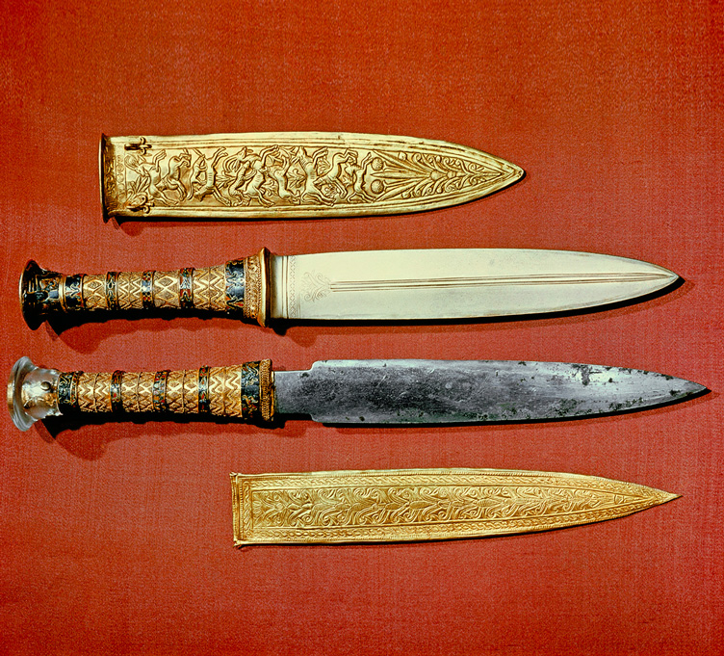
These daggers are from the tomb of an Egyptian pharaoh, or ruler. The dagger on top has a blade of gold. The bottom dagger has a blade of iron.
Job Specialization

The lives of city dwellers differed from those of their nomadic Stone Age ancestors. Urban people developed so many new crafts that a single individual could not master all the skills needed to make tools, weapons, or other goods.
For the first time, individuals began to specialize in certain jobs. Some became artisans, or skilled craftspeople, who made pottery, finely carved statues, or woven goods. Among the crafts that developed in cities, metalworking was particularly important. People learned to make tools and weapons, first out of copper and later out of bronze, a more durable mixture of copper and tin.
Cities had other specialists, too. Bricklayers built city walls. Soldiers defended the walls. Merchants sold goods in the marketplace. Singers, dancers, and storytellers entertained on public occasions. Specialization made people dependent on others for their various needs.
As some villages swelled into the world’s first cities, people could work at jobs other than farming. This was a radical departure from the traditional economies of the Stone Age. A traditional economy relies on custom or tradition and tends not to change over time.
Social Classes

In cities, social organization became more complex. People were ranked according to their jobs, which led to the growth of social classes. Priests and nobles usually occupied the top level of an ancient society. Next came a small class of wealthy merchants, followed by artisans. Below them stood the vast majority of people—peasant farmers who lived in the surrounding villages and produced food for the city.
In many civilizations, slaves occupied the lowest social level. Poor families sometimes sold family members into slavery to pay their debts. Others were prisoners captured in war. Because male captives were often killed, women and children made up the largest number of slaves in some societies.
Arts and Architecture

The arts and architecture of ancient civilizations expressed the talents, beliefs, and values of the people who created them. Temples and palaces often dominated the city landscape, reassuring people of the strength and power of their government and religion.
Skilled workers decorated these massive buildings. In museums today, you can see the temple wall paintings and statues of gods and goddesses.
Furniture and jewelry found in ancient tombs around the world are also on display. These artifacts give ample evidence of the artistic genius of the first civilizations.
Public Works

Closely linked to the temples and palaces in the cities were vast public works that strong rulers ordered to be built. Such projects included irrigation systems, roads, bridges, and defensive walls.
These projects were costly, requiring masses of human labor and sometimes even the lives of workers. Still, they were meant to benefit the city, protect it from attack, ensure its food supply, and, of course, enhance the reputation of its ruler.
Writing

Almost all early civilizations developed a critical skill—writing. Writing may have begun in temples, where priests needed to record precise rituals and prayers, accurate information about the seasons, and amounts of grain collected. Other writing systems may have developed around rulers who proclaimed their great achievements on stone monuments.
Writing systems emerged in different places at different times. They varied greatly. Yet all represented organized efforts to record information. Archaeologists have found masses of ancient writings, ranging from treaties and tax rolls to business and marriage contracts.
Early writing was often made up of pictographs (or pictograms), simple drawings that look like the objects they represent. In time, symbols were added. They might stand for sounds of words or for ideas that could not be expressed easily in pictures.
As writing grew more complex, only specially trained people called scribes could read and write. Scribes were educated in temple schools and kept records for priests, rulers, and merchants. Only a few societies permitted women to attend temple schools. As a result, women were generally excluded from becoming scribes, an occupation that could lead to political power.
Basic Features of Civilizations
Feature | Description
Cities | - Larger and more complex than villages  - Support the other features of civilization
Governments | - Coordinate public-works projects such as bridge and dam construction  - Establish laws and organize defense
Complex Religions | - Belief in one or more Gods or Goddesses  - Institution of rituals
Job Specialization | - Different types of jobs that lead workers to specialize on one task
Social Classes | - Ranked groups are based on job or status
Arts and Architecture | - Artwork that expresses a society’s talents, beliefs, and values
Public Works | - Large-scale projects for the benefit of a city and its people
Writing | - Structured writing system initially used by governments and merchants to record important information
Analyze Charts Which features do you think most affected the daily lives of average people?
Nomads and City Dwellers

Many people remained nomads, following traditional routes as they grazed herds. Nomadic cultures did not build cities. Their governments were simple. Nomadic peoples, however, had their own leaders, religious beliefs, and technologies. They often excelled in the arts. Many nomads had rich oral traditions in poetry. They composed fine music, developed beautiful weavings, and produced exquisite jewelry.
Nomads and city dwellers came into contact through trade and warfare. Nomads needed goods produced by settled peoples. So they traded goods such as meat, furs, and livestock for the grains, cloth, and weapons of city dwellers.
The relationship between nomads and settled people was a driving force throughout history. At times, conflict replaced trade when new nomadic people moved into an area. Nomads might attack settlements or even organize a large enough force to topple great civilizations. Once they conquered a civilization, however, they in turn became settled peoples, giving up the nomadic way of life.
Identify Central Ideas What role did religion play in early civilizations?

