Farming, shown in this ancient Egyptian painting, was crucial to the development of the first civilizations.
Civilization Begins
The Neolithic Revolution led to the rise of civilization. A civilization is an advanced stage of human society marked by a well-organized government and high levels of culture, science, and industry. At different times in different parts of the world, food surpluses allowed some Neolithic villages to grow into cities, the central feature of civilization.

The First Cities and Civilizations

River Valley Civilizations

The world’s earliest civilizations developed independently in four river valleys. The civilization of Sumer rose along the Tigris and Euphrates rivers in the Middle East. A second river valley civilization developed along the Nile River in Egypt. The Indus and other rivers in present-day Pakistan and India were home to the Indus Valley civilization. A fourth river valley civilization, the Shang, emerged along the Huang, or Yellow River in China.
These four river valleys offered benefits to Neolithic farmers. The soil was fertile, and the rivers provided a regular water supply as well as a means of transportation.
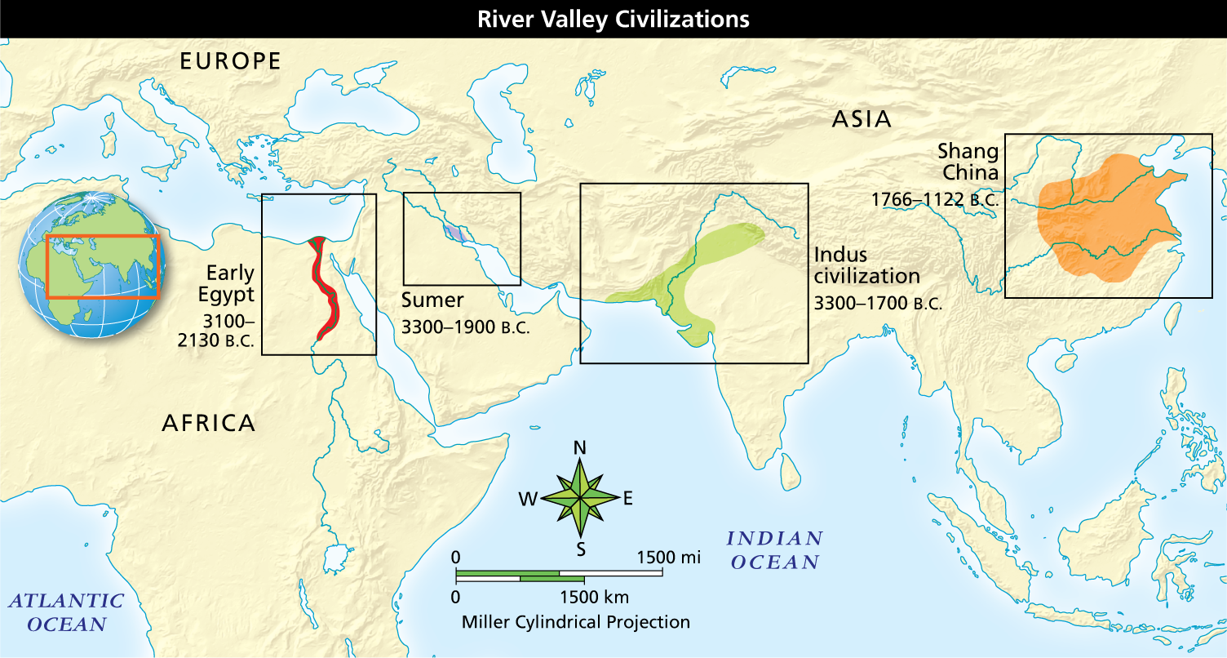
Full Image Description
The map shows the locations and dates of the following four civilizations:
- Early Egypt, 3100–2130 B.C., in the Nile Valley of present-day Egypt
- Sumer, 3300–1900 B.C., in present-day southern Iraq
- Indus civilization, 3300–1700 B.C., in present-day southern and eastern Pakistan and northwestern India
- Shang China, 1766–1122 B.C., in present-day east-central China
Analyze Maps How did river valleys help civilizations to prosper?
The animals that gathered to drink at the rivers offered a source of food. These favorable conditions helped farmers produce the food surpluses needed to support the growing populations in cities.
Other conditions in the river valleys affected farming. Floodwaters from the rivers spread silt—fine sand, soil, or other material—across the valleys. The silt renewed the soil in the river valleys, keeping it fertile. Flooding posed problems, however, to early farmers, just as it does today.
Floodwaters could destroy crops and even whole villages. People had to learn to control floodwaters and redraw boundaries washed away by the water. They also needed to take water from the rivers to irrigate crops. Work on dikes and irrigation ditches had to be organized and managed. Historians think that the need for complex flood control and irrigation projects led to the rise of strong, well-organized governments, another foundation of civilization.

Civilizations in the Americas

Unlike the first civilizations in Asia and Africa, early civilizations in the Americas did not develop in river valleys. The earliest civilizations in the Western Hemisphere developed in two regions. In Mesoamerica, today part of Mexico and Central America, the Olmec, Maya, and Aztec civilizations developed. In Peru, a series of early civilizations led to the Inca civilization.
In the Americas, Neolithic farmers cultivated corn, beans, squash, and potatoes in fertile lowlands and mountain valleys. In Mesoamerica, they reclaimed land from swamps to grow more crops. In Peru, they built terraces into steep mountainsides for new cropland.
Life Away From Cities

Away from the first cities, many people continued to hunt, gather food, or live in farming villages. On some less fertile lands or on sparse, dry grasslands called steppes, nomadic herders tended cattle, sheep, goats, or other animals. Because the lands did not have abundant water or grass, these nomads had to keep moving to find new pastures.
Describe Describe how river valleys were ideal locations for the development of civilization.

