Sumerian Civilization Develops

Beginning around 3500 B.C., a number of cities had emerged in Mesopotamia, each numbering in the tens of thousands. Each city and the land surrounding formed a city-state. The Sumerians had few natural resources, but they made the most of what they had. They lacked building materials such as timber or stone, so they made bricks of clay. These bricks were the building blocks for some of the world’s first great cities, such as Ur and Uruk.
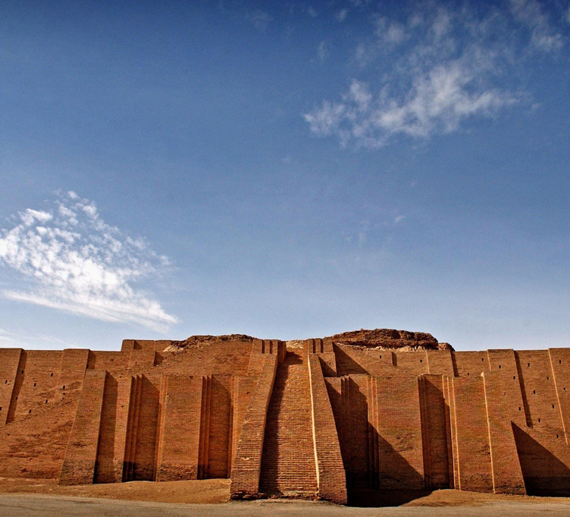
The Ziggurat of Ur is an ancient temple built by Sumerians to honor their moon god, Nanna. Ziggurats were part of a temple complex that usually served as the administrative center of the city.
The First Cities

Sumerian cities had broad avenues used for religious processions or victory parades. The largest buildings were ziggurats (ZIG oo rats), pyramid-temples that soared toward the heavens. On top of each ziggurat stood a shrine to a particular god or goddess. Each city had its own chief god or goddess, but it might have several ziggurats honoring other gods.
Rulers lived in magnificent palaces with spacious courtyards. Most people, though, lived in tiny houses packed in a web of narrow alleys and lanes. Artisans who practiced the same trade, such as weavers or carpenters, lived and worked in the same street. These workshop-lined streets formed a bazaar, the ancestor of today’s shopping mall.
Economic Life

Trade brought riches to the Sumerian cities. Traders sailed along the rivers or risked the dangers of desert travel to exchange goods with distant regions. Archaeologists have found goods from as far away as Egypt and India in the rubble of Sumerian cities. Although it is unclear where and when the wheel was invented, the Sumerians may have made the first wheeled vehicles. Using wheeled carts, Sumerian traders were able to carry larger loads on longer journeys.
Government

Rival city-states often battled for control of land and water. For protection, people turned to war leaders. Over time, these war leaders became hereditary rulers, leading to the rise of monarchies. A monarchy is a form of government led by a king or queen born into a ruling family.
In each city-state, the ruler was responsible for maintaining the city walls and irrigation systems. He led its armies in war and enforced the laws. As government grew more complex, the ruler employed scribes to carry out functions such as collecting taxes and keeping records. The ruler also had religious duties. In the early city-states, rulers probably were priest-kings; that is, the rulers were seen as the chief servants of the gods and led ceremonies meant to please them.
Social Classes

Each Sumerian city-state had a distinct social hierarchy (HY ur ahr kee), or system of ranking groups. The highest class included the ruling family, leading officials, and high priests. A small middle class was made up of scribes, merchants, and artisans.
At the base of society were the majority of people, who were mostly peasant farmers. Some had their own land, but most worked land belonging to the king or to temples. Some were enslaved. Most enslaved people had been captured in war. Some, though, had sold themselves into slavery to pay their debts.
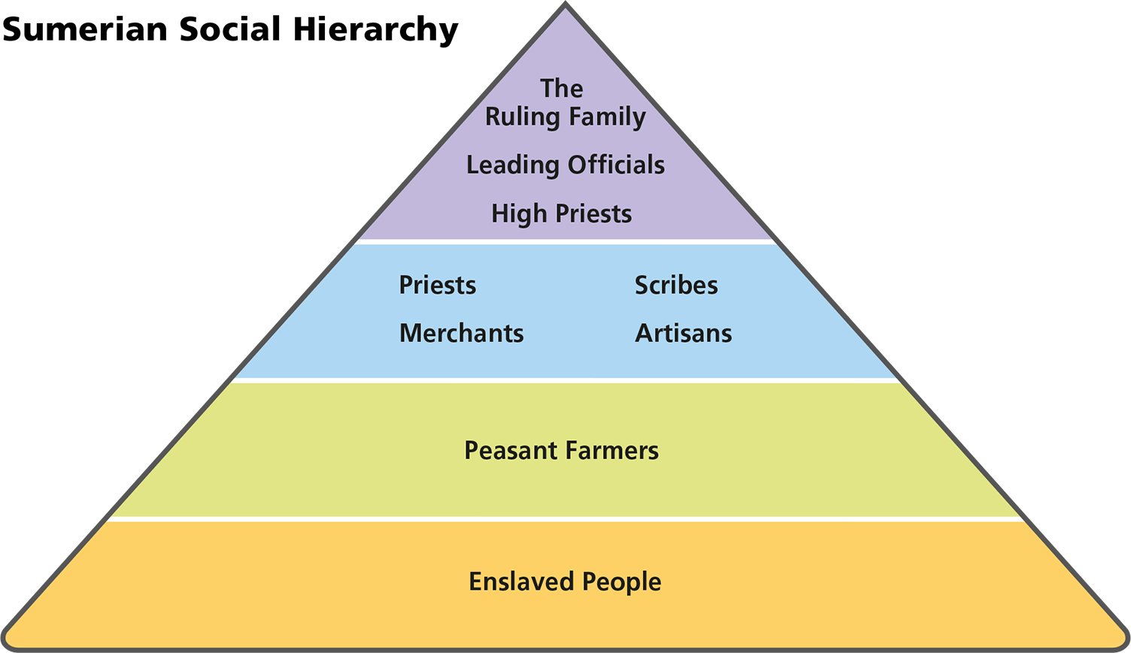
Analyze Information What does the information on the chart indicate about how Sumerian society supported itself?
The role of women in Mesopotamian society changed over time. In Sumer, goddesses were highly honored in religious practice. Perhaps because of the importance of female deities, women held a higher social standing in Sumer than in later civilizations of the region. However, Sumerian women never held legal rights equal to those of men. But some rulers’ wives had supervisory powers, and a number wrote songs about their husbands, revealing to later scholars that they had learned writing and music. On rare occasion, a woman may have inherited property.
Religious Beliefs

Like most ancient peoples, the Sumerians were polytheistic, worshiping many gods. These gods were thought to control every aspect of life, especially the forces of nature. Sumerians believed that gods and goddesses behaved like ordinary people—they ate, drank, married, and raised families. Although the gods favored truth and justice, they were also responsible for causing violence and suffering.
Sumerians believed their highest duty was to keep their gods and goddesses happy and, by doing so, ensure the safety of their city-state. Each city-state had its own special god or goddess to whom people prayed and offered sacrifices of animals, grain, or wine. Sumerian rulers served as the high priest for their city-state’s chief deity, or god.
People celebrated many holy days with ceremonies and processions. The most important ceremony occurred at the new year when the king sought and won the favor of Inanna, the life-giving goddess of love. The king then took part in a symbolic wedding to Inanna. This ritual, Sumerians believed, would make the new year fruitful and prosperous.
The Sumerians believed in an afterlife. At death, they thought, a person descended into a grim underworld from which there was no release. In The Epic of Gilgamesh, a character describes the underworld as “the place where they [the dead] live on dust, their food is mud, / . . . and they see no light, living in blackness. . .”
Sumerian Writing

By 3200 B.C., Sumerians had invented the earliest known writing. It was later called cuneiform (kyoo NEE uh fawrm), from the Latin word cuneus for “wedge,” because scribes wrote by making wedge-shaped marks on clay tablets. Cuneiform grew out of a system of pictographs used to record goods brought to temple storehouses. Later, the Sumerians developed symbols to represent more complicated thoughts. As their writing evolved, the Sumerians used it to record not only economic exchanges but also myths, prayers, laws, and business contracts.
Sumerian scribes had to go through years of difficult schooling to acquire their skills. Discipline was strict. Untidy copying or talking in class could be punished by caning. Students who did well often learned about religion, mathematics, and literature as well.
Summarize Describe the three levels of Sumerian society.
Sumer’s Legacy

Beginning around 2500 B.C., conquering armies swept across Mesopotamia and gradually overwhelmed the Sumerian city-states. The newcomers built on Sumerian learning and advances in many fields. They then helped spread the Sumerian legacy across the Middle East.
Language and Culture

Newcomers to the region adopted many ideas and innovations from the Sumerians. The myths and gods of the newcomers became mingled with those of Sumer. In the process, names changed. The Sumerian goddess Inanna, for example, became Ishtar.
The Akkadians, Babylonians, and Assyrians adapted cuneiform so it could be used with their own languages. These peoples then helped spread Sumerian learning across the Middle East. The river-valley civilization that began in Sumer featured a number of elements, beyond a written language, that reappeared in other, later civilizations. Sumer’s patriarchal family structure, agricultural-based economies, government structures, and the beginning of a trade base influenced later empires and the rise of classical civilizations, such as Greece and Rome. Later peoples also elaborated on Sumerian oral narratives, such as The Epic of Gilgamesh, which was written down in cuneiform by both the Akkadians and the Babylonians.
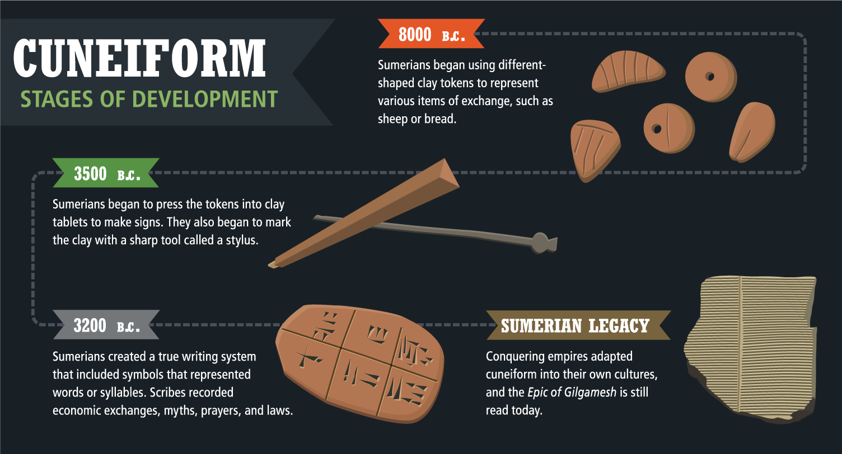
Full Image Description
8000 B.C.: Sumerians began using different-shaped clay tokens to represent various items of exchange, such as sheep or bread. 3500 B.C.: Sumerians began to press the tokens into clay tablets to make signs. They also began to mark the clay with a sharp tool called a stylus. 3200 B.C.: Sumerians created a true writing system that included symbols that represented words or syllables. Scribes recorded economic exchanges. myths, prayers, and laws. Sumerian Legacy: Conquering empires adapted cuneiform into their own cultures, and the Epic of Gilgamesh is still read today.
Analyze Information How did cuneiform writing allow Sumerians to communicate more effectively?
Astronomy and Mathematics

Over the centuries, inventive Sumerians made advances in astronomy and mathematics. To measure and solve problems of calculation, they developed basic algebra and geometry. They based their number system on 60, dividing the hour into 60 minutes and the circle into 360 degrees, as we still do today.
Priests studied the skies, recording the movements of planets, stars, and the moon. This knowledge enabled them to make accurate calendars, which are essential to a farming society. Building on the learning of the Sumerians, later Mesopotamian astronomers developed ever more accurate calendars and learned to predict eclipses of the sun and moon.
Technology

The Sumerians built the earliest known wheeled carts and wagons. They then developed the potter’s wheel, which is used to shape wet clay into bowls and other kinds of pottery. They used bronze to make tools and weapons and developed looms to weave cloth. Equally important was the technology and engineering skills they invented to build irrigation systems and flood control projects.
Achievements in the Arts

Sumerians produced fine gold, wood, and stone carvings. They invented a stringed musical instrument, called the lyre, and performed on other instruments such as pipes and drums. Archaeologists have uncovered intricate jewelry in ivory and precious stones as well as small statues of gods and goddesses. Sumerians also produced cylinder seals, or small round stones bearing a carved design. These seals were rolled onto wet clay as a way of “signing” documents with the carved design representing the “name” of an individual or temple.
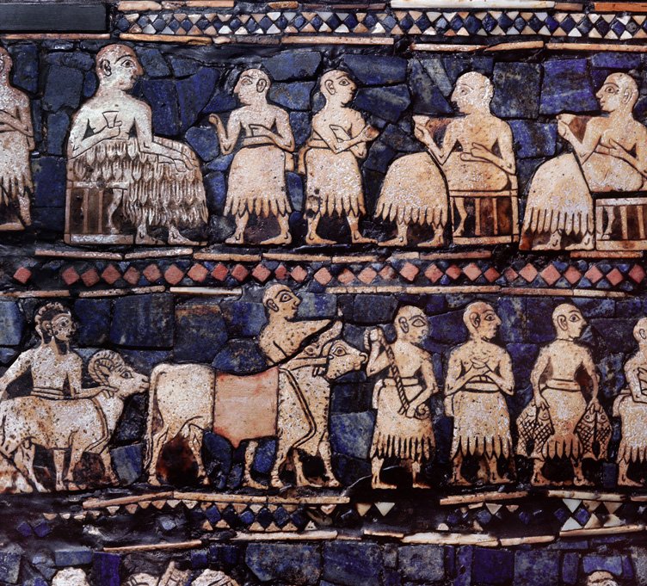
The Standard of Ur is a small wooden panel covered on both sides with mosaics composed of stones and jewels. This image shows a banquet scene with the king and his servants.
Full Image Description
The seated people in the upper row hold cups. The bottom row shows people standing with a goat and an ox, while another person holds two fish. The people are made with tan or off-white stones, while the background is primarily blue jewels or stones.

Sumerian Literature

The early Sumerians had a rich oral literature, reaching far back in time. Oral poems told of the heroic deeds of warrior leaders. Eventually, Sumerian oral literature was written. Much of it was preserved by later peoples who conquered Mesopotamia.
An Ancient Heritage is Passed Along

Even though the Sumerian city-states were conquered and the Sumerian language disappeared, Sumerian inventions and ideas survived. As you will read, many peoples conquered the Middle East, including the Akkadians, Babylonians, Assyrians, and Persians.
These people preserved and furthered Sumerian knowledge and achievements. The rich heritage of Mesopotamian civilizations was later passed on to the Greeks and Romans. From them, this ancient legacy was carried to the Western world. In this way, developments and innovations made more than 5,000 years ago came to shape Western civilization today.
Synthesize What advances did the Sumerians make in mathematics and astronomy?

