Air Circulation and Precipitation
Belts of rising and sinking air form a pattern around Earth. Hot air rises near the Equator. It cools and sinks at the edge of the tropics, rises in the temperate zones, and sinks over the poles.
Patterns of Winds
Global air patterns form as heated air rises and cooled air falls. At the same time, air at the surface is also blowing toward the east or west. The result is prevailing winds, which are the winds that most frequently blow across a region.
Precipitation Patterns
Precipitation is heaviest near the Equator, where moist air is heated and rises. It is also heavy along coastlines, where moist air blows onshore and is forced to rise. Precipitation is lightest where cool air sinks near the poles and at the edges of the tropics, where deserts are normally found.
Most storms occur when two air masses of different temperatures or moisture contents come together. Some storms bring small amounts of rain or snow, while others bring heavy wind and rain and cause damage.
A tropical cyclone is an intense rainstorm with strong winds that forms over oceans in the tropics. A tornado is a swirling funnel of wind that can reach 300 miles (500 km) per hour.
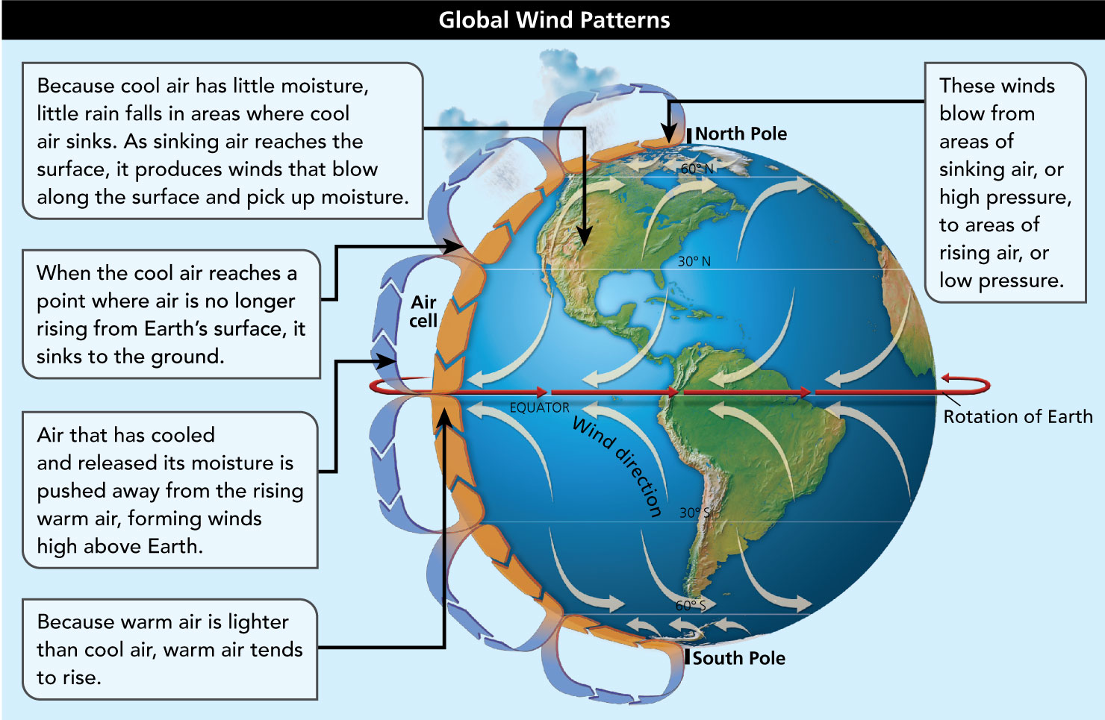
Analyze Diagrams Rising and sinking air form global wind patterns.
- Use Visual Information In what pattern do air cells circulate in the atmosphere?
Image long description
The drawing shows the earth with a series of arrows that indicate the rotation of the earth on its axis, the direction of the winds on the earth's surface, and air cells that are part of the process that produces winds. It does so as follows:
- Winds blow from areas of sinking air, or high pressure, to areas of rising air, or low pressure.
- Because cool air has little moisture, little rain falls in areas where cool air sinks. As sinking air reaches the surface, it produces winds that blow along the surface and pick up moisture.
- When the cool air reaches a point where air is no longer rising from Earth's surface, it sinks to the ground.
- Air that has cooled and released its moisture is pushed away from the rising warm air, forming winds high above Earth.
- Because warm air is lighter than cool air, warm air tends to rise.
- Reading Check Draw Conclusions How do air circulation and precipitation affect people?

Types of Climates
You have already learned about the most important shapers of climate: temperature, precipitation, and wind. These factors form global patterns. For example, temperatures are warmest in and around the tropics and are coolest close to the poles. Precipitation is greatest near the Equator. These patterns of temperature and precipitation create world climate regions. Climate regions are areas that share a similar climate.
The various climate regions can be grouped into three types. Warm climates include tropical wet, tropical dry, and humid subtropical climates. Temperate climates include maritime climates, continental warm summer and continental cool summer climates, and Mediterranean climates. Dry and cold climates include the arid, semiarid, subarctic, arctic, and ice cap climates.

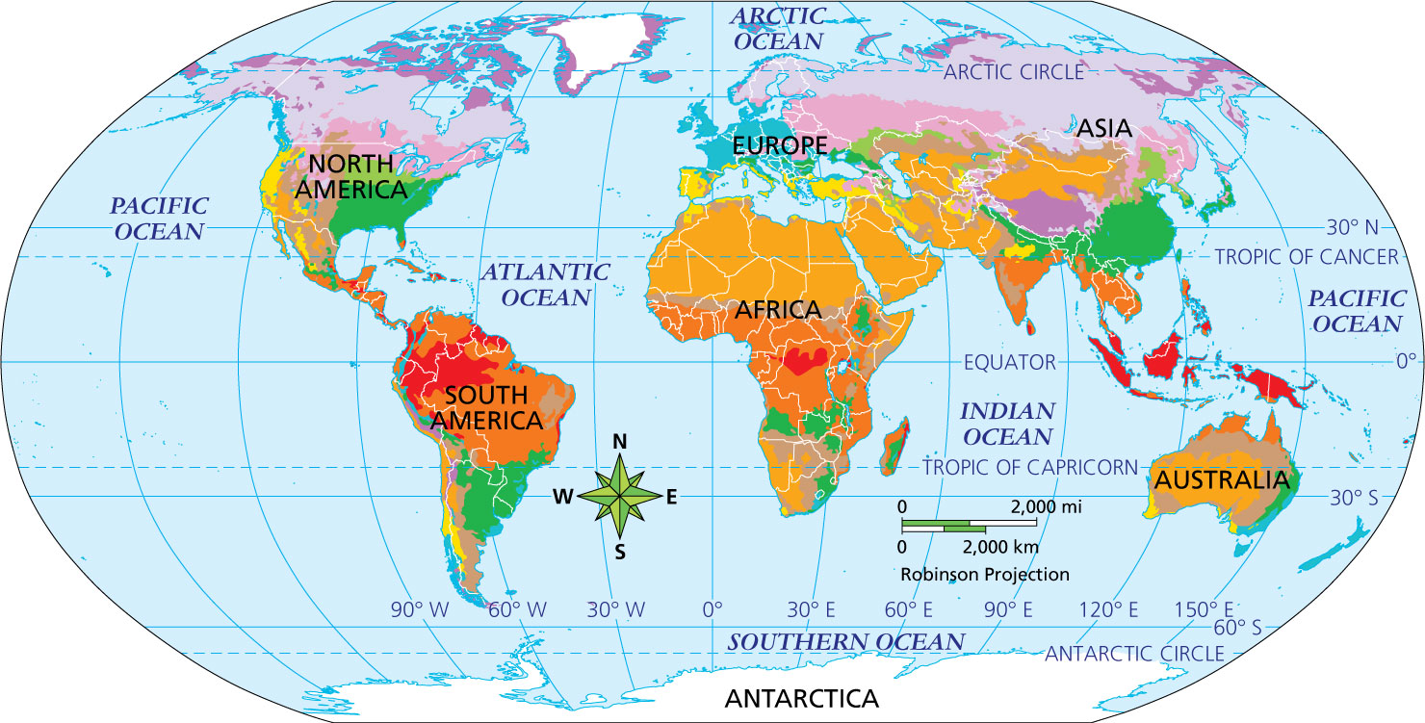
Geography Skills
Even areas separated by oceans can be in the same climate region because conditions give them similar patterns of temperature and precipitation.
- Place Which continent has the smallest share of its area covered by dry climate regions?
- Synthesize Visual Information Why is there more land with tundra climate in the Northern Hemisphere than in the Southern Hemisphere?

KEY | CLIMATE TYPE | DESCRIPTION
 | Tropical wet | Tropical wet climates combine hot temperatures and heavy rainfall year-round. They are clustered around the Equator.
 | Tropical wet and dry | Tropical wet and dry climates have a wet season in summer and a dry season in winter but are warm year-round.
 | Humid subtropical | Humid subtropical climates have year-round precipitation with mild winters and hot summers.
 | Mediterranean | Mediterranean climates have hot, dry weather in the summer and a cooler rainy season in the winter.
 | Semiarid | Semiarid climates are dry but with light precipitation.
 | Arid | Arid, or desert climates, receive very little precipitation.
 | Maritime | Maritime climates are wet year-round, with mild winters and cool summers. They exist where moist winds blow onshore.
 | Continental warm summer | Continental warm summer climates have year-round precipitation; warm summers; and cold, snowy winters.
 | Continental cool summer | Continental cool summer climates also have year-round precipitation, but they have generally lower temperatures.
 | Subarctic | Subarctic climates have limited precipitation, cool summers, and very cold winters.
 | Tundra | Tundra climates have cool summers and bitterly cold, dry winters.
 | Ice cap | Ice-cap climates near the poles are bitterly cold and dry year-round.
- Reading Check Draw Conclusions In the winter, what kind of weather would you expect in a continental warm summer climate?

