Biomes and Ecosystems
Regions on Earth that are made up of similar communities of plants and animals are called biomes. An ecosystem is a group of plants and animals that depend on one another and their environment for survival. Biomes may contain a variety of ecosystems. However, biomes are also sometimes called ecosystems. There are three types of ecosystems: forest, grassland, and cold climate types.
Ecosystems can change over time due to physical processes or human activities. For example, lack of rain might kill off many plants and animals in a temperate forest. Building a city is a human activity that changes an ecosystem.
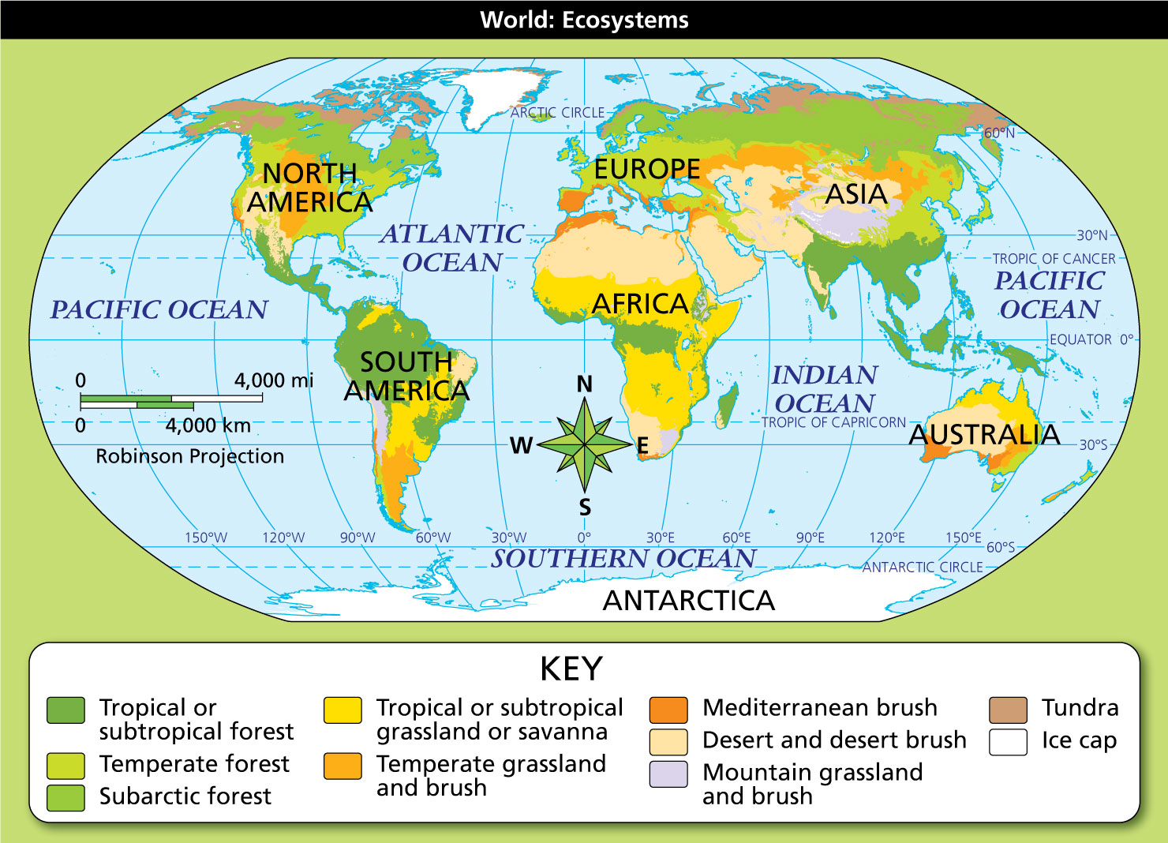
Geography Skills
Each ecosystem or biome is shaped by the climate of the region where it is found.
- Region Which ecosystem dominates northern Africa?
- Evaluate Explanations Based on this map, what
has a large mass of high mountains?

Forest Ecosystems
Forest ecosystems have closely growing trees. The three types differ according to the climate zone they are in. Steady hot temperatures and moist air support the rich ecosystems known as tropical rain forests. Moist temperate climates support thick temperate forests of deciduous tress, which lose their leaves in the fall. Some temperate forests also include evergreen trees. Subarctic forests have stands of coniferous trees, which have needles and produce cones to carry seeds. These features protect trees through the cold, dry winters of subarctic climates.
Grassland Ecosystems
Five ecosystems have mainly grasslands and brush. Grasslands are large areas covered by grasses. Brush includes bushes, shrubs, and low-lying plants. As with the forests, these types of ecosystems depend on their climate.
Tropical or subtropical grassland or savanna is found in tropical areas with dry seasons. A savanna is a park-like landscape of grasslands with scattered trees that can survive dry spells. Temperate grassland and brush is an ecosystem of vast grasslands that cover regions that get more rain than deserts but too little to support forests. The Mediterranean brush ecosystem is found in Mediterranean climates. They have low bushes that have to hold water from winter rains to survive hot, dry summers. The desert and desert brush ecosystem is found in dry semiarid areas and deserts with some rain. These ecosystems support low-lying desert plants that need little water and can live in extreme temperatures. The driest desert areas have little or no plant life. In mountain grassland and brush regions, vegetation depends on elevation, since temperatures drop as altitude increases.
Cold Climate Ecosystems
The third group of ecosystems is based on the cold climates at and near the poles. Cold ecosystems include the tundra and areas around the poles. These polar regions are marked by ice caps.
The tundra is an area of cold climate and low-lying plants. Here, grasses grow and low shrubs bloom during brief, cool summers. Animals of the tundra can survive the cold temperatures and scarce food. The ice cap ecosystem is found around the poles, where extreme cold makes life impossible for plants and most animals.
- Reading Check Identify Implied Main Ideas How do climate differences affect plant and animal life?

