Climates and Ecosystems
Some areas of Earth are hot and dry, and some are cooler and often wet. Some areas have similar temperatures throughout the year, and others have wide swings from one season to another. Earth has many different types of climates, and those differences shape life on Earth.
Get Ready To Read
Start Up
  - Study the photograph of a tropical rain forest. How does it show a relationship between a climate and communities of plants and animals?

Image long description
The two large birds have black bodies and white necks. Their enormous beaks curve down and are orange on top, white on the bottom. They also have an orange crest that sits on the top part of their beaks beginning at their eyes. Behind them can be seen a dense forest. There are smaller plants with large leaves in the foreground and larger trees in the background.
Guiding Questions
  - How is climate different from weather?

Climate and Weather
You have learned about the powerful forces that affect Earth, including movements of Earth in space, water, and sunlight. These forces also shape Earth’s weather patterns. Weather patterns can vary widely from one region to another.

Weather or Climate?
Do you look outside before you choose your clothing in the morning? If so, you are checking the weather. Weather is the condition of the air and sky at a certain time and place. Or do you choose your clothing based on the normal weather for the time of year in the place where you live? If so, you dress according to your local climate. Climate is the average weather of a place over many years.
How you feel about today’s weather may depend on your local climate. If you live in a place with a wet climate, you may be unhappy to see rainy weather, because your climate means that you get rain frequently. On the other hand, if you live in a dry climate where water is scarce, you might be very happy to see rainy weather. Earth’s climates cause humans to respond to the various elements in a variety of ways.
Rain is a form of precipitation, which is water that falls to the ground as rain, snow, sleet, or hail. Temperature is a measure of how hot or cold the air is. Precipitation and temperature are the main ways to describe both daily weather and long-term climate.
Comparing Climates
Climate graphs show the average climate for a place for each month of a year. A climate graph has a curved line that shows average temperatures for each month. It has bars that show average monthly precipitation.
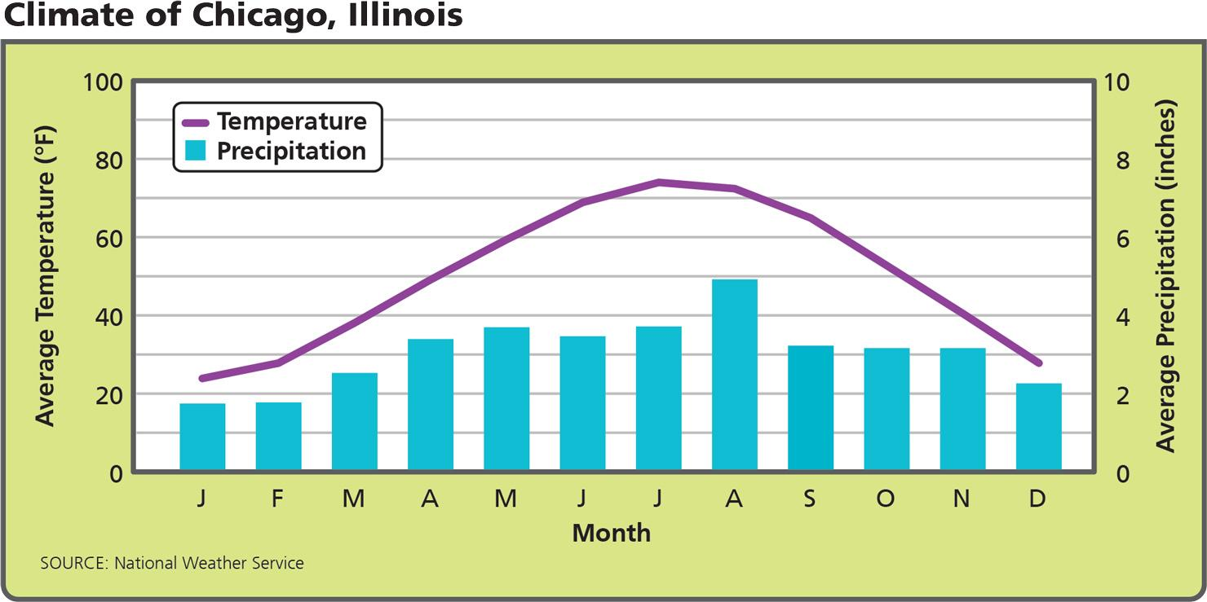
Analyze Graphs This climate graph shows that Chicago has cold winters, hot summers, and moderate precipitation year-round.
- Use Visual Information Which season is rainiest in Chicago?
Image long description
The left side of the graph shows Average Temperature from zero to 100 degrees Fahrenheit. The right side of the graph shows Average Precipitation in inches. The bottom of the graph shows each month from January to December.
The temperature curve shows the following approximate values by month:

- Reading Check Compare and Contrast How is climate different from weather?

Why Do Temperatures Differ?
Energy from the sun heats Earth. Because Earth's surface is curved, different areas of the planet receive different amounts of direct sunlight. As a result, some regions are warmer than others.
In addition, temperature patterns change from season to season. In January, it is winter in the Northern Hemisphere and summer in the Southern Hemisphere. In July, the seasons are reversed.
Latitude Differences
The polar zones, or high latitudes, are the areas north of the Arctic Circle and south of the Antarctic Circle. In the polar zones, the sun is near or below the horizon all year. Temperatures stay cool to bitterly cold.
The tropics, or the low latitudes, are the areas between the Tropic of Cancer and the Tropic of Capricorn. In the tropics, the sun is overhead or nearly overhead all year long. In this region, it is usually hot.
The temperate zones, or the middle latitudes, are between the high and low latitudes. They have a hot summer, a cold winter, and a moderate spring and fall.
Altitude Differences
Temperatures are cooler in areas with high altitude. Altitude is height above sea level. As altitude increases, temperature drops. That is true everywhere on Earth, even in the tropics.
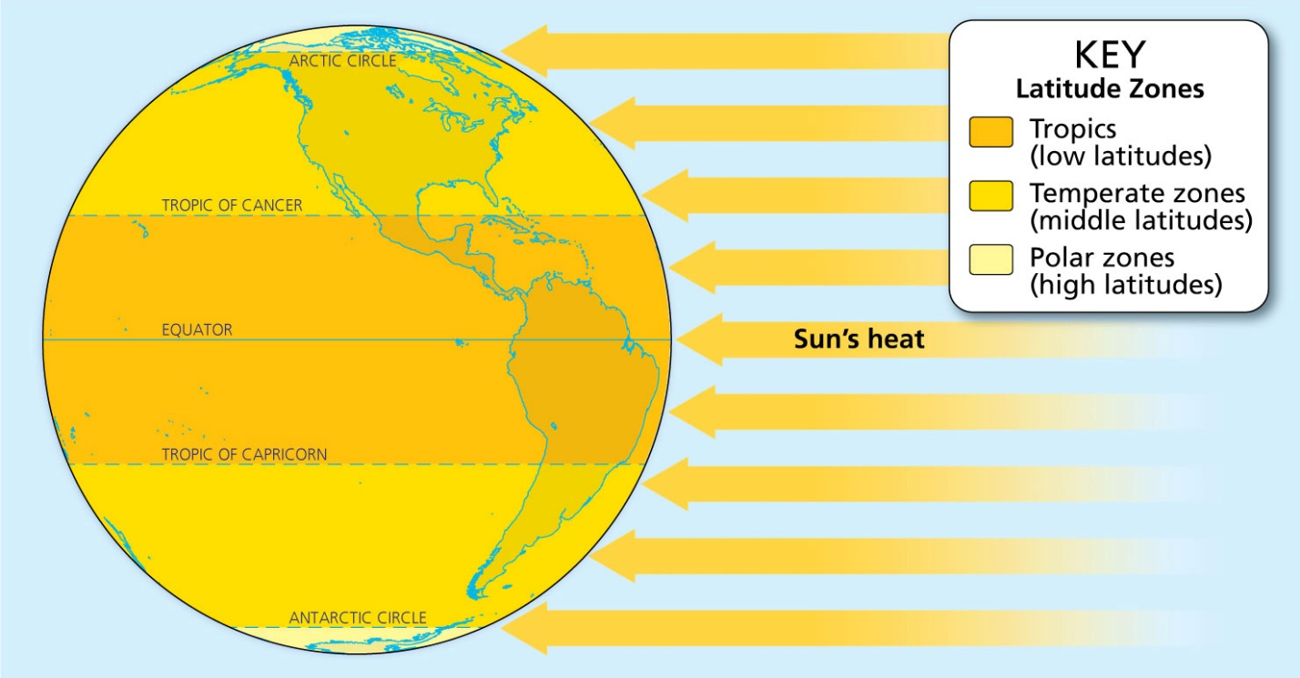
Analyze Diagrams The sun heats Earth unevenly, causing climate to vary in different zones of latitude.
- Use Visual Information Which zones cover the smallest areas of Earth’s surface?
Image long description
The latitude zones are indicated by different colors and are divided as follows:
- The tropics, which are the low latitudes, cover the middle third of the earth, from the Tropic of Cancer in the north to the Tropic of Capricorn in the south.
- The temperate zones, which are the middle latitudes, cover about two-thirds of the earth. In the north this is from the Tropic of Cancer to the Arctic Circle. In the south this is from the Tropic of Capricorn to the Antarctic Circle.
- The arctic zones are small strips at the Arctic Circle and Antarctic Circle.
- Reading Check Identify Supporting Details How does the curvature of Earth explain differences in temperature at different distances from the Equator?

