Grade: 5th
Worksheet
Student’s name: date:12/10/2025

Question 1: Look at the pictures. Choose the correct name for each picture from the word bank and write it on the line.(20 Points)
Word Bank:
Motherboard | Computer Mouse | Monitor | Keyboard | CPU
Productivity Software | Web Browser | Application Software | System Software | Computer Memory
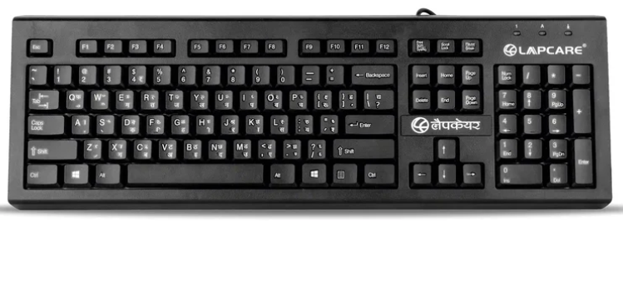   __________________________ _____________________ _______________
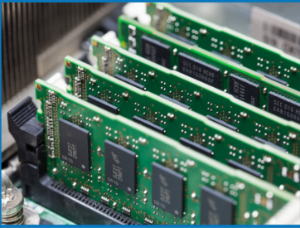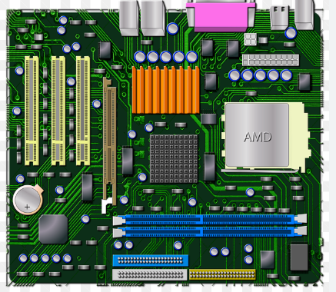
_____________ ________________ _________________ _____________________


_______________ ________________ ________________
Question 2: True or False
- ( ) Hardware means programs that help your computer run.
- ( ) The motherboard connects all the parts of the computer together.
- ( ) Microsoft Word is an example of productivity software.
- ( ) Packets are small pieces of data sent across the internet.
- ( ) System software can include the operating system and device drivers.

Question 3: Multiple Choice
Circle the correct answer.
What is the main job of the CPU?
a. To store pictures b. To process information c. To control the internet
Which of the following is an Operating System?
a. Chrome b. Android c. Excel
Which type of software helps you make presentations?
a. PowerPoint b. Word c. Paint

A device driver helps:
a. The computer communicate with hardware b. You design a game c. You write reports
Which of these is Special Purpose Software?
a. Google Docs b. Restaurant billing program c. Paint

Question 4: Short Answer
- What is the main difference between System Software and Application Software?
__________________________________________________________________________________________________________________________________________
- Give two examples of Productivity Software.
__________________________________________________________________________________________________________________________________________
- Why is it important to make technology useful for different types of users?
__________________________________________________________________________________________________________________________________________

Question 5: You’re helping your teacher create a school website.

a. What type of software would you use to design the site?
_____________________________________________________________________

b. Suggest one feature that makes the website easier for students to use.
__________________________________________________________________________________________________________________________________________
Good Luck 🙂

