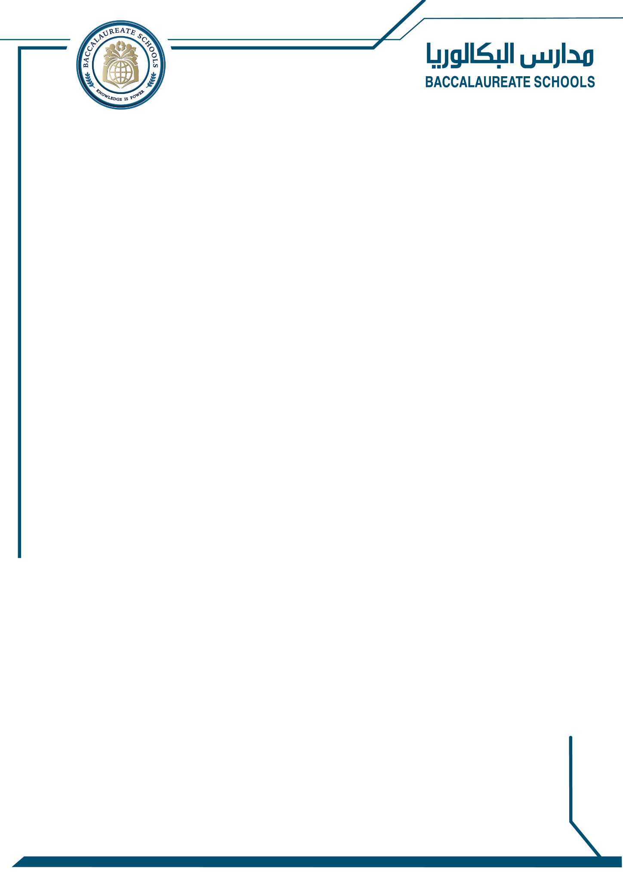
KG2 Spelling Bee First Round: October 30 2025
- Please practice over the weekend and throughout the week the following words that are for the first round of the spelling bee!
- Students are encourages to wear yellow on this day!
Am
The
Go
Do
He
Up
We
At
If
We
PRACTICE MAKES PERFECT!

