Science Unit 2 Study Guide
4th Grade

- The graph shows the average construction cost to build plants that produce electricity using different sources of energy . Plants that use renewable energy are often more expensive to build than plants that use nonrenewable energy.
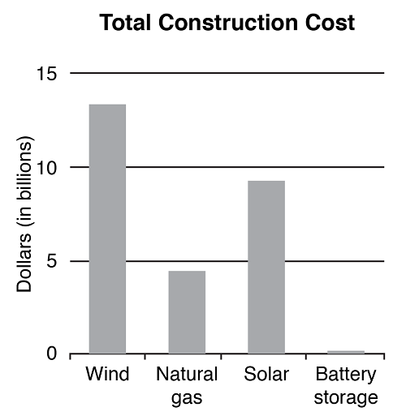

- Wind and solar are the two renewable resource plants that cost the most to build.

- Developing technology to prevent greenhouse emissions and replacing a coal burning plant with a nuclear power plant are two methods that are most likely to reduce greenhouse gases.

True only for a renewable source | True only for a non-renewable source | True for both renewable AND nonrenewable sources
supply is unlimited  produces energy without pollution | supply is limited | used for electricity  energy is from the sun  useful to humans

- The steps for using chemical energy to generate electrical power in the correct order.
- Obtain a fuel source.
- Burn fuel to heat water.
- Use steam to turn a turbine.
- Use the turbine to spin magnets and wire.
- Transfer electricity to customers.
- Leah argued that battery-operated cars can contribute to air pollution. She is right because the electricity used to charge the batteries comes from combustion.

- A generator transforms the energy of motion into electric energy.

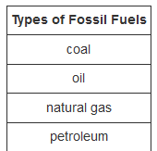

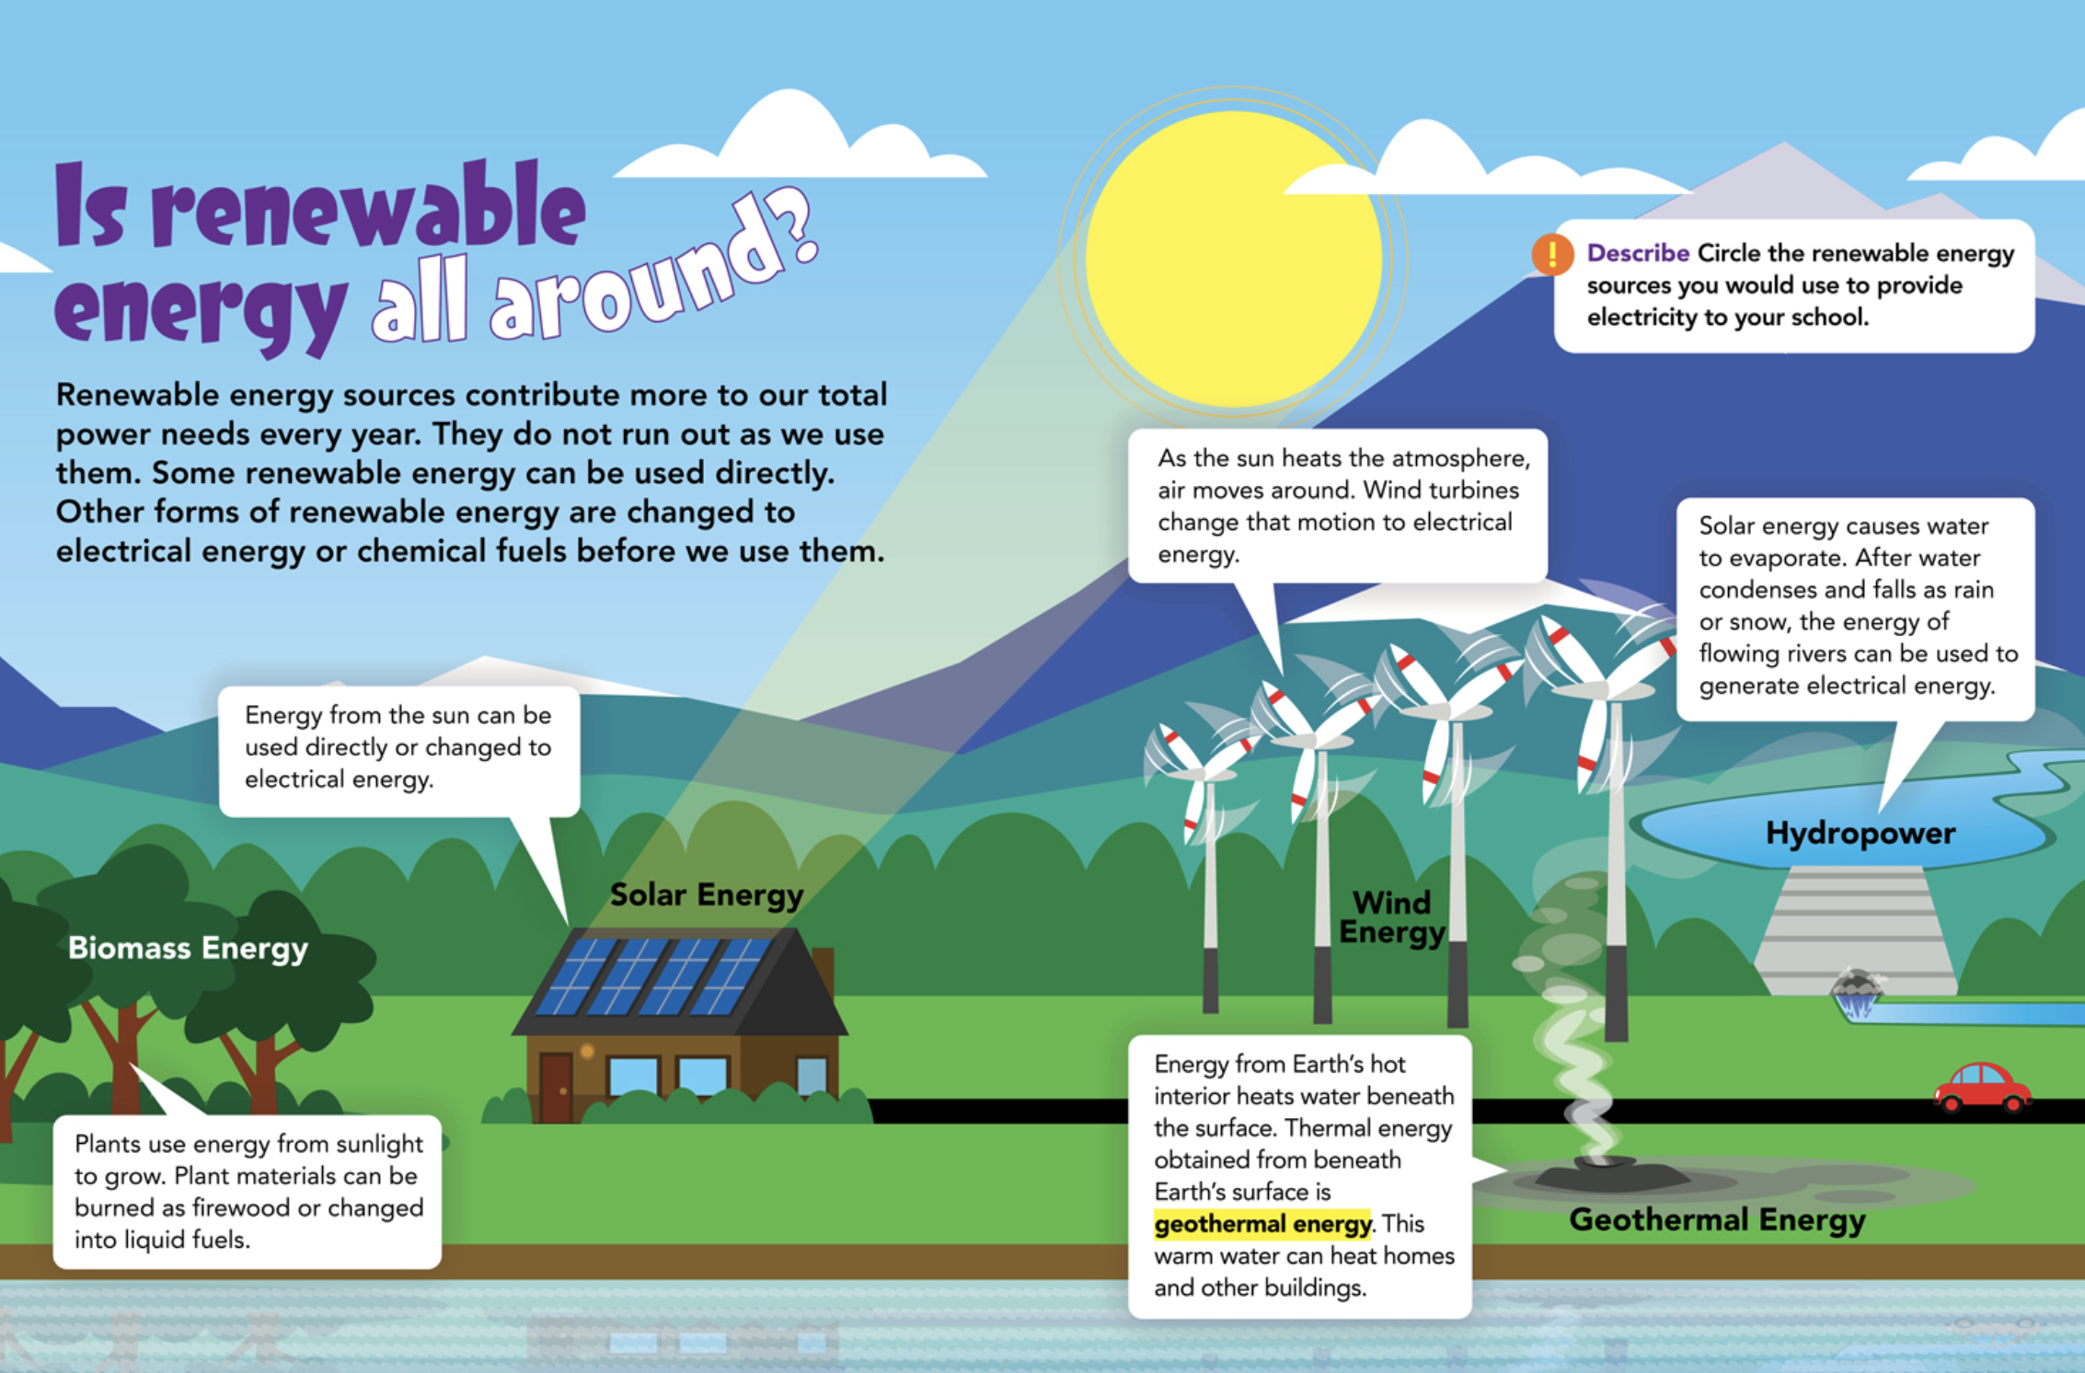
Renewable Fuels

- Biomass energy
- Solar energy
- Wind energy
- Hydropower
- Geothermal energy

The graph shows the primary energy sources in the United States in 2016.
- Natural gas was the greatest primary source of energy in 2016.
- Biomass was the largest supplier of renewable energy in 2016.
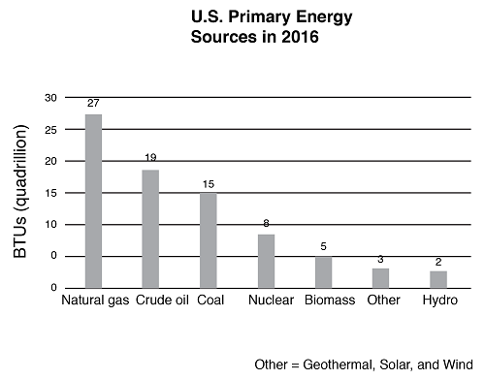

Good Luck

