

Third Grade Science Revision

Topic 2 Lesson 1

Name: ----------------------------

Q1 : Choose the correct answer:

The electrical charge of an object is ………. when the number of positive and negative charges are equal.
a. positive b. negative c. neutral

When matter has an overall positive or negative charge, we say that it has …………...
a. an electric charge b. sound c. light

…………. is the transfer of particles that have an electric charge between objects that are not touching.
a. Friction b. Static discharge c. Distance

The push or pull of charged objects on each other is an force.
a. tension b. electric c. spring

If the both objects have negative electric charges, the two objects
……...... each other.
a. repel b. attract c. pull on

A rubber balloon is ………
a. a conductor b. an insulator c. a magnet

- Which of these is a conductor?
a. a plastic rod b. a metal can c. a rubber balloon

Look at the picture to answer questions 8, 9, and 10.
Two balloons have electric charges
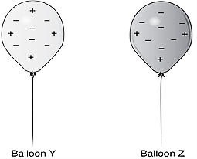

– Balloon Y has a Charge.
a. positive b. negative c. neutral

– Balloon Z has a charge.
a. positive b. negative c. neutral

10– When the balloons come close to each other, they will ………
a. attract b. repel c. pull on

Ahmed moves a plastic rod close to metal plate. The picture shows what happens.
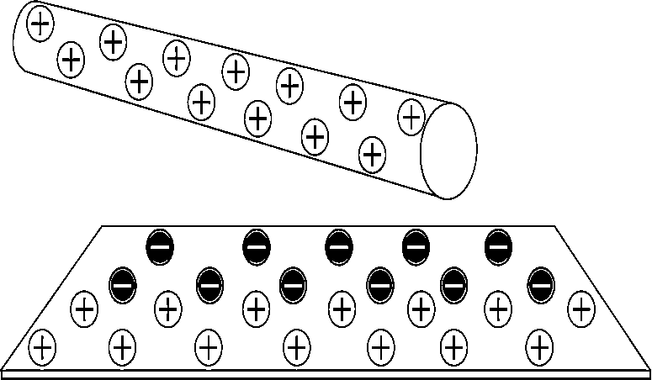

Use the picture to answer questions 11, 12, and 13.

- The plate is …………………
a. a conductor b. an insulator c. a field

– The rod ………… negative charges from the plate.
a. repels b. attracts c. pushes away

– The metal plate has charge.
a. positive b. negative c. neutral

In a conductor, electric charges ……………….
  - can move hardly
  - can move easily
  - cannot move

The diagram shows three objects that have electric charges.

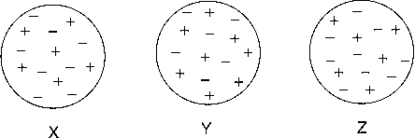

- Which two objects that will repel if they are brought close together.
  - X and Y b. X and Z c. Y and Z

16 – The material that electric charges cannot move easily through is called……..
a. a conductor b. an insulator c. a metal

Q2: Put true or false

NO | Statement | Status
1 | An object with a positive charge and an object with a negative charge attract each other.
2 | Electric charges move easily through conductors such as metals .
3 | The strength of electric force becomes weaker as electrically charged objects get closer to each other.
4 | A rubber balloon is a conductor.

Question -3 : Match the Correct answer from Column B to the Statement from A

NO | A |  | B
1 | Conductor | .........… | A) Is the sum of forces acting on an object.
2 | Force is measured in a unit called | .........… | B) The transfer of particles that have an electric charge between objects that are not  touching.
3 | Net force | .........… | C)The material that electric charges can move easily through
4 | Static discharge | .........… | D)Force acts between objects that are electrically charged.
5 | Electric force | .........… | E) Equal forces working in opposite directions.
6 | Insulator | .........… | F) No electric charge
7 | Neutral | .........… | G)The material that electric charges cannot move easily through
8 | Balanced forces | .........… | H) Newtons

