Name_______________________ Grade 11 Date________________________ Worksheet 2

12.3 DNA Replication

Lesson Objectives
- Summarize the events of DNA replication.
- Compare DNA replication in prokaryotes with that of eukaryotes.

Lesson Summary
Copying the Code Each strand of the double helix has all the information needed to reconstruct the other half by the mechanism of base pairing. Because each strand can be used to make the other strand, the strands are said to be complementary. DNA copies itself through the process of replication:
- The two strands of the double helix unzip, forming replication forks.
- New bases are added, following the rules of base pairing (A with T and G with C).
- Each new DNA molecule has one original strand and one new strand.
- DNA polymerase is an enzyme that joins individual nucleotides to produce a new strand of DNA.
- During replication, DNA may be lost from the tips of chromosomes, which are called telomeres.
Replication in Living Cells The cells of most prokaryotes have a single, circular DNA molecule in the cytoplasm. Eukaryotic cells have much more DNA. Nearly all of it is contained in chromosomes, which are in the nucleus.
- Replication in most prokaryotic cells starts from a single point and proceeds in two directions until the entire chromosome is copied.
- In eukaryotic cells, replication may begin at dozens or even hundreds of places on the DNA molecule, proceeding in both directions until each chromosome is completely copied.

Copying the Code

- Why are the strands of a DNA molecule said to be complementary? ___________________________________________________
_____________________________________________________________________.
- What is the first step in eukaryotic DNA replication?___________________________________________________
_____________________________________________________________________.

- If the base sequence on a separated DNA strand is CGTAGG, what will the base sequence on its complementary strand be?________________________________________________________________________________________________________________________.

- What enzyme joins individual nucleotides to produce the new strand of DNA?___________________________________________________
_____________________________________________________________________.

- What enzyme makes it less likely that DNA will be lost from telomeres during replication?____________________________________
_____________________________________________________________________.

- How does this enzyme work?______________________________________
_____________________________________________________________________.

- What is a replication fork?________________________________________
_____________________________________________________________________.

- Does DNA replication take place in the same direction along both strands of the DNA molecule that is being replicated? Explain your answer. (Hint: Look at the illustration of DNA replication in your textbook.)______________________________________
_____________________________________________________________________________________________________________________________________________________________________________________________.

- Make a sketch of the double helix of DNA. Show how it unzips for replication and how complementary strands are built. Label the nitrogenous bases, replication fork, DNA polymerase, the original strand, and the new strand.

Replication in Living Cells
- Complete the table to compare and contrast DNA replication in prokaryotes and eukaryotes.

 | Prokaryotes | Eukartyotes
Location of DNA
Amount of DNA
Starting Point(s) for Replication

- Is DNA replication always a foolproof process? Explain your answer. _____________________________________________________________
___________________________________________________________________________________________________________________________________________________________________.

BUILD Vocabulary
- The chart below shows key terms from the lesson with their definitions. Complete the chart by writing a strategy to help you remember the meaning of each term. One has been done for you.

Term | Definition | How I’m going to remember
DNA Polymerase | Enzyme that joins individual nucleotides to make a strand of DNA
Replication | The process of duplicating DNA | DNA makes a replica during replication.
Telomere | The tip of a chromosome

Copying the Code
The Role of Enzymes Enzymes have several important jobs in DNA replication. The jobs of some enzymes are listed below.
Write the jobs in the order in which they occur.

join free nucleotides to existing DNA strand unwind DNA
unzip DNA

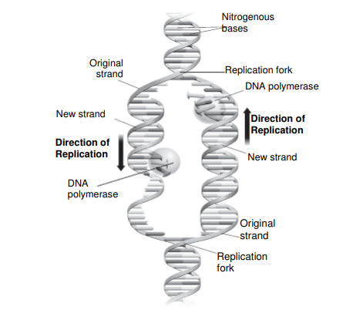
The diagram below shows the replication of DNA. Look carefully at the diagram.

Answer the questions.
4. In your own words, define the word replicate. ________________________
____________________________________________________________________________.
5. Enzymes usually end in -ase. What is the name of the enzyme that joins individual nucleotides? ___________________________________________
___________________________________________________________________________.

6. Circle the correct answer to complete the sentence. A(n) ____________ is the place where a DNA strand opens to make new strands.
original strand old strand replication fork

Replication in Living Cells
During replication, a DNA molecule copies itself. In eukaryotes, DNA is organized into chromosomes within the nucleus. In prokaryotes, DNA is a circular molecule that is free in the cytoplasm.
Follow the directions.
1. Label one diagram as Prokarytic DNA.
2. Label the other as Eukaryotic DNA.
3. Label both drawings with the following terms: unreplicated DNA, replication fork, origin of replication.
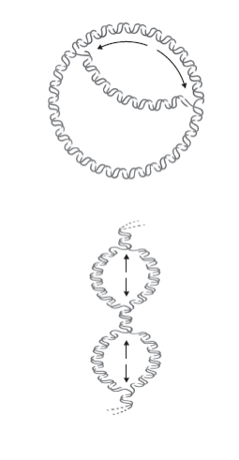

Answer the questions. Circle the correct answers.
4. In which type of cell is DNA circular?
Prokaryotic eukaryotic
5. In which type of cell does replication begin at several points?
Prokaryotic eukaryotic

