*Economic concepts :
Economic Concepts
Economics is the study of how people meet their wants and needs. Societies must answer three basic economic questions:
- What goods and services should be produced?
- How should goods and services be produced?
- Who uses or consumes those goods and services?
Goods: are physical products such as food, shirts, and cell phones. Services: are helpful or valuable actions—often involving skill—offered by businesses such as hotels, restaurants, hospitals, and banks.
People must use resources to make goods and services. Those resources are called factors of production. The three factors of production :are land, labor, and capital. Land includes natural resources. Labor is work that people do. Capital includes money and human-made goods such as machinery and buildings.
There are many ways to combine factors of production to produce goods and services. Generally, though, increasing capital makes it possible to make more goods and services with the same amount of labor.
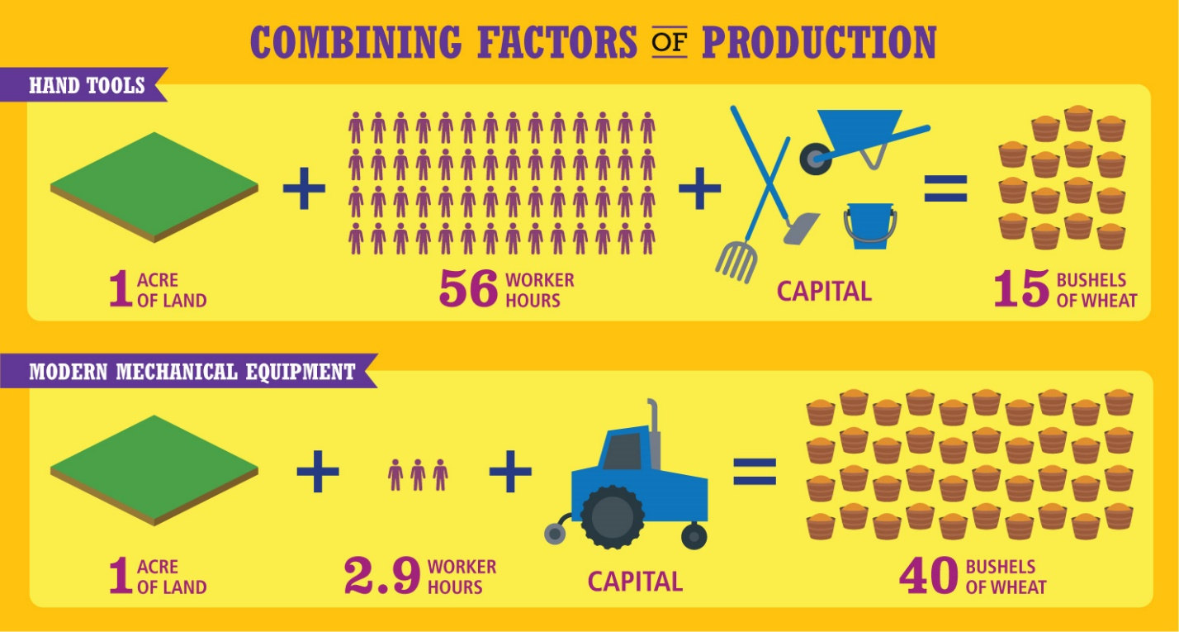
Analyze Diagrams Factors of production can be combined in different ways.
- Infer Based on this diagram, how does using more capital change the amount produced and the need for labor?
Notebook
Image long description
Making Choices
There is no limit to the things that people want, but there are limits to what can be produced. The difference between wants and reality creates scarcity, which is having a limited quantity of resources to meet unlimited wants. Since people have limited money and time, they have to choose what they most want to use them on. The money or the time you spend on one thing cannot be spent on something else. Making a choice involves an opportunity cost, or the cost of what you have to give up.
Economics also involves demand and supply. Demand is the desire for a certain good or service. Supply is the ability and willingness to produce a good or service. Demand and supply are connected to price. If the demand for a product increases, its price will tend to rise. Suppliers may respond to the increased price by producing more. If its supply increases, the price will tend to fall.
The opposite is also true. If demand for a product falls, its price also falls. Suppliers may respond to the lower price by producing less. If supply falls, assuming demand remains the same, the price will rise.
Making Goods and Services
Economies bring together producers and consumers. Producers are people or businesses that make and sell goods or services. Consumers are people or businesses that buy, or consume, goods or services.
Producers try to win consumers’ business by offering better products or services for lower prices than other producers in their industry. If they can sell more products or services, they usually increase production or expand their services. But producers will not make more products if the sale price is less than the marginal cost. Marginal cost is the cost of making one more unit of the product. Therefore, the marginal cost for the producer sets a minimum price for the product.
Businesses make products because of economic incentives. An incentive is something that encourages people to act in a certain way. The desire to earn money gives most producers an incentive to make and sell products or services. The incentive to save money leads most consumers to look for lower prices.
- Reading Check Infer How might a change in the price of one good or service lead to changes in prices of other goods or services?

Economic Systems
Each society’s economic system determines how people make and distribute goods and services. There are four types of economic systems: traditional, market, command, and mixed. The roles of individuals, businesses, and government vary in each system. Economic goals and incentives can also vary.

Analyze Images Market economies encourage people to start new businesses.

Identify Main Ideas What incentive drives people to start a new business?

Traditional Economy
A traditional economy is an economy in which people make economic decisions based on their group’s customs and values. They usually satisfy their needs and wants through hunting or farming, as their ancestors did. People in traditional economies usually do not want to change their basic way of life.
This static nature of the economy is one disadvantage of traditional economies. People do not usually have a high standard of living. Advantages include the lack of waste associated with this economy and the knowledge of what one’s role is within the society. Today, traditional economies are not common.

Market Economy
A market economy is an economy in which individual consumers and producers make economic decisions. This type of economy is also called capitalism. Market economies are based on the principles of freedom, competition, and profit. Market economies encourage people to establish new businesses by giving them economic freedom. They are free to do what they want, within the law, and to earn as much profit as they can.
Market economies have many benefits. Because people own their own businesses, they have a stake in the businesses’ success. That stake makes them highly motivated to find new, better, or faster ways of doing things. In this way, market economies encourage technological innovation and efficiency. Producers focus on making the products that consumers want as inexpensively as possible. They offer those products at prices that consumers are willing to pay.
However, like all economic systems, the market economy does have downsides. It can encourage the growth of huge companies that have little competition and can therefore dictate high prices for their products. It also may result in an unequal distribution of income, leaving some people very rich and some very poor. In addition, some services, such as national defense or police protection, may not function well under private ownership. That is because it would be difficult for businesses to get all members of society to share in the cost of these services.

Command Economy
A command economy is an economy in which the central government makes all economic decisions. This kind of system is also called a centrally planned economy. In a command economy, individual consumers and producers do not make basic economic decisions.
This lack of economic freedom is one disadvantage of command economies. Another disadvantage is lack of competition and lack of incentives motivating workers and managers. Why should they work hard when they do not own the business and have little stake in its success?
A command economy does have some advantages. There is little unemployment because the government makes sure everyone has a job. Also, the social welfare of the public may be valued more than profit. Income tends to be more evenly shared.
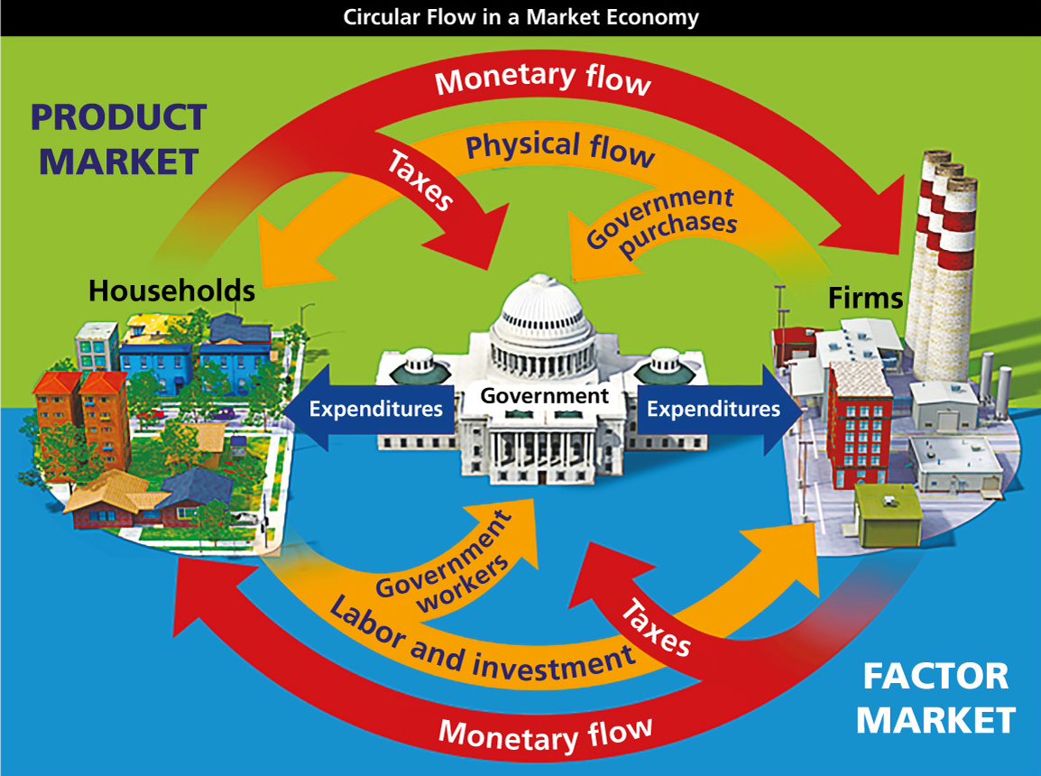
Analyze Diagrams This diagram shows the circular flows of economic activity in a mixed economy.

Mixed Economy
In reality, pure market and pure command economies do not exist. Most societies have mixed economies, with varying degrees of government control. A mixed economy combines elements of traditional, market, and command economic systems.
An example of a mixed economy is socialism. In socialism, some businesses are controlled by the state or worker cooperatives. However, some goods and services are distributed through individual decisions in a market. A socialist government aims to level the extremes of wealth between the rich and poor. It provides many welfare benefits, ensuring that the poor and disabled are cared for. One disadvantage of socialism is the need for higher taxes to pay for these services. Business owners do not gain the full reward of their hard work because of these taxes.
Countries such as North Korea and Cuba have mixed economies that are close to pure command economies. In these countries, government owns and controls most businesses and makes most economic decisions.
Countries such as the United States and Australia have mixed economies that are closer to pure market economies. In these countries, most economic decisions are made by individuals and businesses. The government makes some economic decisions, however. For example, government passes laws to protect consumers’ rights. Government spending and taxation provide jobs and services and influence economic growth.

Reading Check Identify Main Ideas What are the differences among traditional, command, and market economies?

Personal Finance
Income is the money that people receive from the work they do or the money they save or invest. It is the main resource that people use to meet their needs and wants. Like all resources, income is limited. But people’s needs and wants are unlimited. For that reason, people need to make choices as they manage their income.

Budgeting and Saving
A key tool in money management is a budget. A budget is a plan that shows income and expenses over a period of time.

A teen earns some money babysitting to have resources to meet her wants.
In a budget, income should be equal to or greater than expenses. A budget should also include money reserved for saving. Saving is the act of setting aside money for future use. Many people save by putting their money in a bank. A bank is a business that keeps money, makes loans, and offers other financial services.
Many people who save money in banks do so using checking or savings accounts. Banks may pay interest on money deposited in these accounts. Interest is the price paid for using someone else’s money. The interest that banks pay is an incentive for people to save money.

Credit
Banks use deposits to make loans to people and businesses. These loans help people buy houses or make other large purchases. They help businesses get started or grow. As a result, banks are a big part of economic growth.
Loans are a form of credit. Credit is an arrangement in which a buyer can borrow to purchase something and pay for it later, such as by using a credit card. Credit helps consumers and businesses buy goods and services that they could not buy otherwise. Credit has a cost, however. Banks charge interest on the money they lend to people and businesses. As a result, it costs more for a consumer to purchase a good using credit than to pay cash for the good at the time of purchase. The availability of loans and credit depends on supply and demand.


