
9th Grade English
1st Semester Final
Study Sheet

Literature
1. The Moral Logic of Survivor Guilt (pg. 153)
Author: Nancy Sherman
Genre: Editorial

Background
Traumatic events take a toll on the physical and mental well-being of the individuals who must endure
them. Survivors of the Holocaust, rescue workers, and war veterans, for example, might wonder how
they were able to make it out alive when others did not. The term “survivor guilt” is used to describe
these feelings.

Concept Vocabulary (pg. 160)
1. burden __________________________________________________________________________
2. conscience _______________________________________________________________________
3. entrusted ________________________________________________________________________
4. culpability ________________________________________________________________________
5. remorse _________________________________________________________________________
6. empathic ________________________________________________________________________

Comprehension Check (pg. 157)

1. What is survivor guilt? ______________________________________________________________
_________________________________________________________________________________

2. According to the writer, what other emotions do soldiers describe when they talk about feeling
guilt?_____________________________________________________________________________
_________________________________________________________________________________

3. What happened to Private Joseph Mayek, and why does Captain John Prior feel responsible?
_________________________________________________________________________________
_________________________________________________________________________________

4. Write a summary of “The Moral Logic of Survivor Guilt” to confirm your understanding of the text.

Possible Answer:
The Moral Logic of Survival Guilt” explains that people often feel guilty for surviving when others do
not, even if they couldn’t have changed the outcome. This guilt happens because we care about others
and feel responsible, even when it isn’t actually our fault. The author shows that survival guilt is a normal
human reaction, not a sign of doing something wrong.

Analyze Craft and Structure

Development of Ideas “The Moral Logic of Survivor Guilt” is an editorial, a form of argumentative writing. As with all types of arguments, an effective editorial must include a clear claim, or central idea, and specific supporting details.
• The claim or central idea of a text is more than the topic—it is the key message that the writer
wants to communicate about the topic.
• Specific details are the evidence a writer uses to support and develop the central idea. Facts,
examples, numerical data, personal observations, and expert opinions are different types of
supporting details.

Study from notebooks, worksheets and text book pg. 159

Word Study

GREEK ROOT -PATH-
The Greek root -path- means “feeling.” It comes from the Greek word pathos. This root is found in the two closely related words, empathetic and sympathetic.

Empathetic means “identifying with the feelings of others.” If you empathize with someone, you can feel what the other person must be feeling.

Sympathetic means “feeling concern for the feelings or situation of others, especially in times of sorrow or grief.”

A. Directions: Fill in the chart to show all the forms of the words.
NOUN | VERB | ADJECTIVE | ADVERB
empathy
 |  | sympathetic

Grammar
Effective writers use varied punctuation to clarify connections among ideas, including colons, semicolons, and dashes.
: | Use a colon to introduce a list, an example, a quotation, or a sentence that summarizes or explains the sentence before it.
; | Use a semicolon to join closely related complete sentences or to separate items in a series that already contain several commas.
— | Use dashes to indicate an abrupt change of thought or a dramatic interruption, set off a summary statement at the end of a sentence, or set off a nonessential appositive.
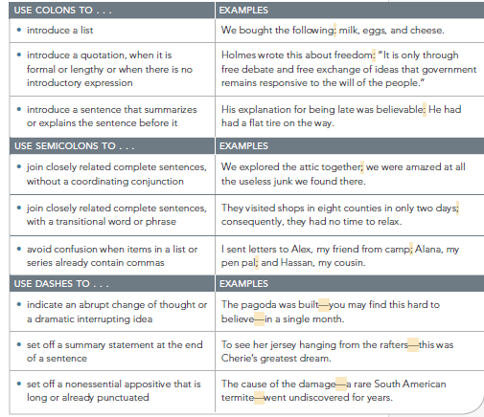

Study from notebooks, worksheets and text book pg. 159

2. The Key to Disaster Survival? Friends and Neighbors
Genre: Radio Broadcast
Author: Shankar Vedantam

Background/ Summary
In his podcast, “The Key to Disaster Survival? Friends and Neighbors,” NPR Science Correspondent
Shankar Vedantam talks to political scientist Daniel Aldrich.

In late August, 2005, Aldrich was a newcomer to New Orleans. He had heard the storm warnings, but he didn’t plan to leave town until a neighbor advised him to take his family someplace safe without delay. It was nearly midnight on Saturday, but he and his wife bundled the children into the car and left the city. Hurricane Katrina struck New Orleans early Monday morning.

Since that night, Aldrich has researched disaster sites all over the world. He finds that while emergency services and government aid can rescue, restore, and rebuild, it is good neighbors that are the key to the survival of neighborhoods, communities, and cities.

Media Vocabulary
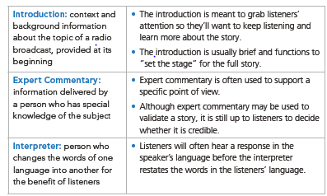

* Notes for lesson are recorder in students note books,

Comprehension Check
1. What information does show’s host give the listener during the introduction of the broadcast?
Answer: The host mentions several recent disasters — like an earthquake in Japan, tornadoes in
Missouri and Alabama, and wildfires — then says that new research suggests that neighbors, not
justemergency responders or government aid, play a critical role in survival.

2. What events causes Daniel Aldridge’s neighbor to knock on Aldridges’s door late at night?
Answer: to warn him and his family — especially because he knew they had small children — that
they should evacuate

3. What events does Aldridge use to study the effect of neighbor’s helping one another in Japan?
Answer: Aldrich studies disasters around the world, including the 2004 tsunami in Indian fishing
villages and earthquakes in Japan (notably the Kobe earthquake) to examine how neighbor-to-
neighbor support affects survival.

4. Who helped Michinori Watanabe save his father?
Answer: When the power went out after an earthquake in Japan, Watanabe ran to his neighbors
asking for a generator. One person he already knew (but had only just met) brought him a
generator, which he used to power his father's breathing machine.

3. Survival Is Your Own Responsibility
Author: Daryl R. Mille
Genre: Public Letter

BACKGROUND
In 2015, Mount McKinley, the tallest mountain in North America, was officially renamed Denali,
its original Native American name. Denali is the centerpiece of the vast Denali National Park and
Preserve in Alaska, a total of 9,493 square miles of wilderness. The area is very remote—there
are few marked trails, and vehicle access is limited

Comprehension Check

1. What part of the world does Miller’s letter focus on?
_______________________________________________________________________________
2. What were the rules of survival a hundred years ago?
_______________________________________________________________________________

3. What is distinctive about many of the rescues conducted by the National Park Service each
year?
____________________________________________________________________________

4. What does Miller consider a person’s “best resource” related to surviving in the wilderness of
Alaska?
_____________________________________________________________________________

Grammar

Infinitives and Infinitive Phrases: An infinitive is a verb form that generally appears with the word to in front of it and acts as a noun, an adjective, or an adverb. An infinitive phrase consists of an infinitive and its objects, complements, or modifiers, all acting together as a single part of speech. Like an infinitive, an infinitive phrase acts as a noun, an adjective, or an adverb.

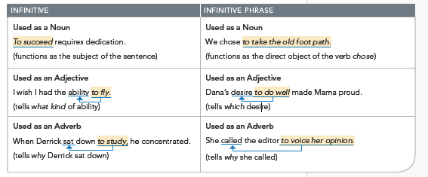

4. I have a Dream
Author: Dr. Martin Luther King
Genre: Speech

BACKGROUND
Because speeches are written to be spoken aloud, they are a more fluid form of literature than most other nonfiction. A strong speaker will react to unspoken signals from his or her listeners and adjust a speech accordingly. He or she might change words or add whole phrases. This is the case with Dr. Martin Luther King, Jr., one of the great speakers of the modern age. The text that appears here represents the speech exactly as it was delivered by Dr. King on the steps of the Lincoln Memorial

Comprehension Check

1. About how much time has passed between the signing of the Emancipation Proclamation and Dr.
King’s speech?
_______________________________________________________________________________
_______________________________________________________________________________
2. When his audience returns home after his speech, what does Dr. King want them to know about
the situation African Americans face?
_______________________________________________________________________________
_______________________________________________________________________________

3. What dream does Dr. King have for his four children?
_______________________________________________________________________________
_______________________________________________________________________________

Analyze the Text

1. Interpret What does King mean when he refers to the African American as an “exile in his own
land”?
__________________________________________________________________________________
__________________________________________________________________________________

2. Summarize Explain the comparison King makes between the African American struggle for equality
and the cashing of a check.
__________________________________________________________________________________
__________________________________________________________________________________

3. Paraphrase (a) When you paraphrase, you restate a text in your own words. Paraphrase King’s
comments on the urgency of “Now.” (b) Speculate To which group of people might King have been
directing that part of his argument? Explain.
__________________________________________________________________________________
__________________________________________________________________________________

4. Evaluate What idea is King trying to convey when he says that “unearned suffering is redemptive”?
__________________________________________________________________________________
__________________________________________________________________________________

5. Essential Question: How can words inspire change? What have you learned about the power of
words by reading this speech?
__________________________________________________________________________________
__________________________________________________________________________________

Analyze Craft and Structure

Argument In a persuasive speech, the speaker tries to convince listeners to think or act in a certain way. Strong persuasive speakers present information and supporting evidence clearly and logically so listeners can follow the reasoning. Persuasive speakers may charged language—language that appeals to emotions. In addition, they often use rhetorical devices—patterns of words and ideas that create emphasis and emotion.

These devices include the following forms:
• Parallelism: repeating a grammatical structure or an arrangement of words to create rhythm and
momentum
• Repetition: using the same words frequently to reinforce concepts and unify the speech
• Analogy: drawing a comparison that shows a similarity between two unlike things

Parallel Structure Parallelism, or parallel structure, is the use of similar grammatical forms or patterns to express similar ideas. Effective use of parallelism adds rhythm and balance to your writing and strengthens connections among your ideas.
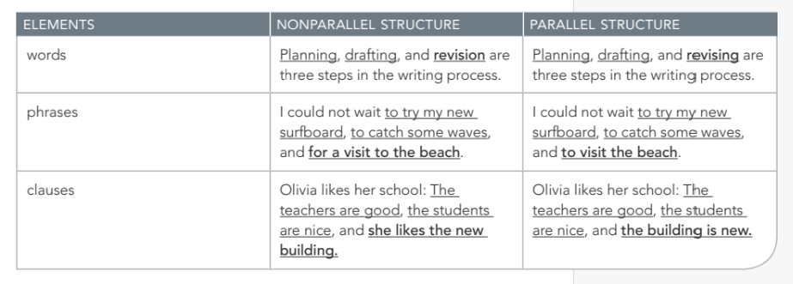

Concept Vocabulary
- Prosperity: ___________________________________________________________________
- tribulations: __________________________________________________________________
- oppression: __________________________________________________________________
- hallowed : ___________________________________________________________________
- redemptive: _________________________________________________________________
- exalted: ___________________________________________________________________

Study From Class notes, worksheets, and text book pg. 268

