
7th Grade English
1st Semester Final
Study Sheet

Literature
1. Learning to Love My Mother
Interview: Maya Angelou with Michael Maher
Background
In Michael Maher’s BBC TV interview with Maya Angelou, the writer talks about her relationship
with her mother. After her parents’ divorce, Angelou found herself abandoned by her mother at the
age of three. She didn’t see her mother again until she went to live with her in San Francisco ten
years later. Their relationship had many problems, but Angelou was able to forgive her mother for
the simple reason that her mother loved her. Angelou says that her relationship with her mother
taught her that love heals. Angelou reads an excerpt from her book, Mom & Me & Mom, and
Maher asks her what lessons she hopes readers will learn. Angelou’s answer demonstrates great
kindness and a profound insight into the essential bond between mothers and daughters.

Comprehension Check
1. What are some of the ways in which Vivian Baxter was unlike Maya Angelou’s grandmother?
2. How did Vivian Baxter react to her daughter’s calling her Lady?
3. According to Angelou, what would Vivian Baxter have thought about there being an African
American president?
4. What are two life lessons Angelou thinks people should learn?
5. What is one reason Angelou forgives her mother for abandoning her?
6. Explain how Maya Angelou overcame her problems with her mother, and describe how she based
her advice to others on her own experience.

Media Vocabulary
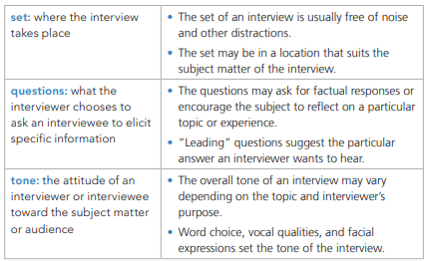

Grammar
Action Verbs and Linking Verbs A verb is a word that expresses an action or a state of being. A complete sentence must have at least one verb.

• An action verb tells what action someone or something is doing.

• A linking verb joins the subject of a sentence with a word or phrase that describes or renames the subject. The most common linking verbs are forms of be, such as am, is, are, was, were, has been, and will be. Other linking verbs include seem, become, stay, and feel.
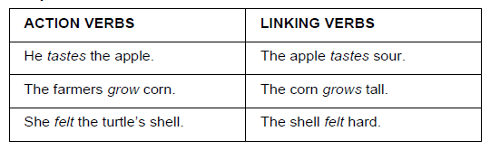

DIRECTIONS: Identify each underlined verb by writing action or linking.
1. The astronauts eat freeze-dried food. ______________________________________
2. They wear space suits when they leave the ship. ______________________________
3. Sometimes, the astronauts are bored. ______________________________________
4. Applicants compete with one another to win a spot in the space program. _________
5. Astronauts can stay busy with work. ________________________________________

Study from worksheet, notebook and textbook pg. 161

2. Poetry Collection “Mother to Son” + “To James”
Genre: Poetry
Authors: Langston Hughes (Mother to Son), Frank Horne (To James)
Background
Mother to Son: Even after the abolition of slavery, life was very hard for most African Americans.
Poetry, music, and the other arts were creative outlets that allowed them to express the hardships of
their lives and to find inspiration.

To James From 1914 through 1937, Harlem, a neighborhood in New York City, was the setting for an
awakening of African American culture that came to be known as the Harlem Renaissance. During this
period, African American writers such as Langston Hughes and Frank Horne searched for the truest way
to express their experiences. Each developed a unique style that ultimately helped shape not just
African American culture but also world culture.

Comprehension Check
MOTHER TO SON
1. Identify three words or phrases from the poem that describe the staircase.
2. What does the speaker tell her son NOT to do?

TO JAMES
1. What event does the speaker refer to at the poem’s start?
2. What goal does the speaker of the poem identify?
3. Which actions repeat throughout the poem?

Concept Vocabulary
1. Flung
2. Catapulted
3. Lurched

Study from worksheet, notebook and textbook pg. 94

Analyze Craft and Structure:
Figurative Language: Symbolism A symbol is anything—an object, person, animal, place, or situation—that represents something else. A symbol has its own meaning, but it also stands for something larger than itself, usually an abstract idea. For example, a dove is a type of bird that symbolizes peace.
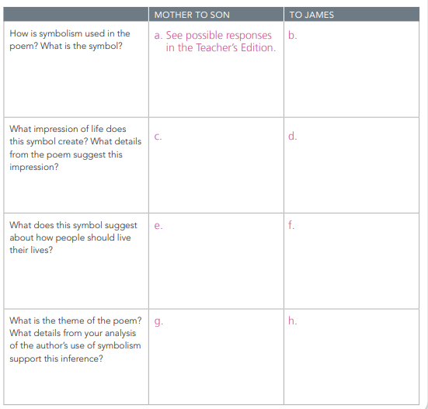

Study from worksheet, notebook and textbook pg. 101

Author’s Style Rhythm and Repetition:
Rhythm is the pattern of strong and weak beats in spoken or written language. In free verse poems such as “To James” by Frank Horne and “Mother to Son” by Langston Hughes, the structural pattern can be irregular and closer to the natural rising and falling of spoken language. The term “free verse” refers to poetry that has no standard pattern of rhyme or rhythm.

Repetition is the repeated use of any element of language. Poets can repeat a sound, a word, a phrase, a sentence, a rhyme, a rhythm, or all of these elements to emphasize ideas and create musical effects. Here are some examples:
• The sun sank in the sea.
• We didn’t look, we didn’t listen, we only were.
• I gallop’d, Dirck gallop’d, we gallop’d all three;

Study from worksheet, notebook and textbook pg.102

Grammar
Conjunctions connect parts of a sentence. Coordinating and subordinating conjunctions both clarify relationships between ideas. Coordinating conjunctions connect words, phrases, and clauses of equal importance. Subordinating conjunctions connect a less important clause to a more important clause.

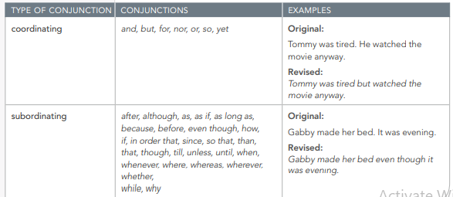

Study from worksheet, notebook and textbook pg.68

3. Future of Space Exploration Could See Humans on Mars, Alien Planets (pg.
Genre: News Article
Author: Nola Taylor Redd
What will it take to make interstellar travel a reality?

BACKGROUND
In 1969, Neil Armstrong became the first astronaut to walk on Earth’s moon. The next big step in space exploration is to put a person on another planet, such as Mars. In this article, former astronaut Mae Jemison and NASA engineer Adam Steltzner discuss the future of space
exploration and what is needed to make it possible. Comprehension Questions (Found on page 167)

*Comprehension Check Questions in notebook. (Questions found on page 175)
1. What is the goal of the 100-Year Starship project?
2. What does Jemison mean when she says that the project must be inclusive?
3. What is one of the challenges faced by the project?

Text Questions:
1. What can you infer the author’s purpose is in writing the news article? ________________________
__________________________________________________________________________________

2. What does Mae Jemison mean when she says “‘The public was left out of space.’”?
__________________________________________________________________________________

3. What does Mae Jemison mean when she says “‘I believe that pursuing an extraordinary tomorrow
will create a better world today’”? ______________________________________________________
__________________________________________________________________________________

Vocabulary
Future of Space Exploration:
1. Colonize: ___________________________________________________
2. Planetary: __________________________________________________
3. Interstellar: _________________________________________________
4. Justify: _____________________________________________________
5. Alternative: _________________________________________________
6. Certainly: ___________________________________________________
7. Discredit: ___________________________________________________
8. Assumption: _________________________________________________

Word Study
latin Suffix: -ary
The Latin suffix -ary means “belonging to or relating to.” For example, the word customary means “belonging to or relating to a custom.” In some cultures, it is a custom for people to shake hands with one another when meeting for the first time, so one could say that shaking hands is a customary gesture. *(See Worksheet )

Analyze Craft and Structure
Development of ideas: Text Structure
In order to communicate effectively, authors of nonfiction think about the best way to present
information.
1. In what part of the article does Redd explain what the 100-Year Starship project is? Why does
she describe it in this part of the article? ___________________________________________
_______________________________________________________________________________

2. Where in the article does Redd first quote Mae Jemison? Why does she quote her in this part
of the article? __________________________________________________________________
______________________________________________________________________________

Grammar
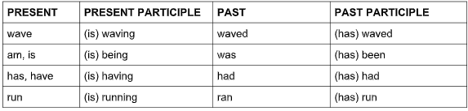
A verb has four principal parts: present, present participle, past, and past participle

Identify the principal part of the verb: present, past, present participle, or past participle.
1. Neil Armstrong walked on the moon.
2. _________ Mae Jemison is talking to people about space travel.
3. _________ Mae Jemison has traveled to outer space.
4. _________ Space exploration leads to knowledge and innovation.
5. _________ Many people object to the space program.

Study from worksheets and quizzes

4. UFO Sightings and News
Genre: Web Article
Author: Benjamin Radford

Background
A UFO, or “unidentified flying object,” is an unusual light or object in the air that is difficult to explain. Some people believe that UFOs are intelligent aliens traveling in spaceships. From 1952 to 1969, the United States Air Force investigated about 12,000 reports of UFO sightings

Check for Comprehension

1. What do some researchers believe about the Star of Bethlehem?
____________________________________________________________________________
2. What term did people use during the late 1800s to identify unknown objects in the sky?
____________________________________________________________________________
3. According to the Web article, who experienced the “most dramatic early UFO encounter” in
1897?
____________________________________________________________________________

4. According to the Web article, what is the first and most famous UFO abduction case?
____________________________________________________________________________

5. To confirm your understanding of the Web article, write a summary of “UFO Sightings & News.”
____________________________________________________________________________

Vocabulary

- Equate: ______________________________________________________
- Millennia: ____________________________________________________
- Extraterrestrial: ________________________________________________
- Unidentified: __________________________________________________
- Attributed: ____________________________________________________
- Perpetrated: ___________________________________________________

Grammar

Simple and Compound Subjects and Predicates Every sentence has a subject and a predicate and expresses a complete thought. The subject tells whom or what the sentence is about. The predicate tells what the subject is, does, or has done to it.

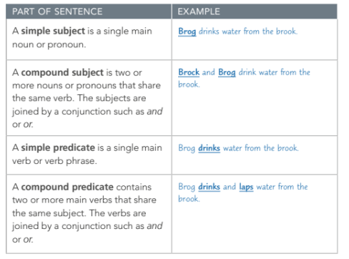

Study from worksheets and Handouts

