

First Grade
Social Studies Study Sheet Unit (1-4)

Question 1:
Circle the correct choice
Is a drawing of a place that can show a city or park

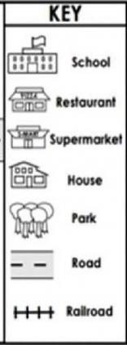
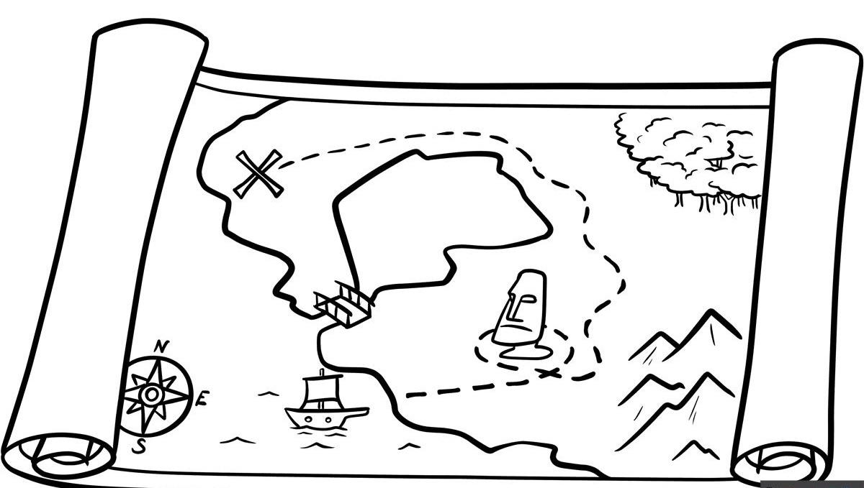
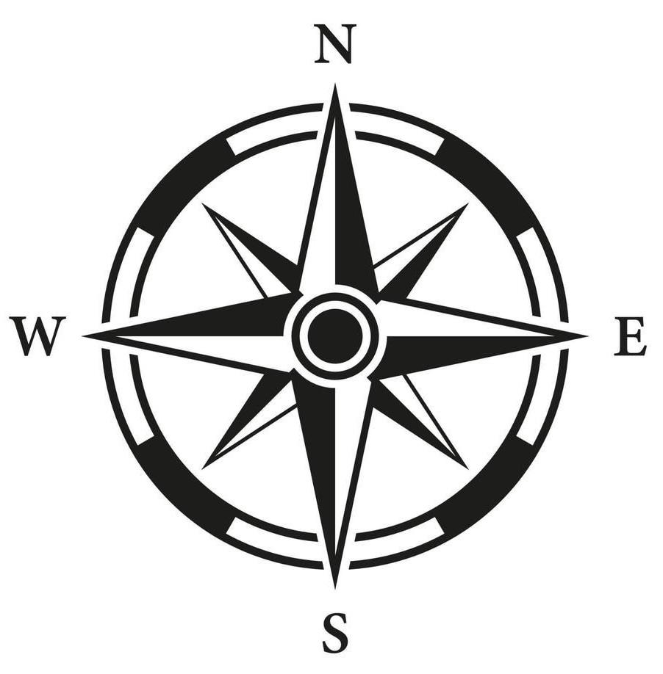

- Map. B) key. C)Compass Rose

Question 2:
Which of these is bad for the environment?

- Planting trees
- throwing trash on the ground
- Caring for the rivers

Question 3:
The shape that shows North,East,South and west is called a —————-. It helps tell us what direction to go

.

- Map. B). Key. C)compass rose

Question 4:
What is a mountain?

- A flat area of land
- A body of water
- A very high landform

Question 5:
What keeps the sand and sunlight out of a camel’s eyes?
- it’s long eyelashes
- There is no sunlight in the desert
- Their fur protects their eyes from the sun

Question 6)
What is the environment?

- a city. B)A map. C) The world around us

Question 7)
A map can have symbols or shapes .A —————— helps us know what those symbols mean

- Map. B) key. C) Compass Rose.

Question 8)
What does it mean to recycle something?

- A) to use something once and throw it away
- To turn something old into something new
- To buy lots of new things

Question 9)
We must protect earth’s ————— resources so they do not run out

- artificial. B) Natural. C) New

Question 10)
Can you draw a circle around the school, grocery store, the library

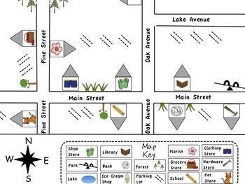


Question 11)
What is this picture showing you?

- Mountain
- Globe
- Camel

Question 12)
Match the physical feature with its description.

- Desert. Flat area of land

- Valley. Hot and dry land

- Plain. Between two high landforms

Question 13)
What animals lives in the desert?

- Bear
- Camel
- Polar bear

Question 14)
Match each word with its correct answer

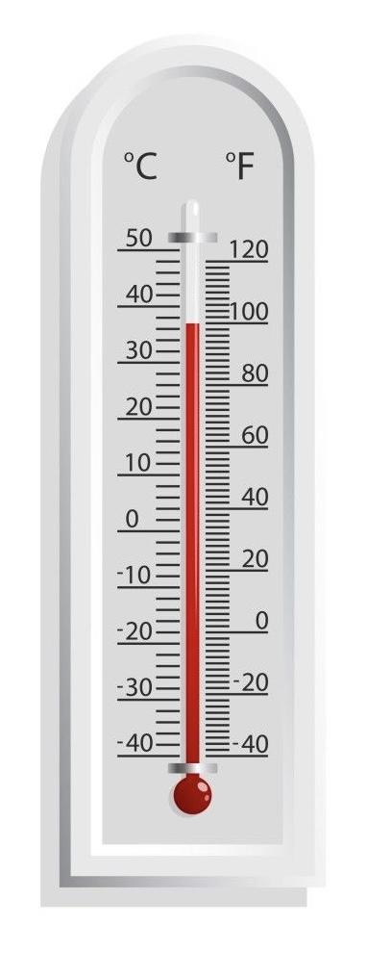

Hot. It is how hot or cold something is.

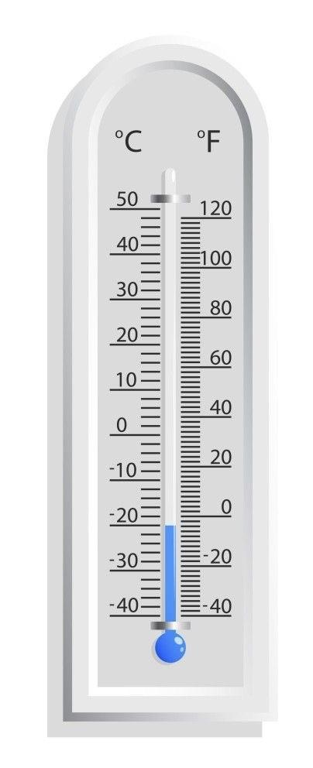

Cold. The desert is dry and sandy like the Sahara Desert.

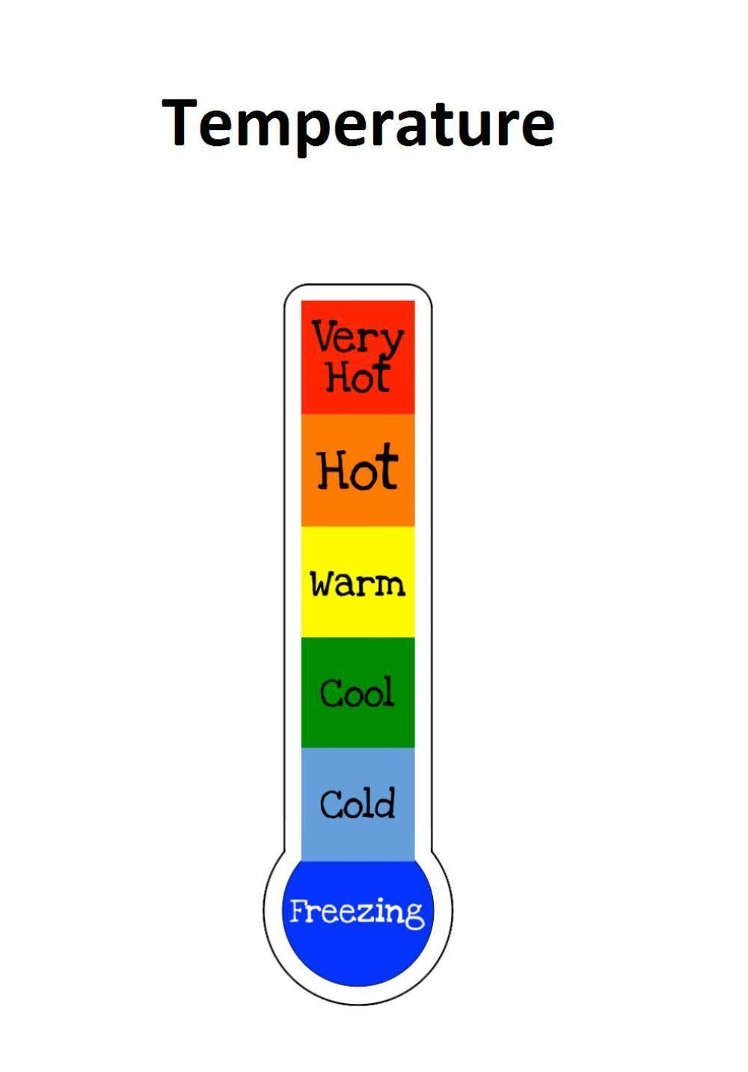

Temperature. Dessert is snowy like Antarctica.

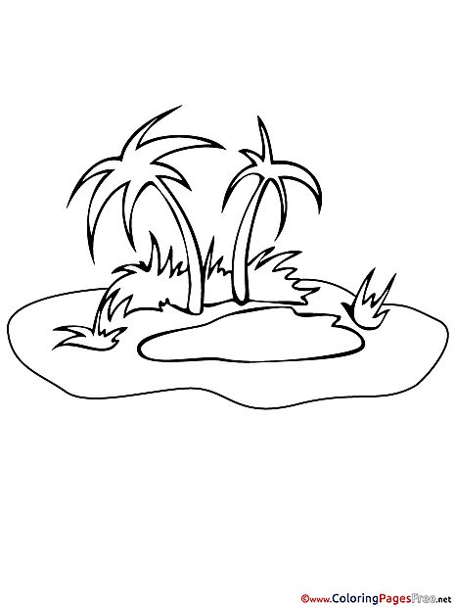

Oasis. Is the body of water you can find in a hot desert.

Question 15)
Recycling means making old things into new things. How should we sort these objects to help recycle?

