The First English Colonies
In the early 1600s, the English developed two clusters of settlements along the Atlantic coast. Their first colonies were in Virginia and New England. During the 1600s and early 1700s, English colonies expanded to cover the east coast of North America.
Jamestown Succeeds

After two failed attempts, the English finally established their first colony. In 1607 English settlers in Jamestown founded the colony of Virginia. The area, however, was already heavily populated by the Powhatan Indians.
The Pilgrims Arrive

In 1620, another group of English settlers founded the Plymouth colony in present-day Massachusetts. These settlers were Pilgrims, English Protestants who rejected England’s established church. They came to North America to worship freely.
The Pilgrims also wanted to govern themselves. Before they left their ship, the Mayflower, they wrote the Mayflower Compact. Those who signed it agreed to form a government and obey its laws. The idea of self-government later became a founding principle of the United States.
As in Jamestown, the Pilgrims learned from American Indians about crops and farming. They survived thanks to this help.
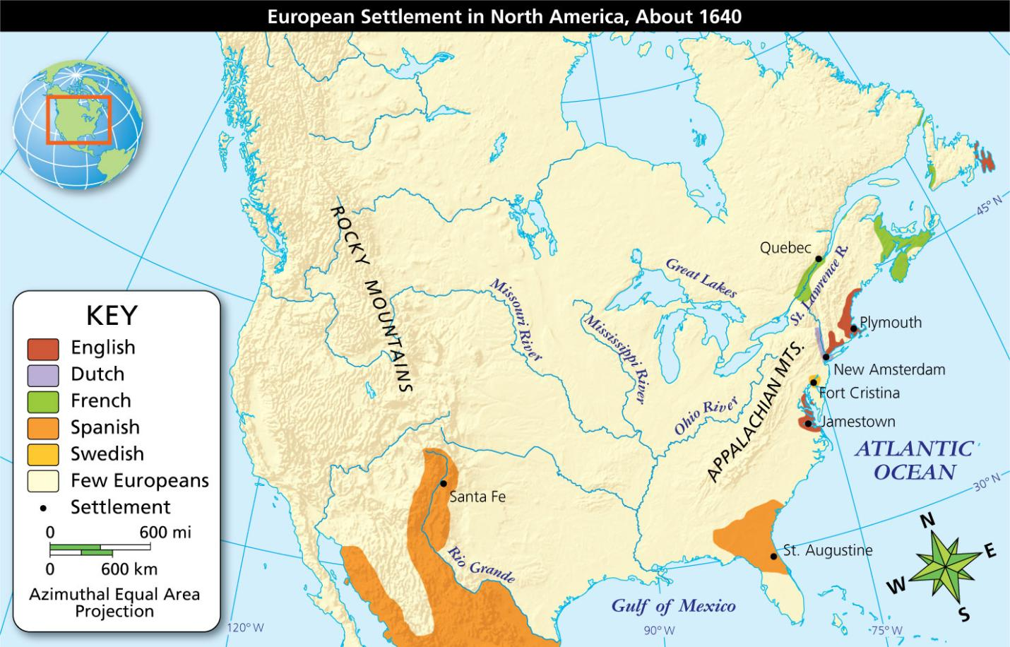
Geography Skills
European settlement spread in North America during the 1600s.
- Region What part of North America was settled by the Spanish?
- Infer Why did the east coast of North America attract the French, English, and Dutch?

Impact on American Indians

Europeans introduced useful items to American Indians such as new tools and new crops. A brisk fur trade

benefited both Europeans and native trappers.
There were also serious clashes between English colonists and Indians. Unlike the French, English colonists mainly wanted land for farming. Often, they simply took that land from Indian nations, or they forced them to sell at a low price.
When American Indian groups resisted colonists, colonists often responded violently. European weapons and diseases took the lives of many Indians.
- Reading Check Identify Main Ideas How did English colonization affect American Indians?

New Netherland
The Dutch, from the Netherlands, also sent explorers and settlers to North America. Yet the Dutch were unable to protect their holdings in the region for very long.
In 1609, the Dutch East India Company sent Henry Hudson to North America to find a water route to Asia. Instead, he discovered a major river in what is now New York that was later named the Hudson River.
In 1625, the Dutch built New Amsterdam at the mouth of the Hudson River to protect their fur trade. The town had the finest harbor on the Atlantic coast. Meanwhile, Dutch farming settlements spread up the Hudson River valley.
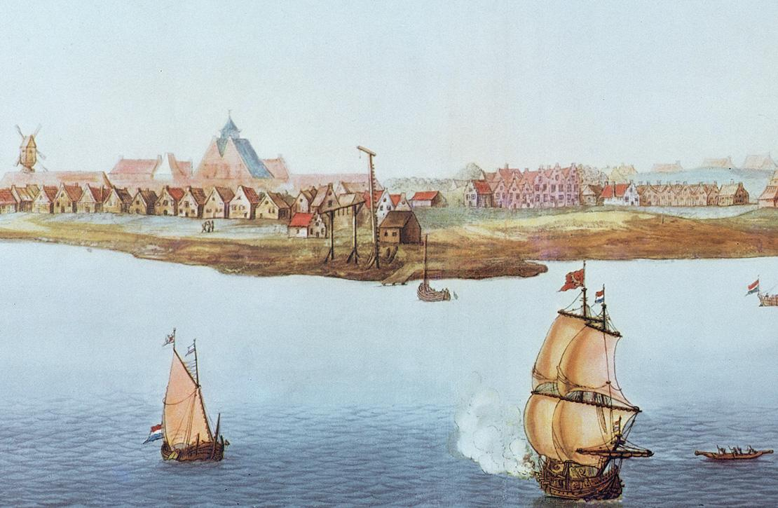
Analyze Images The capital of New Netherland, New Amsterdam, was built at the southern tip of Manhattan Island.
- Location How did New Amsterdam’s location contribute to its growth?
- Reading Check Summarize Why did the Dutch settle New Netherland?

Slavery in the English Colonies
Long before Europeans came to the New World, slavery had existed in Africa and Europe. European colonists in the Americas sought enslaved workers to do heavy labor on plantations, or huge farms. Europeans first enslaved American Indians, but too many of them escaped or died of diseases from Europe. Europeans began to seek to buy enslaved Africans who were resistant to those diseases and who were less likely to escape into territory where they did not know their way.

The Triangular Trade

The African slave trade became part of the triangular trade, a trade route with three legs linking North America, Africa, and the West Indies. Between 1500 and 1870, 9 million to 11 million Africans were enslaved and transported to the Americas. The deadly Middle Passage was the sailing route from Africa to the Americas.
Enslaved Africans were forced aboard ships and chained together to prevent escapes and mutinies, or revolts. They were chained together so that they could not move freely. Many enslaved Africans died of diseases on the filthy ships before reaching North America.
Olaudah Equiano, an African kidnapped with his sister and sold into slavery, wrote about the Middle Passage. He wrote how he felt while aboard a slave ship bound for Barbados, in the West Indies.

Primary Source
“I became so sick and low that I was not able to eat. I now wished for the last friend, death, to relieve me.”
—Olaudah Equiano, The Interesting Narrative of the Life of Olaudah Equiano, or Gustavus Vassa, the African

Life Under Slavery

By treating enslaved Africans as property, slave owners denied them rights and freedom. Enslaved Africans in the Americas had to adjust to life in unfamiliar surroundings and harsh living conditions. They were often beaten for failing to follow orders.
Work lasted from dawn to sundown. Food was meager and housing was uncomfortable. Enslaved Africans had no freedom of movement. Family members could be sold separately to different owners.
Enslaved women played a large role in keeping families together. They told stories from their African heritage. Enslaved Africans found other ways to maintain their culture, including music and dance. Africans also introduced new foods and cooking methods to the Americas.
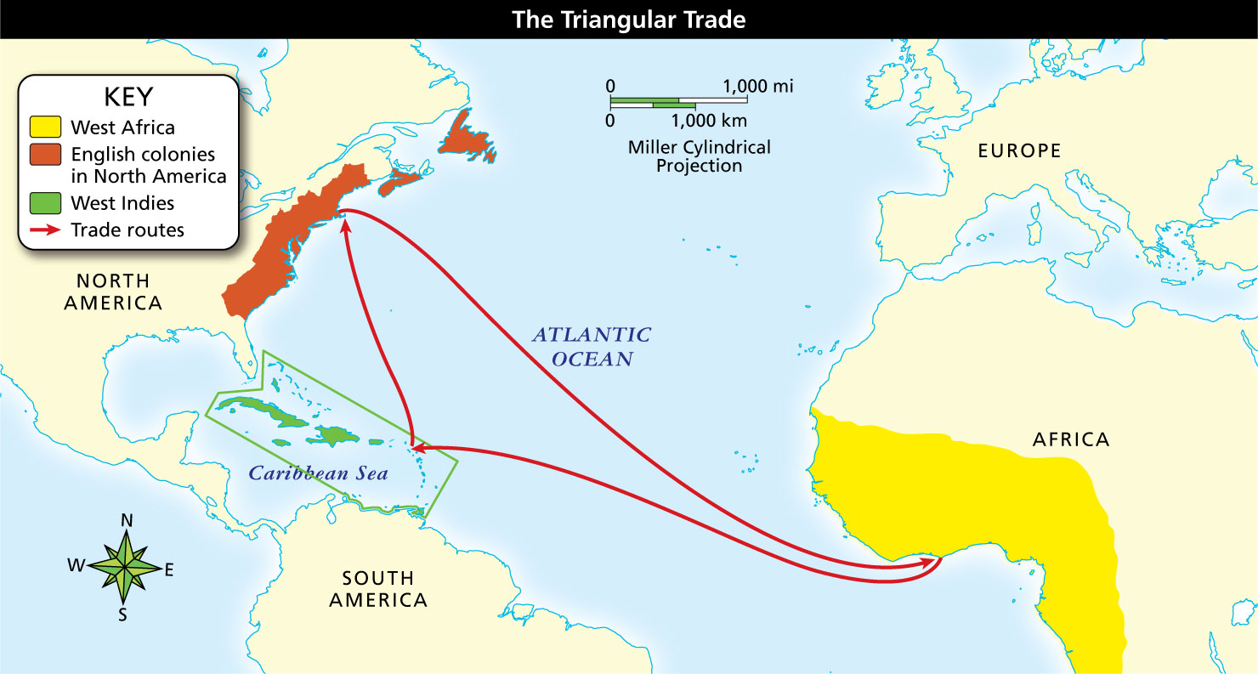

Geography Skills
The trade route bringing enslaved people from Africa to the Americas was shaped like a triangle.

Reading Check Identify Supporting Details How did enslaved Africans maintain their culture despite slavery?

