European Colonization
North Europeans explored what is now Canada around 1000. English explorer John Cabot sailed to the same region around 1497. Soon after, French, Dutch, and English explorers probed the east coast of North America, looking for a Northwest Passage, a nonexistent water route through North America to Asia. The Spanish, though, were the first to settle in the region.
Watch the video, Introducing Canadian History
- Study the image of English colonists trading at a Powhatan Indian village. How was it challenging for both sides?

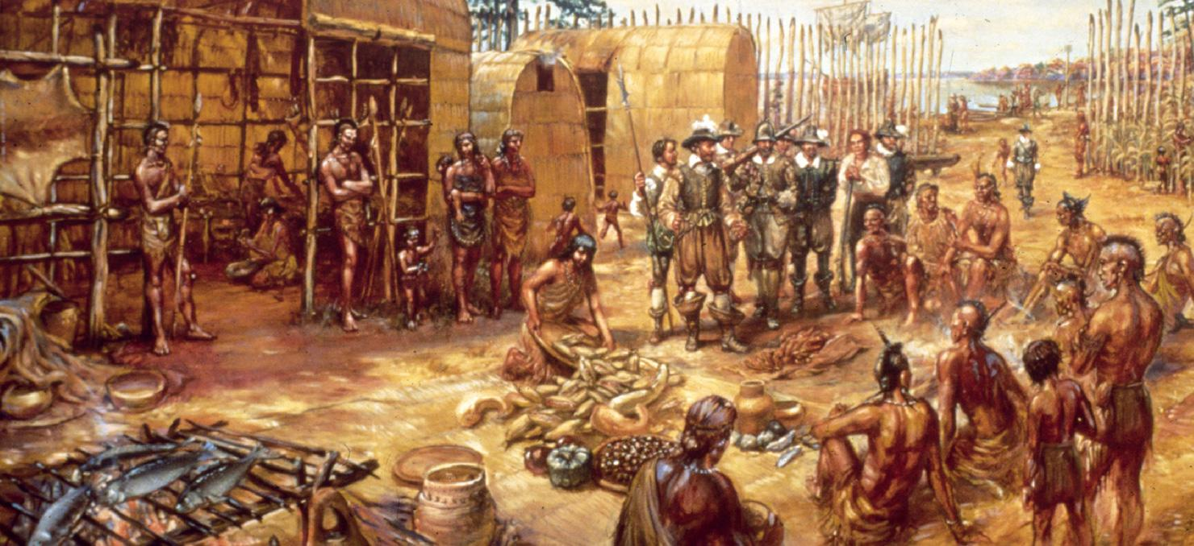

Where and What Was New Spain?
In 1492, Christopher Columbus landed in the West Indies. Despite the fact that millions of people already lived in the Americas, he claimed them for Spain. Later during the 1500s, Spain conquered what is now Mexico. Mexico became the center of a huge colony called New Spain. Spain grew very wealthy from the silver and gold of New Spain.

Spanish Settlements
New Spain expanded to the north. The Spanish built the first European settlement in what is now the United States in Florida in 1565.

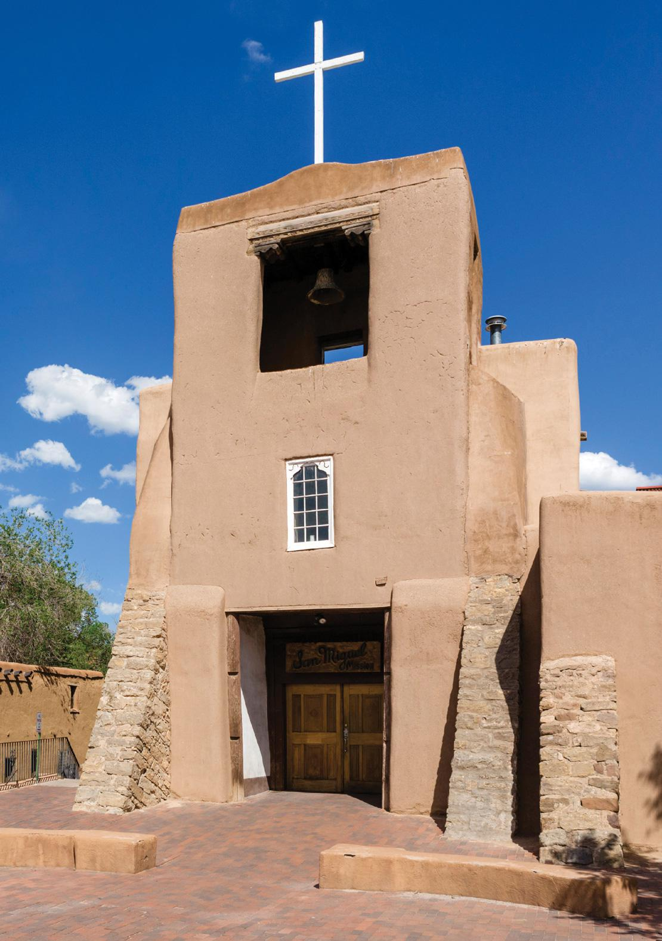

What Happened to American Indians?

The Spanish forced many American Indians to live on missions to convert them to Christianity. The Spanish forced them to do hard work without much rest. The Spanish and other Europeans brought diseases that American Indians had never faced before. As many as nine out of ten American Indians may have died from these diseases.
- Reading Check Identify Supporting Details What is a mission?

New France
During the 1500s, France sponsored explorers who came to North America looking for a Northwest Passage. Jacques Cartier found that American Indians offered valuable beaver fur. He claimed for France what is now eastern Canada, which became known as New France.
In 1608, Samuel de Champlain founded Quebec, the first permanent European settlement in New France. Unlike the Spanish, the French generally did not enslave the Indians. Rather, they focused on trade with Indian fur trappers. The French were also less of a threat because they took little land.
From New France, the French explored lands to the west and the south. In 1682, Robert de La Salle traveled south on the Mississippi River to the Gulf of Mexico. He named the area he explored Louisiana in honor of the French king, Louis XIV. The French now claimed the whole Mississippi Basin, including the Louisiana Territory.
- Reading Check Compare and Contrast Compare the treatment of American Indians by the Spanish and the French.

The First English Colonies
In the early 1600s, the English developed two clusters of settlements

along the Atlantic coast. Their first colonies were in Virginia and New England. During the 1600s and early 1700s, English colonies expanded to cover the east coast of North America.
Jamestown Succeeds
After two failed attempts, the English finally established their first colony. In 1607 English settlers in Jamestown founded the colony of Virginia. The area, however, was already heavily populated by the Powhatan Indians.

The Pilgrims Arrive
In 1620, another group of English settlers founded the Plymouth colony in present-day Massachusetts. These settlers were Pilgrims, English Protestants who rejected England’s established church. They came to North America to worship freely.
The Pilgrims also wanted to govern themselves. Before they left their ship, the Mayflower, they wrote the Mayflower Compact. Those who signed it agreed to form a government and obey its laws. The idea of self-government later became a founding principle of the United States.
As in Jamestown, the Pilgrims learned from American Indians about crops and farming. They survived thanks to this help.
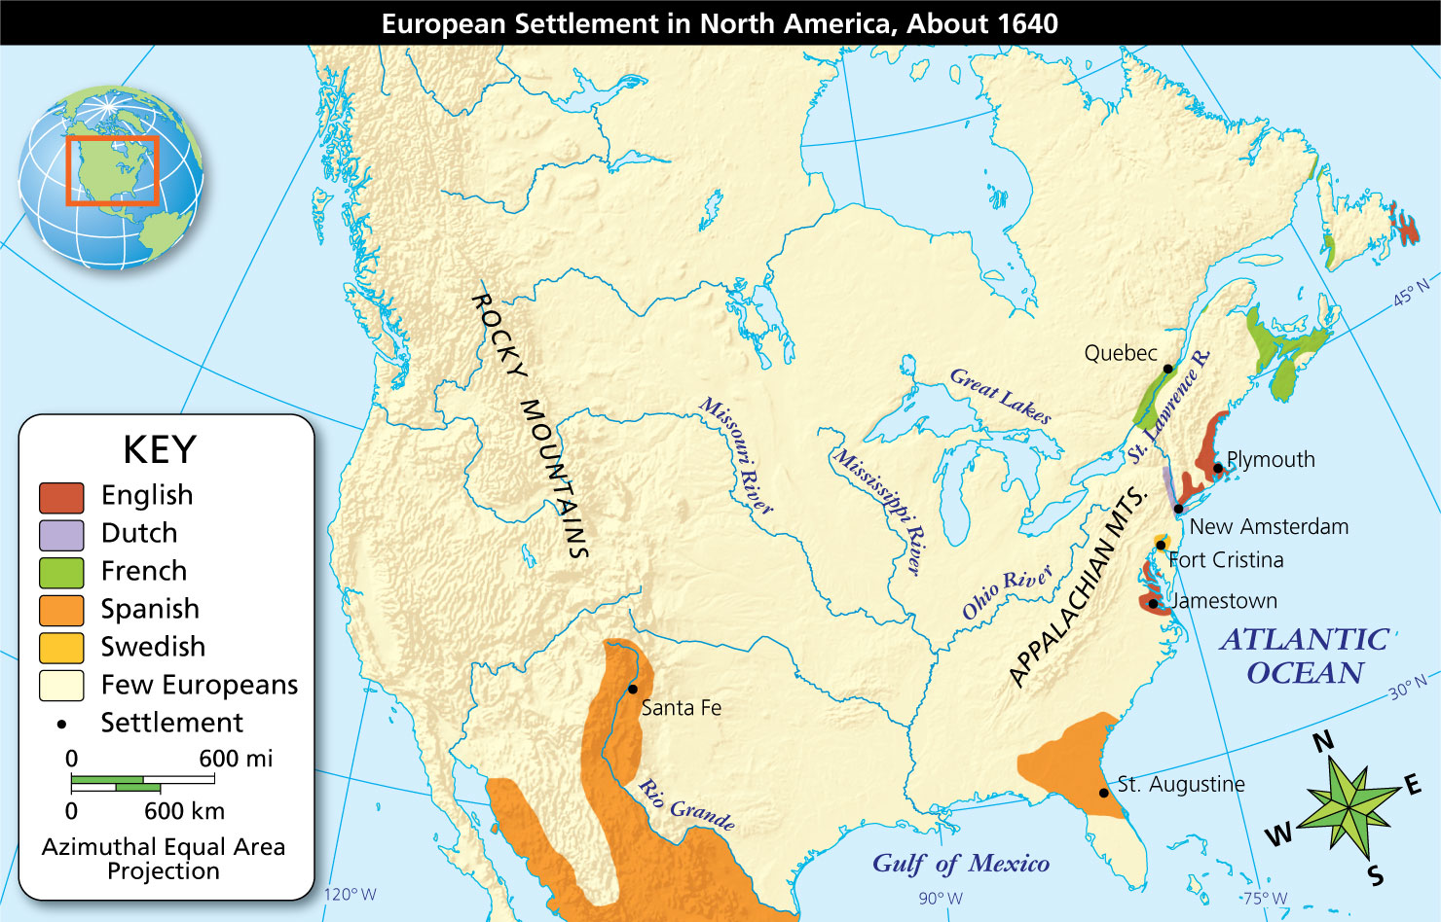
Geography Skills
European settlement spread in North America during the 1600s.
- Region What part of North America was settled by the Spanish?
- Infer Why did the east coast of North America attract the French, English, and Dutch?

Impact on American Indians

Europeans introduced useful items to American Indians such as new tools and new crops. A brisk fur trade benefited both Europeans and native trappers.
There were also serious clashes between English colonists and Indians. Unlike the French, English colonists mainly wanted land for farming. Often, they simply took that land from Indian nations, or they forced them to sell at a low price.
When American Indian groups resisted colonists, colonists often responded violently. European weapons and diseases took the lives of many Indians.
- Reading Check Identify Main Ideas How did English colonization affect American Indians?

