Astronomy and Mathematics (The Maya Civilization )

Maya texts reveal that priests were dedicated students of astronomy and astrology, the study of the stars and planets that assumes heavenly bodies influence human affairs. Advances in astronomy were closely linked to mathematics. Maya priests needed to measure time accurately in order to produce an accurate calendar. They developed a 365-day solar calendar as well as a 260-day religious calendar, recording the correct timing for important ceremonies.
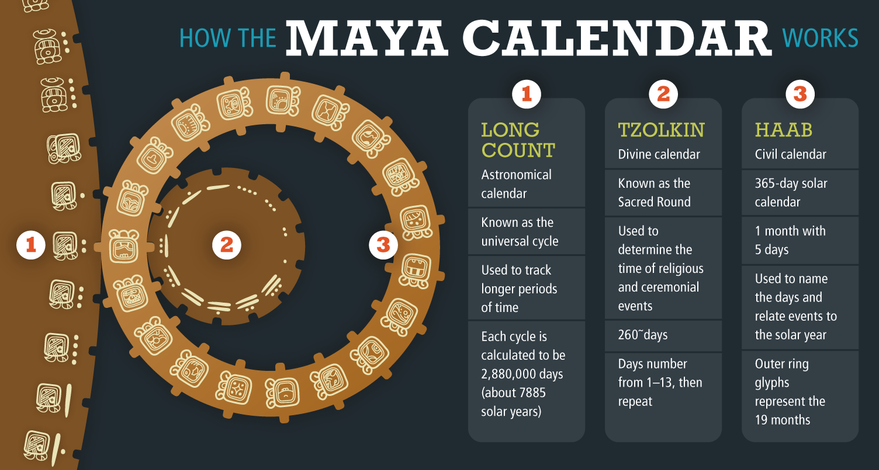
Analyze Information The Maya calendar consists of three linked calendars. Which calendar is closest to the one we use today?
Maya priests also invented a counting system based on three symbols: a dot to represent one, a bar for five, and a shell for zero. With these three symbols, they could keep track of events. Even peasants could use this simple form of arithmetic for trade. The Maya were one of the only early civilizations to understand the concept of zero. Along with counting, the Maya developed other, more sophisticated concepts in mathematics.
Maya Civilization Declines

About A.D. 900, the Maya abandoned many of their cities. In the Yucatán Peninsula, cities flourished for a few more centuries, but there, too, the Maya eventually stopped building them. By the time the Spanish arrived in the 1500s, the Maya mostly lived in farming villages. Archaeologists do not know for sure why Maya civilization declined, although theories abound. For example, frequent warfare may have taken its toll on society, or overpopulation could have led to over-farming and exhaustion of the soil.
Throughout the region, however, the remoteness of their jungle and mountain locations allowed many Maya to survive the encounter with the Spanish. Today, more than two million Maya people live in Guatemala and southern Mexico.
Explain What made it important for Maya mathematicians and astronomers to work in unison?

The Aztec

Sometime shortly after about A.D. 1200, bands of nomadic people from the north migrated into the Valley of Mexico, which lies in the high plateau of central Mexico. These people identified themselves as separate tribes, such as the Mexica (may SHEE kah), from whom Mexico gets its name. All the tribes spoke one language—Nahuatl (NAH hwaht el)—and believed their origins began in the same legendary birthplace, Aztlan. Together, these tribes are known as the Aztecs.
Aztec Hierarchy
ELITE
EMPEROR | COUNCIL OF NOBLES | PRIESTS/PRIESTESSES
elected by council of nobles, priests and military leaders; function was to lead war | officials, judges, governors of conquered provinces; owned/received land | peformed rituals to please the gods and prevent droughts and other disasters
COMMONER
WARRIORS |  | MERCHANTS
military; could become nobles depending on victories in battle |  | long-distance, not local, traveling traders; could become nobles depending on trades  artisans
PEASANT FARMERS |  | SERFS/ENSLAVED PEOPLE
could not own land |  | prisoners of war/debtors; enslaved people could own land and buy their freedom
Analyze Information In Aztec society, birth determined social status. Rank was visible in Aztec clothing. Nobles dressed in fine textiles, often cotton, and sandals. Where could a woman have influence in Aztec society?
Empire Building

In A.D. 1325, the Aztecs founded their capital city, Tenochtitlán (teh nawch tee TLAHN). According to Aztec legend, the gods had told the Aztecs to search for an eagle holding a snake in its beak and perching atop a cactus. When they saw this sign, they would know where to build their capital.
Indeed, they finally saw the sign on a swampy island in Lake Texcoco (tesh KOH koh), and there they built their city. Today, Mexico City sits atop this same site.
As their population grew, the Aztecs found ingenious ways to create more farmland in their lake environment, just as the Maya had modified their environment by farming raised beds in the river valley. The Aztec built chinampas, artificial islands made of mud piled atop reed mats that were anchored to the shallow lake-bed with willow trees. On these “floating gardens,” the Aztecs raised maize, squash, and beans, the same crops grown by their predecessors the Maya. They gradually filled in parts of the lake and created canals for transportation. Wide stone causeways linked Tenochtitlán to the mainland.
The Empire Expands

In the 1400s, the Aztecs greatly expanded their territory. Through a combination of fierce conquests and shrewd alliances, they spread their rule across most of Mexico, from the Gulf of Mexico in the east to the Pacific Ocean in the west. By 1517, the Aztec empire numbered an estimated 5 to 6 million people.
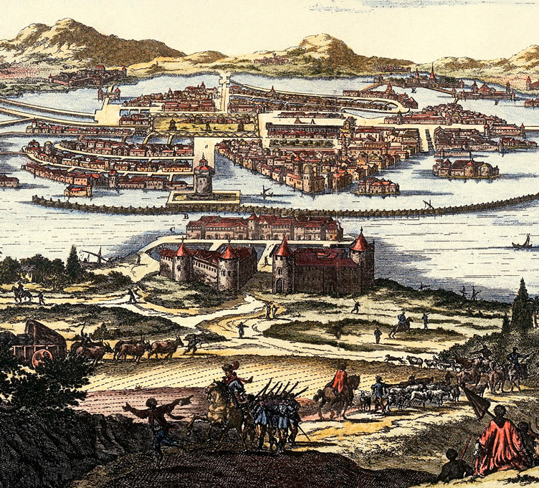
Tenochtitlán was one of the largest cities in the world at the height of the Aztec empire, with some 200,000 inhabitants in the early 1500s. The Spanish later constructed Mexico City, shown here in the 1600s, on the same site.
Government and Society

War brought immense wealth as well as power to the Aztec empire. Tribute, or payment from conquered peoples, helped the Aztecs turn their capital into a magnificent city. From its temples and royal palaces to its zoos and floating gardens, Tenochtitlán seemed a city of wonders. It was also the center of a complex, well-ordered empire.
Like the Maya, the Aztecs had a clear social hierarchy. A council of nobles, priests, and military leaders elected the emperor, whose primary function was to lead in war. Below him, nobles served as officials, judges, and governors of conquered provinces. Next came the warriors, who could rise to noble status by performing well on the battlefield. The priests were a class apart. They performed rituals to please the gods and prevent droughts or other disasters.
The Aztec had a powerful middle class, which included long-distance traders, who ferried goods across the empire and beyond. With goods from the highlands such as weapons, tools, and rope, they bartered for tropical products such as jaguar skins and cocoa beans.
The majority of people were commoners who farmed the land. At the bottom of society were serfs and enslaved people, who were mostly prisoners of war or debtors. Despite their low status, enslaved people's rights were clearly established by law. For example, enslaved people could own land and buy their freedom.
Religion and Mythology

Like the Olmec and the Maya before them, the Aztecs believed in many gods. They revered Huitzilopochtli (weets ee loh POHCH tlee) as the patron god of their people. His temple towered above central Tenochtitlán.
The Aztecs also worshipped Quetzalcoatl (ket sahl koh AHT el), which was akin to the Olmec snake god and the Maya god Kukulcan, the feathered serpent who reigned over earth and water. The Aztecs also worshiped the other powerful gods of an earlier culture that had been centered at the city of Teotihuacán (tay oh tee wah KAHN.)
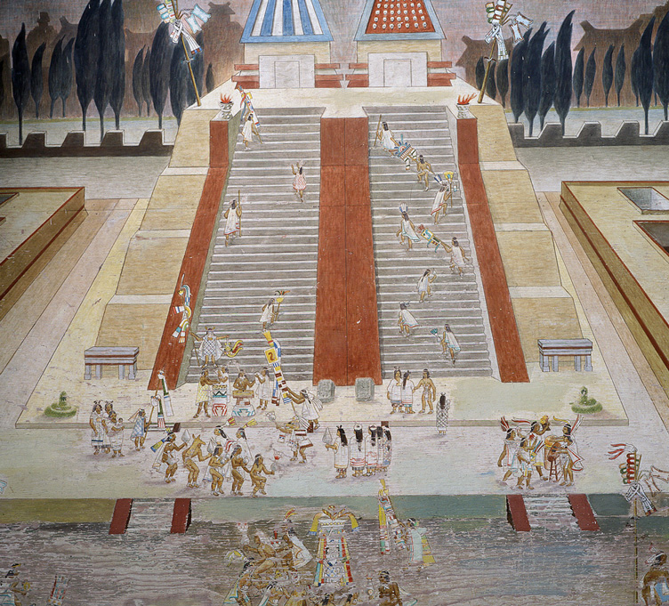
An Aztec temple, like the one shown in this illustration, was the place priests went to pray and make ritualistic sacrifice. Unlike Maya temples, Aztec temples have stairs on only one side.
Teotihuacán

had dominated life in the Valley of Mexico from about A.D. 200 to A.D. 750. The city was well planned, with wide roads, massive temples, and large apartment buildings to house its population of perhaps 200,000. Along the main avenue, the enormous Pyramid of the Sun and the Pyramid of the Moon rose majestically toward the sky.
Citizens of Teotihuacán worshiped gods such as Quetzalcoatl and Tlaloc (TLAH lohk), the rain god. After Teotihuacán fell, possibly to invaders, its culture survived and greatly influenced later peoples of Mesoamerica. The Aztecs, for example, believed that the gods had created the world multiple times. In their mythology, it was in Teotihuacán that the gods created the world in which the Aztecs lived.
In Aztec mythology, the gods frequently sacrificed themselves for the good of the people. They believed a god named Nanahuatzin (nah nah WAHTS een) had sacrificed himself to become the sun. To give the sun strength to rise each day, the Aztecs offered human sacrifices. Most of the victims were prisoners of war, who were plentiful because the Aztecs carried on almost continuous warfare.
Keepers of Knowledge

Priests were the keepers of Aztec knowledge. They recorded laws and historical events in the Aztec hieroglyphic writing system. Some priests ran schools. Others used their knowledge of astronomy and mathematics to foretell the future.
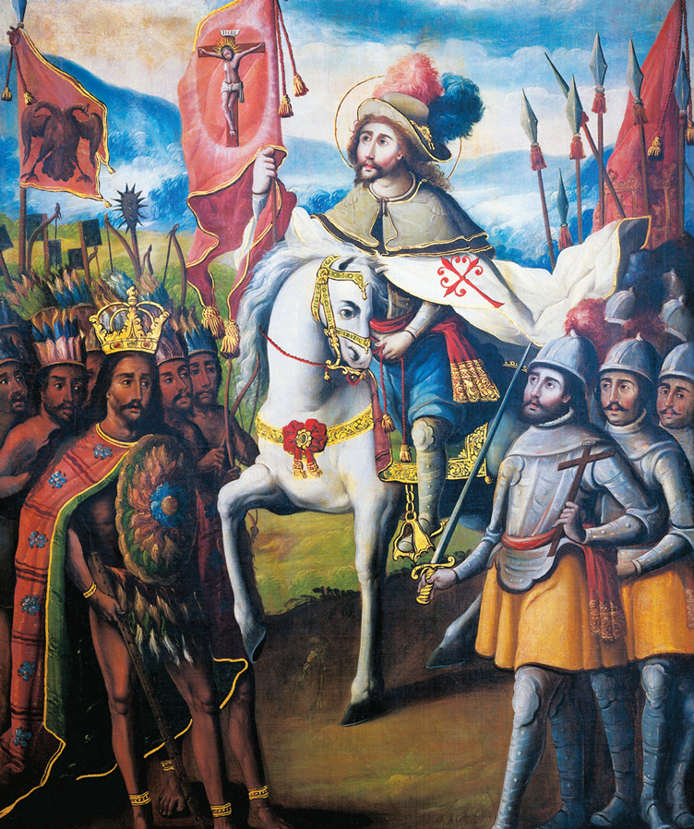
Spanish explorers and invaders found the Aztec empire at the height of its size and power in the early 1500s. This painting shows how a European artist imagined a meeting between the Aztec emperor Moctezuma and the Spanish conqueror Hernán Cortés.
Ideas developed in Aztec civilization in astronomy enabled the Aztecs to develop two calendars. One major idea was the development of a 260-day ritual calendar based on the movements of the sun. Aztec astronomers observed that it was 260 days for the sun to cross a certain point in the sky. This calendar was a ritual calendar used to schedule the best days to build houses and conduct ceremonies.
A second major idea was the development of a second 365-day calendar that was based on the movements of the constellation Pleiades. The Aztec astronomers watched the course of Pleiades across the night sky. When the constellation disappeared, and the sun was at its highest point, the Aztecs knew the rainy season was beginning. When Pleiades began to appear, it marked the dry season. These ideas in astronomy developed in Aztec civilization allowed the Aztecs to plant and harvest crops.
The Aztec civilization developed important ideas in mathematics, too. One major idea was the development of a numbering system based on 20. They used their numbering system to do precise measurements of land holdings and to calculate the area of fields for taxation. A second major idea was the use of symbols to write numbers and other symbols, such as the arrow, heart, and hands, to stand for fractions. The Aztec civilization developed ideas about multiplication and division, as well as some principles of geometry.
Like many other ancient peoples, the Aztecs believed that illness was a punishment from the gods. Still, Aztec priests used herbs and other medicines to treat fevers and wounds. Aztec physicians could set broken bones and treat dental cavities. They also prescribed steam baths as cures for various ills, a therapy still in use today.
Discontent Grows

The Aztecs developed a sophisticated and complex culture. But among many of the peoples they conquered, discontent festered and rebellion often flared up. At the height of Aztec power, word reached Tenochtitlán that pale-skinned, bearded men had landed on the east coast. When these armies from Spain arrived, the Spanish found ready allies among peoples who were ruled by the Aztec empire.
Summarize Describe the religion and mythology developed by the Aztecs.

