

Climate and Climate Change

science study sheet

Third Grade

Name: ______________ Date: ______________

Part 1: Key Vocabulary
Climate: | The usual weather of a place.
Weather: | What the air is like today.
Climate Change: | Long-term change in climate.
Pollution: | Dirty air, land, or water

Part two: What Is Climate?
- Climate is the usual weather of a place over a long time.
- It tells us if a place is usually hot, cold, wet, or dry.
- Climate changes slowly, not day by day.
Weather is day-to-day. Climate is long-term.

Part three: Types of Climate
- Hot Climate – Very warm most of the year (deserts).
- Cold Climate – Very cold with snow and ice (polar regions).
- Mild Climate – Not too hot or too cold.
- Wet Climate – Lots of rain.
- Dry Climate – Very little rain.
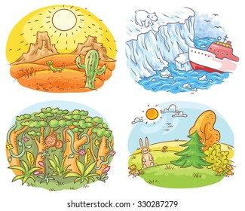

Part four: What Is Climate Change?
- Climate change means long-term changes in Earth’s climate.
- The Earth is getting warmer over time.
- This is called global warming.
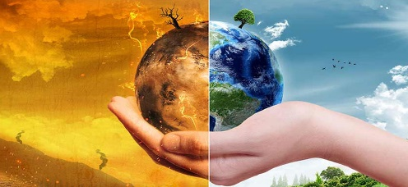

Part five: Causes of Climate Change
- Burning fossil fuels (cars, factories)
- Cutting down too many trees.
- Air pollution that traps heat around Earth.
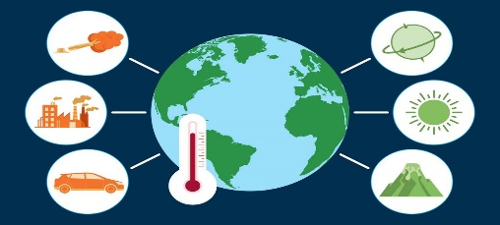

Part six: Effects of Climate Change
- Hotter temperatures.
- Melting ice at the North and South Poles.
- Strong storms and floods.
- Changes in where plants and animals can live.
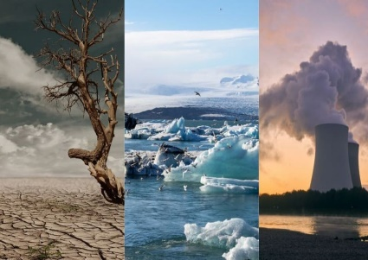

Part eight: How Can We Help the Earth?
- Turn off lights to save energy.
- Use less water.
- Recycle paper, plastic, and glass.
- Plant trees.
- Walk or ride a bike when possible.
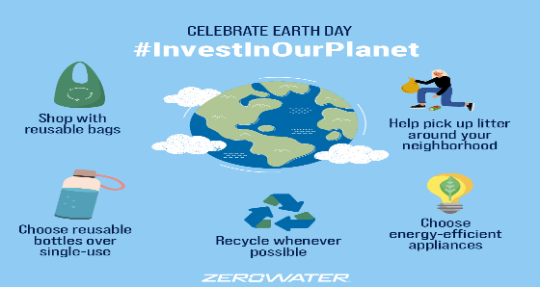

Part nine: Write T for True or F for False)

- Climate is the weather of a place over many years. (T)
- Weather and climate mean the same thing. (F)
- A dry climate has a lot of rain. (F)
- Global warming means the Earth is getting colder. (F)
- Cutting down trees can cause climate change. (T)
- Climate change can melt ice at the poles. (T)
- Recycling helps protect the Earth. (T)

Part ten: Short Questions
- What is climate?
Climate is the usual weather of a place over a long time.
- What is weather?
Weather is what the air is like today.
- Name one type of climate.
Hot climate. (Accept: cold, mild, wet, dry)
- What is climate change?
Climate change is a long-term change in Earth’s climate.
- What is global warming?
Global warming means the Earth is getting warmer.
- Name one cause of climate change.
Burning fossil fuels. (pollution, cutting trees)
- Name one effect of climate change.
Melting ice. (hotter weather, strong storms)
- Name one way to help the Earth.
Recycle. save energy, plant trees)

